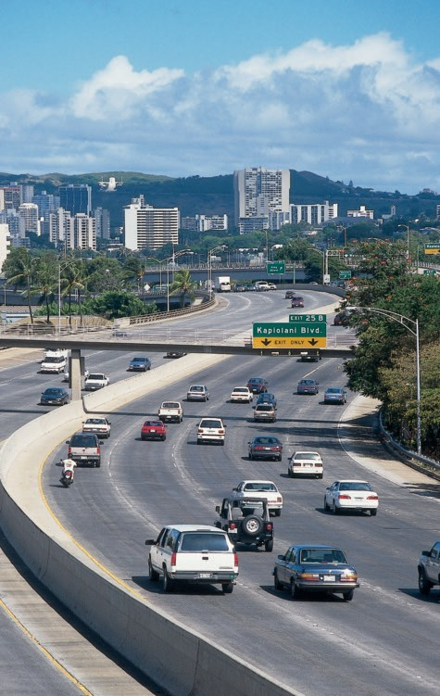

***OFFICIAL***

**INCLUDES**

**Complete Test Questions and Answers From**

**State of Hawaii**

**Dept. Of Transportation**

**$5.20**

### DRIVER LICENSING OFFICES

**City & County of Honolulu**

Honolulu – 925 Dillingham Boulevard, Suite 101A Phone 768-9100 Downtown, Fort Street Mall (renewals & duplicates,

8:00 a.m.–4:00 p.m.), Phone 768-4145

Hawaii Kai Town Center, 6600 Kalanianaole Highway #101, (renewals & duplicates, 8:00 a.m.–4:00 p.m.), Phone 768-4800

Aiea – Pearlridge Shopping Center, 98-1005 Moanalua Road 244B (renewals & duplicates, 9:00 a.m.–5:00 p.m.), Phone 768-5200 Kaneohe – Koolau Center, 47-388 Hui Iwa Street, Phone 239-6301

Windward City Shopping Center, 45-480 Kaneohe Bay Drive C06 (renewals & duplicates, 8:00 a.m.-4:00 p.m.), Phone 768-4100

Kapolei – 1000 Uluohia Street, Phone 768-3100 Wahiawa – 330 North Cane Street, Phone 768-4054

Waianae – 87-670 Farrington Highway (Monday & Wednesday), Phone 768-4222

Hours of Operation Monday-Friday except holidays 7:45 a.m. to 4:00 p.m.

Testing Hours 7:45 a.m. to 3:30 p.m.

### County of Hawaii

Hilo Office, 349 Kapiolani Street, Phone 961-2222

West Hawaii Civic Center, 74-5044 Ane Keohokalole Highway, Phone 323-4800 Naalehu Office, 95-5355 Mamalahoa Highway, Phone 854-7214

(Tuesdays and Wednesdays by appointment only)

Pahoa Office, 15-2615 Keaau-Pahoa Road, Phone 965-2721

(M-F 8:00 a.m. – 3:30 p.m.)

Waimea Center, 65-1158 Mamalahoa Highway Suite 1-A, Phone 881-3488

Hours of Operation Monday-Friday except holidays 7:45 a.m. to 4:00 p.m.

Testing Hours 8:00 a.m. – 3:00 p.m.

### County of Maui

Kahului Service Center, Maui Mall, 70 E. Kaahumanu Avenue, Suite A17, Phone 270-7363

Lahaina, 900 Front Street, Unit I-17, Phone 270-7363

Hana, 4610 Hana Highway (Tuesday & Thursday, 8:00-11:00 a.m.), Phone 248-7280

Kihei, 303 Lipoa Street (M-F 8:00-10:45 a.m. & 12:00-3:00 p.m.), Phone 270-7363 Molokai, Mitchell Pauole Center, 100 Ailoa Street, Phone 553-3430

Lanai, 717 Fraser Avenue, Phone 565-7878

Hours of Operation Monday-Friday except holidays 8:00 a.m. to 4:00 p.m. Call 808.270.7363 or visit us at <http://co.maui.hi.us/2125/DMV-Wait-Times>

### County of Kauai

Lihue Civic Center, Kapule Building, 4444 Rice Street Suite 480, Phone 241-4242

Hours of Operation Monday-Friday except holidays 7:45 a.m. to 4:00 p.m.

(c) Copyright 1977, 2006 Director of Transportation, State of Hawaii

No part of this manual may be reproduced in any form without the written permission of the Director of Transportation of the State of Hawaii.

HPC 0*7/17*

Printed and published by Hagadone Printing Company, Inc. 274 Puuhale Road, Honolulu, Hawaii 96819, Phone 847-5310



DAVID Y. IGE

GOVERNOR

Aloha,

EXECUTIVE CHAMBERS

H O N O L U L U



You are about to learn the skills and assume the responsibilities of driving on the roadways in our State. As you drive, I ask that you obey our traffic laws and develop safe driving habits. Please keep in mind that you have a legal and moral responsibility for the safety of others.

I encourage you to show your “aloha spirit” when you drive. Be patient, courteous and watch the road at all times. The information in this manual will teach you to be a safe and respectful driver. Please read it carefully and apply that knowledge daily. By becoming a good driver, other motorists will follow your lead.

Be safe and enjoy driving in our beautiful State.

Sincerely,



**DAVID Y. IGE**

Governor, State of Hawai‘i

### RESPONSIBLE AGENCIES and WEBSITES

1. State of Hawaii Department of Transportation Motor Vehicle Safety Office

<http://hidot.hawaii.gov/highways/library/motor-vehicle-safety-office/> (Program Coordination)

1. City and County of Honolulu Department of Customer Service [www.co.honolulu.hi.us/csd/vehicle](http://www.co.honolulu.hi.us/csd/vehicle)
2. Maui County Department of Finance [www.mauicounty.gov](http://www.mauicounty.gov/)
3. Hawaii County Department of Finance

Vehicle Registration and Licensing Division

<http://www.hawaiicounty.gov/finance-vrl/>

1. Kauai County Department of Finance

<http://kauai.gov/DriversLicense>

NOTE: For further information see inside front and back covers.

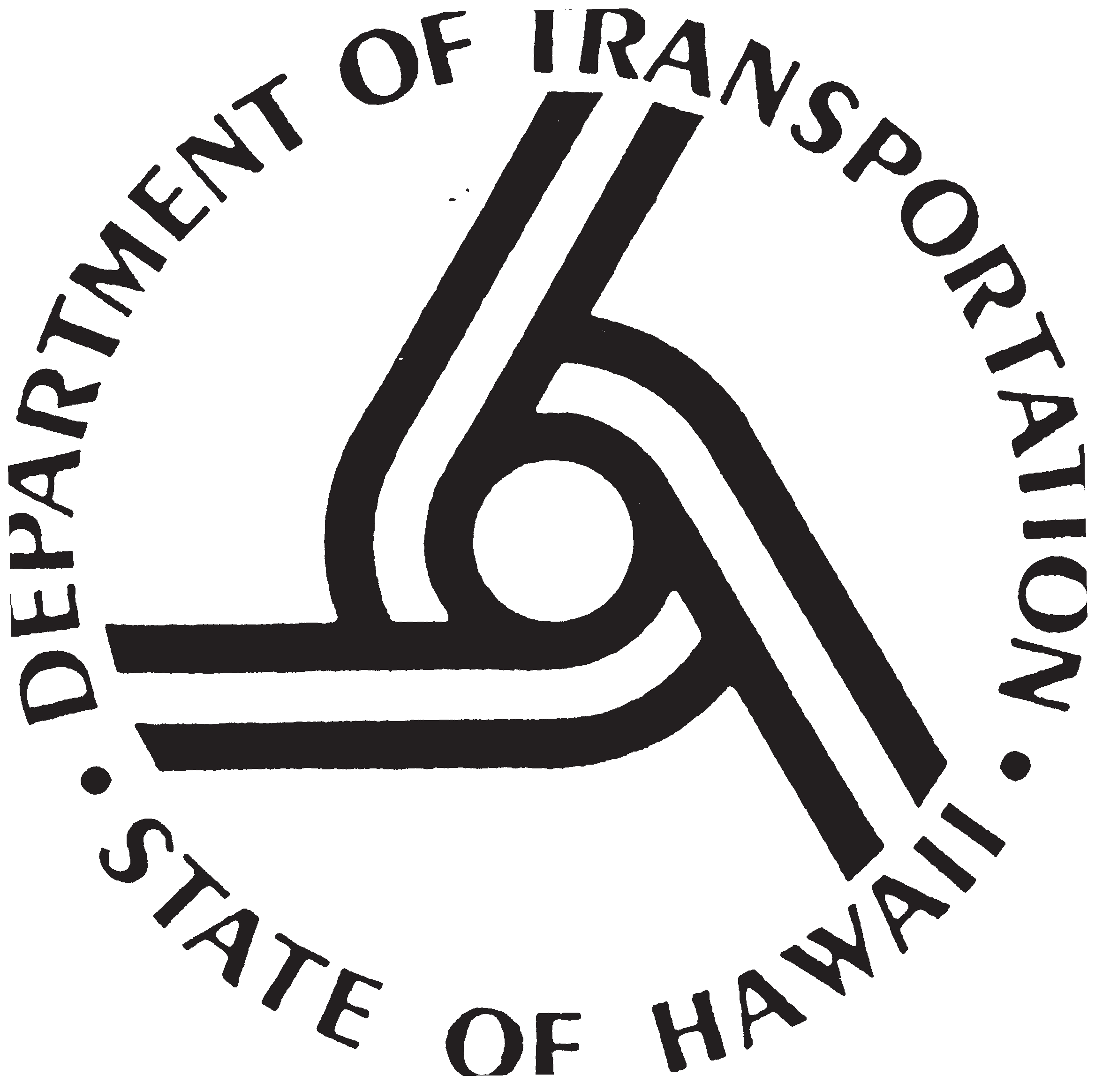

**STATE OF HAWAII DEPARTMENT OF TRANSPORTATION**

### INTRODUCTION

This manual is designed for use as a guide to help you become a safer driver and to help you qualify for a Hawaii driver’s license. The information contained herein does not supersede either state laws or county ordinances or any duly adopted rule or regulation.

Additional manuals are sold at the driver licensing offices.

A separate **Motorcycle Operator Manual**, DOTH2053, is available to provide more comprehensive coverage of laws and operating techniques concerning motorcycles.

A separate **Driver’s Manual for Commercial Vehicle Driver Licensing**, DOTH2044, is available to prepare drivers to pass the knowledge and skill tests to get a commercial driver’s license.

Occasionally changes to rules or laws are made between printings of this manual. You may check for updated information at the web sites listed on Page 4. These sites provide details about documents that are required to prove identity, date of birth, social security number, legal presence in the USA and principal residence. Some documents can serve more than one purpose. For example, a birth certificate can document a person’s legal name, date of birth and legal presence. Two documents are required to prove principal residence. Details about acceptable documents to prove identity, date of birth, social security number, legal presence and principal residence are available at web site [http://hidot.hawaii.gov/hawaiis-legal-presence-law/.](http://hidot.hawaii.gov/hawaiis-legal-presence-law/) Additional informa- tion is available in Hawaii Administrative rules 19-122 located at web site [http://hidot.](http://hidot/) hawaii.gov/highways/home/doing-business/hawaii-administrative-rules/.

### STATE OF HAWAII DRIVER’S MANUAL

MESSAGE FROM THE GOVERNOR 3

LIST OF RESPONSIBLE AGENCIES 4

INTRODUCTION 6

TABLE OF CONTENTS 7

DEFINITION OF TERMS 8

Chapter I Licensing of Drivers 10

Chapter II Vehicle Equipment and Inspection 18

Chapter III Vehicle Registration 21

Chapter IV The Driver 24

Chapter V Traffic Laws, Ordinances, Rules and Regulations 26

Chapter VI Signals, Signs and Lane Markings 33

Chapter VII Accident Procedures 52

Chapter VIII No Fault Insurance—Financial Responsibility 53

Chapter IX Alcohol and Other Drugs 55

Chapter X Safe Driving Techniques 57

Chapter XI Trucks, Buses and Motorcycles 85

Chapter XII Pedestrian Safety 95

Chapter XIII Bicycle Safety 97

APPENDIX

Questions with Illustrations 99

Location of Offices and Facilities, Hours of Operation and

Telephone Numbers . . . . . . . . . . . . . . . . . . . . . . . . . . . . . . . inside front and

back covers

### DEFINITIONS

Abandoned Vehicle Any vehicle left unattended on the highway for more than 24 hours.

Emergency Vehicle Any vehicle of the police and fire departments or federal agency having similar functions and any federal, state and county ambulance and any private vehicle designated by ordinance, properly equipped with a blue or red flashing light and warning sound system.

Bicycle A device with two or three wheels having a diameter of 16" or greater propelled by human power.

Bus Every motor vehicle designed for carrying more than ten pas- sengers and used for the transportation of persons.

Business District The territory contiguous to and including a highway when within any six hundred feet along such highway there are buildings in use for business or industrial purposes which occupy at least three hundred feet of frontage on one side or three hundred feet collectively on both sides of the highway.

Commercial Motor

Vehicle

For purposes of driver licensing, means a motor vehicle or combination of motor vehicles used in commerce to transport passengers or property:

1. If the vehicle has a gross combination weight rating of 26,001 or more pounds inclusive of a towed unit(s) with a gross vehicle weight rating of more than 10,000 pounds;
2. If a single vehicle has a gross vehicle weight rating of 26,001 or more pounds;
3. If the vehicle (any GVWR), is designed to transport sixteen or more occupants including the driver; or
4. If the vehicle, (any GVWR), is used in the transportation of hazardous materials requiring placarding

For purposes of motor carrier regulations, means any

self-propelled or towed motor vehicle used on a highway in commerce to transport passengers or property when the vehicle—

1) Has a gross vehicle weight rating or gross combination weight rating, or gross vehicle weight or gross combination weight, of 10,001 pounds or more, whichever is greater; or

1. Is designed or used to transport more than 8 passengers (including the driver) for compensation; or
2. Is designed or used to transport more than 15 passengers, including the driver, and is not used to transport passengers for compensation; or
3. Is used in transporting hazardous material in a quantity requiring placarding.

Commercial Driver’s A license issued by a state or other jurisdiction in accordance License with the standards contained in 49 CFR Part 383 to an indi- vidual which authorizes the individual to operate a class of

commercial motor vehicle.

Crosswalk That part of a roadway at an intersection included within the connections of the lateral lines of the sidewalks on opposite sides of the highway measured from the curbs or, in the absence of curbs, from the edges of the transversable roadway; or any portion of a roadway at an intersection or elsewhere dis- tinctly indicated for pedestrian crossing by lines or other mark- ings on the surface.

Driver Every person who drives or is in actual physical control of a vehicle.

Gross Vehicle The weight of the vehicle plus the vehicle’s load-carrying Weight Rating capacity.

Highway The entire width between the boundary lines of every way publicly maintained when any part thereof is open to the use of the public for purposes of vehicular travel.

Safety Zone The area or space officially set apart within a roadway for the exclusive use of pedestrians and which is protected or is so marked as to be plainly visible.

NOTE: Additional definitions may be found in The Statewide Traffic Code, Hawaii Revised Statutes 291C and 286-2, HRS. See web site [http://capitol.hawaii.gov/.](http://capitol.hawaii.gov/)

### CHAPTER 1 LICENSING OF DRIVERS

**PERSONS EXEMPTED FROM LICENSE**

YOU ARE EXEMPTED FROM OBTAINING A HAWAII DRIVER’S LICENSE:

1. When you are employed by and driving a motor vehicle owned by the federal government that does not fit the definition of a commercial motor vehicle (federal fire fighters and active duty military are exempt) and possess a valid driver’s license issued by an agency of the federal government.
2. When you are thirteen years of age or older and operating any road machine, farm tractor or implement of husbandry temporarily on a highway.
3. When you are at least eighteen years of age and have in your possession a valid driver’s license equivalent to a Hawaii Class 1, 2 or 3 driver’s license issued to you in any state of the United States, District of Columbia, The Commonwealth of Puerto Rico, U.S. Virgin Islands, American Samoa, Guam, a province of the Dominion of Canada, or the Commonwealth of the Northern Mariana Islands. Compact foreign drivers’ licenses accompanied by an International Driving Permit issued in the foreign jurisdiction are valid for one year.
4. When you are a non-resident at least twenty-one years of age and have in your possession a valid commercial driver’s license issued to you in any state of the United States, District of Columbia, a province of the Dominion of Canada, or Mexico.

NOTE: Compact foreign drivers licenses accompanied by an International Driving Permit issued in the foreign jurisdiction are valid for one year from the date of arrival (your first port-of-entry) into the United States.

### WHO CANNOT BE LICENSED

You cannot be licensed to operate a motor vehicle in Hawaii:

1. During the suspension period when your license has been suspended or revoked by a court.
2. For a period of two years after you have been convicted of drunk driving while unlicensed.
3. Unless you have successfully passed the required examination.
4. When you are required to but fail to comply with the financial responsibility laws.
5. When the examiner of drivers has good cause to believe that you by reason of physical or mental disability would not be able to operate a motor vehicle with

safety upon the highways.

1. When you are between 16 and 18 years of

age without consent from the parent(s)

or guardian specified in legal custody documents.

1. When you are under 16 years of age.
2. When you are physically or mentally disqualified by law.
3. When you have outstanding traffic citations.

### IDENTIFICATION AND LEGAL PRESENCE

The new driver license security requirements relating to identity and legal presence in this country began on March 5, 2012. Anyone applying for a new or renewed driver’s license will be required to provide an original or certified copy of at least one of the following docu- ments to establish identity and legal presence in the USA. The more common documents used to prove identity and legal presence are listed below. Additional information is available at web site: [***http://hidot.hawaii.gov/hawaiis-legal-presence-law/***](http://hidot.hawaii.gov/hawaiis-legal-presence-law/)

The underlined items may be used to document both identity and legal presence.

1. A valid, unexpired U.S. passport;
2. Certified copy of a birth certificate filed with a state office of vital statistic or equivalent agency in the individual’s state of birth;
3. Consular report of birth abroad issued by the U.S. Department of State, Form FS-240, DS-1350 or FS-545;
4. Valid, unexpired permanent resident card (Form I-551) issued by DHS or INS;
5. Unexpired employment authorization document issued by DHS, Form I-766 or Form I-688B;
6. Unexpired foreign passport with one of the following: a valid, unexpired U.S. visa affixed or an approved I-94 form documenting the applicant’s most recent admittance into the United States or a DHS admittance stamp.
7. Certificate of naturalization issued by DHS, Form N-550 or Form N-570;
8. Certificate of citizenship, Form N-560 or Form N-561, issued by DHS;
9. Applicants that established a name other than the name that appears on a source document (marriage, adoption, court order, or other mechanism permitted by state law or administrative rule) must provide evidence of the name change through the presenta- tion of documents issued by a court, governmental body or other entity as determined by the state;
10. Additional documentation may be required if the documentation provided is questionable.

Documents used to show principal residence must include your name and principal address in Hawaii. The principal address is the location where you currently reside even if the residence location is temporary. Documents commonly used include: a driver’s license; a motor vehicle registration or title; a current voter registration card; or a utility bill that is not more than two months old. A complete list of documents that can be used is in 19-122-302(2) (D), Hawaii Administrative Rules (see web address <http://hidot.hawaii.gov/highways/home/> doing-business/hawaii-administrative-rules/).

Drivers who choose not to provide a social security number or unable to provide one may obtain a limited purpose driver’s license. This license will be valid for driving only. It will not be an acceptable identification document for federal purposes, such as boarding an airplane.

### TYPES OF LICENSES

**Instruction Permit** – An instruction permit allows you to operate a motor vehicle when supervised by another driver who is at least 21 years of age and who is licensed to drive that type of vehicle. In all vehicles except motorcycles, the licensed driver must sit in the right front seat. You must be at least 15 years to be eligible for an instruction permit. If you are under age 18, refer to section ***Driving by Minors***.

**Provisional license** – If you are under the age of 18, you must operate on a provisional license for at least 6 months before being eligible for a class 3 driver’s license. Refer to the section ***Driving by Minors***.

**Moped license** (class 1) – You must have a class 1 license to operate a moped in Hawaii

highways. You must pass a special knowledge test and an off-street skills test. Refer to the Motorcycle Operator Manual available at any driver licensing office.

**Motorcycle license** (class 2) - You must have a class 2 license to operate a motorcycle on Hawaii highways. You must pass a special knowledge test and an off-street skills test.

Refer to the Motorcycle Operator Manual available at any driver licensing office.

**Driver’s License** (class 3) – To get a class 3 license, you must be at least 17 years old. If under the age of 18, you must complete a graduated licensing program that will allow you to develop your driving skills over time as you gain experience and maturity. Refer to the section Driving by Minors.

**Larger Class License** – Other class licenses are required if you drive certain types of vehicles. You must be at least 21 years old before applying for any of these licenses. Each class or endorsement requires special tests. Refer to the section Category 4 License. Refer to the Hawaii Commercial Driver’s License manual to obtain a commercial driver’s license.

**Limited Purpose license** – If an applicant refuses or is unable to provide a social security number, the applicant will be eligible for issuance of a limited purpose instruction permit, limited purpose driver’s license or limited purpose provisional driver’s license upon meeting all other applicable requirements.

### OBTAINING A DRIVER’S LICENSE OR INSTRUCTION PERMIT PRELIMINARY EXAMINATIONS

You will be given the following tests when you apply for a driver’s license or instruction permit as required:

* 1. A vision test
  2. A knowledge test relating to rules of the road and traffic control devices
  3. A practical road test

The knowledge and road tests may be waived for class 1 through 3 license applicants if the applicant is at least 18 years old and possesses a valid driver’s license that

was issued by another state of the United States, the District of Columbia, the Com- monwealth of Puerto Rico, American Samoa, Guam, a province of the Dominion of Canada, or the Commonwealth of the Northern Mariana Islands, or a country that has a reciprocal licensing agreement with Hawaii. Renewal applicants may be waived also.

### HAWAII LICENSES

On successful completion of licensing procedures, you will be issued a driver’s license similar to the following.

The license contains information including your driver license number, date of birth, dates of issuance and expiration, physical characteristics such as hair color and sex, class of license and endorsements indicating what type of vehicle the driver is licensed to operate, and any license restriction, such as requirement for corrective lenses.

The license also indicates if the driver is under 21 years old, a commercial driver and if he or she has consented to be an organ donor or has an advance healthcare directive.

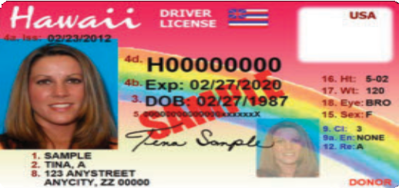

**Over 21 License**

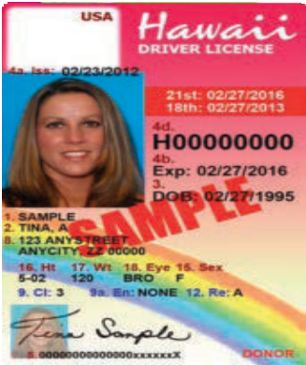

**Under 21 License**

### DRIVING BY MINORS

Information on Hawaii’s graduated licensing program is at hidot.hawaii.gov/highways/files/2013/01/Hawaii-Graduated-Licensing-Brochure.pdf

* Persons younger than 18 years of age must provide written consent from their parent(s) or legal guardian unless married or emancipated.
* The minimum age to acquire an instruction permit is 15 1/2 years.
* You must pass the preliminary examinations by taking a vision screening test and a rules of the road test.
* You may operate a motor vehicle upon any highway with an instruction permit only when accompanied by a licensed driver at least 21 years of age. If between the hours of 11:00 p.m. and 5:00 a.m., you must be accompanied by your parent or guardian.
* All occupants must use safety belts or child restraints.
* You must hold a valid instruction permit for a period of 180 days before applying for a provisional license.
* The minimum age to obtain a provisional license is 16 years.
* You must complete a State certified driver’s education course and possess the classroom and behind the wheel certificates.
* You must pass a road test.
* Your provisional license allows you to transport only one person under age 18 who is not a household member.
* With a provisional license, you may drive between 11:00 p.m. and 5:00 a.m. only when accompanied by a licensed parent or guardian unless driving to and from employment or driving to and from the driver’s school-authorized activity. During these hours, you may not transport more than one person under 18 unless accompanied by your parent or guardian.
* All occupants must use safety belts or child restraints.
* You must hold a provisional license for six months before applying for a driver’s license.
* The minimum age to obtain a driver’s license is 17 years.

### DRIVER LICENSE CATEGORIES

**Class Type of Vehicle**

1. Mopeds
2. Motorcycles and motorscooters.
3. Any single vehicle with a GVWR of 18,000 pounds or less and vehicles designed to transport 15 or fewer passengers, including the driver.
4. Any vehicle that is not a commercial motor vehicle.

A (CDL) Any combination of vehicles with a GVWR of 26,001 pounds or more; GVWR of vehicles towed is in excess of 10,000 pounds.

B (CDL) Any single vehicle with a GVWR of 26,001 pounds or more, or if the GVWR of the towed vehicle is not in excess of 10,000 pounds.

C (CDL) Any single vehicle or combination of vehicles that meets neither the definition of A or B and designed to transport 16 or more pas- sengers or used to haul hazardous materials requiring placards.

### Endorsement

H (CDL) Vehicles hauling hazardous materials in placardable amounts. T (CDL) Vehicles towing double and triple trailers.

P (CDL) Vehicles designed to transport 16 or more passengers including the driver.

N (CDL) Tank vehicles.

X (CDL) Tank vehicles hauling hazardous materials in placardable amounts. S (CDL) School bus

CDL endorsments and restrictions are listed on web page [www.fmcsa.dot.gov/regulations/title491/section/383.153](http://www.fmcsa.dot.gov/regulations/title491/section/383.153)

### DRIVER PERFORMANCE TEST

You must be accompanied to the testing station by a licensed driver and provide a vehicle in safe operating condition with a current safety inspection certificate and no-fault insurance card. All vehicle safety defects must be corrected prior to taking the test.

You will not be asked to violate any laws. No tricks will be used. Passengers are not permitted during the tests.

### MOTORCYCLE/MOTORSCOOTER/MOPED EXAMINATION (CATEGORY 1 & 2)

You will be required to pass a special written examination for motorcy- cles/motorscooter and an off-street skills test. It includes questions on rules of the road, highway signs and the operation of motorcycles. Refer to the Motorcycle Operator Manual available at any field office, or at web site

<http://hidot.hawaii.gov/highways/library/motor-vehicle-safety-office/>

[www.hidot.hawaii.gov/highways/files/2013/01/mvso-Motorcycle-Operator-Manual.pdf](http://www.hidot.hawaii.gov/highways/files/2013/01/mvso-Motorcycle-Operator-Manual.pdf)

### LIGHT MOTOR VEHICLE TEST (CATEGORY 3 LICENSE)

The following test is administered for a Category 3 driver’s license (cars and lightweight trucks (18,000 pounds GVWR or less) and buses designed to carry 15 or fewer occupants).

You will be required to satisfactorily demonstrate your ability to:

* start your vehicle and drive through a business district
* demonstrate parallel parking
* demonstrate while driving, proper turning, starting, stopping proce- dures and signals
* be able to start on a slight grade
* demonstrate your knowledge of and obey traffic laws and ordi- nances and safe driving practices.

### CATEGORY 4 LICENSE

You will be required to pass the skills test (vehicle inspection test, basic control skills test and road test) described in the Hawaii Commercial Driver’s License Manual. Copies of this manual are available at any field office, or at web site <http://hidot.hawaii.gov/highways/library/motor-vehicle-safety-office/>

### LICENSE RENEWAL

You may renew your driver’s license at any driver licensing office in Hawaii. Your license can be renewed within six months before the expiration date. EVERY HAWAII STATE DRIVER’S LICENSE IS VOID AFTER THE EXPIRATION

DATE. *THERE IS NO GRA CE PERIOD.* Your license may be renewed within a year after the expiration date. You must follow the procedure for an original license if you fail to renew your driver’s license during the renewal period. Before your license is renewed, you must pass a vision test. You may also be required to pass a road test. You may renew your license twice consecutively by mail but must pres- ent yourself before the examiner of drivers on the third renewal.

### DUPLICATE LICENSE

You may apply for a duplicate license whenever your license is lost, stolen or mutilated.

Proper identification is required upon application.

### CHANGE OF ADDRESS OR NAME ON DRIVER’S LICENSE

Whenever you change your residence address you must, within 30 days, notify the county exam- iner of drivers in writing of your old and new address, your name and driver’s license number.

A change of name requires that you appear in person at the office of the appropriate examiner of drivers within 30 days with proof of the change.

### RESTRICTED LICENSE

Driver licenses can be issued to individuals who have disabilities or reduced capability to drive safely in all types of traffic conditions. This means that drivers who have experienced medical problems such as major surgery, amputation, or serious illnesses do not necessarily have to give up driving. Additionally, drivers who experience

diminished reflexes or vision problems should know that it does not always result in the loss of their driving privileges.

The driver’s licensing office can review a driver’s medical report provided by the dri- ver’s health care provider and administer vision and skills tests that measure a driver’s functional ability to safely operate a motor vehicle. Once this assessment has been com- pleted, a license with restrictions may be issued which will permit the driver to continue driving within the safe limits of the driver’s ability.

Only when it has been determined that a driver cannot operate a vehicle safely under any condition, is the driver license withdrawn. Often no restrictions are required, but when they are, one or more of the following conditions are specified on the driver license.

|  |  |  |  |
| --- | --- | --- | --- |
| LICENSE RESTRICTIONS | | | |
| CODE | DESCRIPTION | CODE | DESCRIPTION |
| B | CORRECTIVE LENSES MUST BE WORN | P | NO PASSENGERS IN CMV BUS |
| C | MECHANICAL AID | V | MEDICAL VARIANCE |
| D | PROSTHETIC AID | W | FARM WAIVER |
| E | NO MANUAL TRANSMISSION VEHICLE | X | NO CARGO IN CMV TANK VEHICLE |
| F | OUTSIDE MIRROR | Z | NO FULL AIR BRAKE EQUIPPED CMV |
| G | LIMIT TO DAYLIGHT ONLY | 2 | FULL HAND EQUIPMENT |
| H | LIMITED TO EMPLOYMENT | 3 | MECHANICAL SIGNALS |
| I | LIMITED -­‐ OTHER | 4 | POWER STEERING |
| J | OTHER | 5 | POWER BRAKES |
| K | INTRASTATE ONLY | 6 | STEERING KNOB |
| L | NO AIR BRAKE EQUIPPED CMV | 7 | CUSHION |
| M | NO CLASS A PASSENGER VEHICLE | 8 | MEDICAL |
| N | NO CLASS A/B PASSENGER VEHICLE | 9 | THREE-­‐WHEEL MOTORCYCLE |
| O | NO TRACTOR-­‐TRAILER CMV |  |  |

16

### NATIONAL DRIVER’S REGISTRY SERVICE

Information on applicants for an original or renewed Hawaii driver’s license is for- warded to the National Driver Register Program, Washington, D.C. If the records of the NDR show that you have had a license suspended or revoked in another state or D.C., a Hawaii driver’s license will not be issued.

### ORGAN DONOR PROGRAM

When you make an application for a Hawaii driver’s license or renewal, you may designate that you, pursuant to the Uniform Anatomical Gift Act, are a donor of body organs or parts upon your death. Please tell your family about your wish to donate. Their permission to use organs will be requested.

### ADVANCE HEALTH CARE DIRECTIVE

You may indicate that you have an advance health care directive. In the event of serious illness or an accident in which you cannot speak for yourself, the advance directive states your wishes for health care. Putting “AHCD” on your license will alert medical personnel that you have special instructions. Please tell your familty and your doctor that you have completed an advance health directive and give copies to them.

### VETERAN STATUS

Beginning October 1, 2014, if desired by the license applicant, a notation of “veteran” may be placed on the front of the license of any person who served in any of the uniformed services of the United States and was discharged under conditions other than dishonorable. As of April 26, 2016 a veteran notation may be displayed for veterans of the Korean conflict and persons who served in the armed forces of the Republic of Korea, who fought under the command of the United Nations led by the United States, during the Korean conflict and are currently United States citizens.

### DRIVER’S LICENSE FOR MOPEDS

A moped is a two- or three-wheeled device with a motor no larger than two horse-power.

You are required to have a driver’s license (any category) to operate a moped on the public streets and highways.

If you do not have a driver’s license, you may obtain a Category 1 license (mopeds) by following the procedure required for that license category and using you moped for any required performance test.

### OTHER IMPORTANT INFORMATION LICENSE DISPLAY

You must have a valid driver’s license with you at all times while operating a motor vehicle or moped, and must show it on demand to a Police Officer.

### TRAFFIC CITATIONS

A person charged with a violation of the Hawaii Vehicle Law will be issued a written traffic citation in most cases. Two types of traffic citations are: less serious “traffic infrac- tion” and the serious “traffic crime.” The less serious traffic offenses will be subject to civil rather than criminal proceedings with such sanctions as fines and driver’s license and vehicle registration stoppers. People receiving traffic infraction citations may pay, write a statement, or appear in person. However, a person receiving traffic crime citations may face the possibility of jail and, therefore, court appearances are required.

If you have a question about your traffic citation, whether it is for a traffic crime or traffic infraction, call the number listed on the citation or the District Court on the island: Kauai 482-2355, Maui 244-2800, Hawaii 961-7470, Oahu 538-5500.

17

### CHAPTER II

**VEHICLE EQUIPMENT AND INSPECTION**

**EQUIPMENT REQUIRED**

Every motor vehicle operated on the highways of the State shall be equipped with brakes, steering, horn, door handles, tires, exhaust system, lights, glass, windshield wipers, odometer, speedometer, bumpers, wheels, wheel lug nuts, fenders, floor pans, hood and hood catches, and gas tank meeting established standards.

**ILLEGAL EQUIPMENT**

The following motor vehicle equipment is prohibited:

1. A red light showing from the front, or a blue light visible outside of the vehicle, except on authorized emergency vehicles;
2. A bell, exhaust whistle or siren, except on authorized emergency vehicles;
3. A muffler cut-out or by-pass, or a muffler that makes more noise than an origi- nal equipment manufacturer muffler.

**SAFETY INSPECTION OF VEHICLES**

All motor vehicles operated on the public highways must have an official Periodic Motor Vehicle Inspection (PMVI), at least once a year, except that ambulances must be inspected once every six months, and new vehicles do not need to be inspected until two years after their initial inspection on the date that they are first sold.

Many service stations and garages are authorized to conduct PMVIs, also known as safety inspections; issue certificates of inspection; and affix stickers. A copy of the rules that regulate the inspection program can be viewed at web

site: [http://hidot.hawaii.gov/dot/highways/home/doing-business/hawaii-administrative-rules/.](http://hidot.hawaii.gov/dot/highways/home/doing-business/hawaii-administrative-rules/)

Click on Chapter 19-133.2.

A Hawaii state automobile insurance identification card is required to pass the inspection. Upon approval, a sticker is affixed to the vehicle and two copies of the inspection certificate is issued to you. This must remain in the vehicle. The inspection results are sent eletronically to the motor vehicle registration file.

### RECONSTRUCTED VEHICLES

Vehicles which have been modified, rebuilt or altered may be required to comply with county reconstructed vehicle inspection requirements. A bill of sale or receipt is required for all parts that have been added to the vehicle. The inspection will be con- ducted by a qualified reconstruction inspector. Upon completion of the inspection, you will be issued an emblem indicating compliance. Administrative rules 19-134 are at [http://hidot.hawaii.gov/highways/home/doing-business/hawaii-administrative-rules/.](http://hidot.hawaii.gov/highways/home/doing-business/hawaii-administrative-rules/) Click on Chapter 19-134 (See inside back cover for inspection station location.)

### VEHICLE CONDITION AND MAINTENANCE

You are responsible for the condition of the vehicle you are driving even though you may not be the owner of the vehicle. General care and maintenance should be per formed regularly by you or by an experienced mechanic. The following information may help you to better understand important parts of your vehicle:

**Steering:** Your steering wheel should be able to turn smoothly and easily from the maximum right position to the maximum left position and back again. There should be no more that two inches of free play in the steering wheel, if you have power steering (check with the motor running); or 3 inches, if you do not have power steering. Your vehicle should respond quickly to small movements of the steering wheel. The vehicle should not pull to either side, and the wheels should not “shimmy”.

**Tires:** Don’t take tires for granted. Check them at least once a month. Check the door jamb for the vehicle manufacturer’s recommended pressure and tire size. Proper pres- sure extends tire life and improves handling. Replace tires that have less than 1/16 inch of tire tread. An easy method of checking tire tread is to use a Lincoln penny. Place the-

penny upside down within the tread. If the top of Lincoln’s head is visible, the tire needs

to be replaced. Also, check tires for cuts, bulges, tread separation and uneven wear. Check your spare tire too. If you begin to notice a slight steering wheel vibration or an unusual noise, check to see if you have a tire problem. You can get helpful tire informa- [tion at: http://www.nhtsa.dot.gov/cars/problems/Equipment/Tires/index.html](http://www.nhtsa.dot.gov/cars/problems/Equipment/Tires/index.html)

**Brakes:** If the brakes can’t stop your vehicle, you shouldn’t make it go. A common brake test is to apply the brakes rather hard at a speed of 4 to 8 mph. The vehicle should not pull to either side. Do this test in a place where you will not require others to do a brake test too. If you have antilock brakes, go to an open area such as a deserted section of a parking lot and try them out so you know what to expect in an emergency situation. You usually need to be going over 10 mph for them to activate. Also, it’s easier to acti- vate ABS on a wet and slippery surface. Practice NOT pumping the brake pedal. For more information about brakes go to: [www.nhtsa.gov.](http://www.nhtsa.gov/) Then search for Brakes.

**Directional Signals:** Directional signals enable you to communicate with other driv-ers, so make sure they operate correctly at all times. Any change in the dash light indi-cation reflects improper operation. If the directional signals fail, use hand signals until you can have them repaired.

**Brake Lamps:** Brake or stop lamps warn other drivers that you are slowing or stopping.

Check these lamps frequently to make sure they operate when the brakes are applied.

**Tail Lamps and Side Marker Lamps:** Tail lamps and side marker lamps warn other drivers of your presence. Check them periodically for proper operation.

**Horn:** Every vehicle is required to be equipped with a horn in good working condi- tion to give audible warning.

**Head Lamps:** The head lamps of your vehicle are of critical importance in night driving, in rainy weather, in fog, and while driving through tunnels. They must work properly and be correctly adjusted at all times.

**Windshield:** The windshield should be free of cracks and breaks that interfere with your vision. The windshield wipers should clean the windshield evenly, without leav- ing streaks. Windshield washers enable you to clean the windshield while you are driv- ing. Keep the reservoir filled and check the operation frequently.

**Rear-View Mirrors:** Rear-view mirrors should be adjusted to give you the maximum view to the rear horizon. All mirrors should be maintained in a clean condition and be firmly attached to the vehicle.

**Hood Latches:** Front opening hoods are equipped with a primary latch and a sec- ondary catch. They should operate properly to insure that the hood will not open and block your vision while you are driving.

**Safety Belts:** Safety belts help to keep you from being injured and can save your life. Protect yourself, your passengers and others by using safety belts at all times while driv- ing. All front seat occupants are required by law (291-11.6, HRS) to use seat belts. Children under age 4 must be in a child restraint; persons age 4 through 17 must be belt- ed in the rear seats. Air bags are supplemental occupant protection for a first impact. Since the bags deflate immediately occupants must rely on the belts for protection if subsequent impacts occur. If the air bags deploy, it is advisable to replace them so you will maintain a maximum of occupant protection.

**Door Latches:** Door latches and locks provide you with safety and security. Be sure all doors latch and lock properly.

**Exhaust System:** The exhaust system carries exhaust gases to an exit point located to reduce entry of fumes into the passenger compartment and reduces the noise to an acceptable level. To prevent carbon monoxide poisoning, keep your exhaust system free of leaks. Replace all defective parts immediately. Replacement mufflers must not allow more noise than the original equipment manufacturer muffler.

### CHAPTER III

**VEHICLE REGISTRATION, OWNERSHIP DOCUMENTS AND APPLICATION FOR TITLE**

Hawaii law requires that the motor vehicle you operate on the public highways in the State be REGISTERED IN THE COUNTY IN WHICH YOU OPERATE THE

VEHICLE. Similarly, Hawaii law requires that your vehicle must be licensed each year by the county in which you operate the vehicle. Your vehicle must have a current and valid safety inspection certificate before it can be registered. Proof of motor vehicle insurance is required for cars, buses and trucks being inspected, while proof of liability is required for motorcycles being inspected.

### FIRST REGISTRATION

Registration of your vehicle provides an official record of its ownership. When you first register a vehicle in Hawaii, it is subject to special requirements. Specifically, your vehicle is subjected to inspection and weighing to properly record (a) its iden- tification number, and (b) its weight.

### MOTOR VEHICLE REGISTRATION AND TITLE

Registrations and titles are issued by the appropriate agency in each county. (See back cover for listing.) The Hawaii certificate of ownership of title is held by the legal owner or the lien holder until the lien is satisfied (loan on vehicle is paid). The regis- tration is issued to the purchaser who must keep the certificate in the vehicle. Motor vehicle registrations are staggered and expire annually at the end of the 12th month.

### RENEWAL APPLICATIONS

Registration renewal applications are mailed to your last recorded address. Any errors you find on the application should be reported promptly to the appropriate county agency.

### RENEWAL BY MAIL

You can avoid waiting in line by mailing your application with a check or money order for the exact amount shown on the application under “TOTAL FEE.” Mail to your county agency within ten (10) working days prior to the end of the expiration month. Return both parts of the renewal application. DO NOT DETATCH THE STUB.

### RENEWAL ONLINE

You may renew your registration online if your vehicle is currently registered in the City and County of Honolulu at [www.co.honolulu.hi.us](http://www.co.honolulu.hi.us/) or the County of Maui at [www.mauicounty.gov/mvrenewal.](http://www.mauicounty.gov/mvrenewal) Check their website for additional information.

### CHANGE OF ADDRESS OR NAME ON THE MOTOR VEHICLE CERTIFICATE OF REGISTRATION

Whenever the address of the registered owner of a motor vehicle is changed from that stated on the application of the certificate of registration, the registered owner must, within thirty (30) days after the change, notify the appropriate county agency,

in writing of his old and new addresses, along with the vehicle license number, make, and vehicle identification number.

Whenever the name of a registered owner of a motor vehicle is changed from that shown on the application of the certificate of ownership, the registered owner, shall, within thirty (30) days after the change, *appear in person* at the appropriate county agency with proof of change of name, the certificate of ownership properly endorsed and the current year’s certificate for such change of name in the records.

### U.S. ARMED FORCES MEMBERS EXEMPTION

When you are a member of the U.S. Armed Forces, on duty at a military installa- tion in the State of Hawaii, and are a legal resident of another State, you may register your vehicle with that State and are exempt from the payment of the Hawaii Excise Tax on motor vehicles brought into Hawaii.

A 100% medically disabled veteran with accompanying paperwork is exempt from paying registration fees.

If your vehicle was last registered and titled in another State and currently sub- ject to Hawaii State registration, you must submit to the appropriate county agency where you are stationed an application together with your vehicle’s out-of-state cer- tificate of title and registration, your vehicle’s current Hawaii State certificate of motor vehicle safety inspection, a vehicle shipping receipt and a verification of vehi- cle identification serial number. In cases of a non-title state, you must present an appli- cation together with your certificate of registration and one or more notarized bill(s) of sale establishing a chain of ownership; a current Hawaii State vehicle safety inspec- tion and a verification of vehicle serial number.

### NEW VEHICLES PURCHASED IN HAWAII

When you purchase a new vehicle in the State of Hawaii, you must obtain an appli- cation form countersigned by the licensed new car dealer certifying the sale of the motor vehicle.

### NEW VEHICLES PURCHASED IN ANOTHER JURISDICTION

The various States require different forms of ownership documents. Hawaii will

accept the manufacturer’s’ certificate of origin or a notarized bill of sale.

### NEW VEHICLES PURCH’A’ S’ ED IN A FOREIGN COUNTRY

When you purchase a vehicle in a foreign country, you must obtain a bill of sale

from the foreign dealer issued in your name. The vehicle must have manufacturer’s certification label indicating compliance with USA standards and a 17-character Vehicle Identification Number (see 286-42(a), Hawaii Revised Statutes).

### USED VEHICLES PURCHASED IN A FOREIGN COUNTRY

When you purchase a used vehicle in a foreign country, you must have certificate of registration and bill of sale as proof of ownership. See 286-42(a), HRS.

### USED VEHICLES PURCHASED IN ANOTHER JURISDICTION

When you purchase a vehicle in another jurisdiction (State), you must obtain from the seller named on the out-of-state title, the certificate of title, certificate of registra- tion and a notarized bill of sale. When the vehicle is purchased in a non-title State, you must obtain from the seller the current certificate of registration or certification of registration from the non-title State and notarized bills of sale, one from the seller to you and one from the previous owner to the seller.

### USED VEHICLES BROUGHT INTO THE STATE OF HAWAII FROM ANOTHER STATE IN YOUR NAME

If your vehicle is registered in another State, you are entitled to apply for a permit (temporary registration) which will allow you to operate your vehicle upon the public streets and highways of Hawaii up to its expiration date. However, under no circum- stances will a permit be issued to exceed a twelve-month period. Certificate of regis- tration, shipping receipt, and current certificate of Hawaii State motor vehicle safety inspection must be presented.

Upon expiration of the permit (temporary registration), except for members of the

* 1. Armed Forces, you must register your vehicle with the appropriate county agency where you reside.

### DISPLAY OF LICENSE PLATES

Motorcycles, trailers and semi-trailers must display a license plate on the rear; all other vehicles must display a license plate on both the front and rear.

### MOPED LICENSING

Mopeds are required to be inspected, registered and licensed. The license plate and

inspection sticker must be displayed on the rear of the moped.

Mopeds are required to be registered and licensed as bicycles. The license tag or decal must be displayed on the rear fender.

### CHAPTER IV THE DRIVER

Any driving situation involves three basic elements: the environment (the highway and traffic), your vehicle, and the driver—(you). Of these three elements, only you as a driver have the ability to gather information about the existing situation; apply your skill, knowledge, experience and judgment; and take the action required to safely complete the driving task. While good judgment can help to compensate for lower levels of skill, knowledge or experience, poor judgment can nullify any degree of expertness in these areas. Your judgment is primarily influenced by your attitude when you drive.

### EMOTIONAL ASPECTS OF DRIVING

If you are worried, distracted, or if your mind is preoccupied, you cannot count on being sufficiently alert to drive safely. Troubles from home, quarrels, misunderstand- ings, financial worries, serious illness in the family, personal fears, or overconfidence can make you temporarily accident-prone. Strong emotions can work the same way. Persons who have just had violent arguments, or who are angry or in grief, need some time for “cooling off” or for making an adjustment before they drive a car. Taking out your frustrations or anger while driving on the streets or highways is exercising very poor judgment and can prove to be an expensive way to expend emotions. *Worry and safe driving do not mix.* If worried, ill, nervous, frightened, angry or depressed, let someone else drive.

As a well-adjusted person, you are more likely to be a good driver. You must always act not merely from your personal point of view, but with consideration and courtesy to other users of the streets and highways.

Remember, each person possesses a certain amount of power when behind the wheel, because full control of the vehicle is in the hands of the driver. Your attitude at the time you get behind the wheel and the use of this power tends to reveal the type of individual you are. Are you a bully, a thoughtless lawbreaker, a self-centered lane stealer? Are you a reliable, courteous, psychologically and emotionally mature person, prepared to share the road in the interest of traffic safety?

### MEDICAL ASPECTS OF DRIVING

Your physical condition has an important bearing on your ability to drive safely. Alcohol, drugs, illness or disability are factors which may cause or contribute to a traffic crash.

### DRIVER AGE AND ACCIDENTS

One of the most significant statistics that results from motor vehicle accident data is that of the relationship of the driver’s age to the number of accidents in which the driver is involved. These statistics show that the youngest drivers (under age 20) have about twice as many accidents as would be expected for the number of drivers in this group. As driver age increases they continue to have less accidents until about 50 to 54 years of age. These drivers have the least number of accidents of any age group. Starting at age 55 accidents occur more frequently as age increases. Drivers above age 75 are involved in an increased number of accidents, but still less than those drivers under the age of 25.

### PROBLEMS OF THE YOUNGER DRIVER

Young adults have a desire for acceptance and recognition of their capabilities by others. As drivers they sometimes find it necessary to demonstrate these capabilities. Quite often there demonstrations are carried to lengths that exceed the capabilities of the vehicle, the road, and those of the most experienced and skillful drivers. Frequently such activity serves only to prove the younger drivers’ lack of ability and results in disaster. You can avoid being “trapped” in this kind of a situation by:

* + 1. Resisting the desire to exhibit and compete. Such activity only serves as an indication of your inexperience and immaturity.
    2. Declining all challenges to prove your or your vehicle’s capabilities. Such refusal is adequate proof of your maturity and responsibility.

### PROBLEMS OF THE OLDER DRIVER

Increased driving experience most often leads to increased driving skill and capa- bility. Statistics show that drivers become safer as they add experience through the years up to a point. Eventually the aging process will result in:

1. Reduced hearing and eyesight capabilities;
2. A reduction in physical dexterity and an increase in reaction time;
3. Increased decision time in driving situations; and
4. Decreased attention span and ability to concentrate on the driving task.

Older drivers very often do not recognize the gradual decrease in their capability to cope with the driving situation and become increasingly dangerous to themselves and others.

All drivers, including older experienced drivers should:

1. Keep physically fit;
2. Have annual physical examinations;
3. Know the effect of medication on your driving ability;
4. Recognize and drive within your limitations; and
5. Seek and comply with a physician’s advice concerning your driving capabilities.

### GENERAL

**CHAPTER V**

**TRAFFIC LAWS AND REGULATIONS**

You are required to obey all traffic laws when driving a vehicle upon a street or highway.

### POLICE OFFICERS

You must obey all lawful orders and directions of a police officer.

### TRAFFIC SIGNS AND MARKINGS

You must operate your vehicle as indicated by traffic signs, signals and pavement markings.

### DRIVING ON RIGHT SIDE OF ROADWAY

You must drive on the right half of the roadway. Vehicles going in opposite direc- tions must pass each other on the right. On narrow roads you must allow vehicles going in the opposite direction at least one-half of the main traveled portion of the road. When moving slower than other traffic you should drive in the extreme right lane.

### DRIVING ON THE LEFT SIDE OF ROADWAY

You may drive on the left half of the roadway when:

* Overtaking and passing a vehicle going in the same direction on a road that has two or three lanes of moving traffic and there is no traffic coming from the opposite direction.
* There is an obstruction in the roadway and oncoming vehicles are not using the left half of the road.
* Driving on a one-way street or road.

You MUST NOT drive on the left half of the roadway when:

* The road has four or more lanes for moving traffic unless otherwise directed by signs.
* Approaching the top of a hill or on a curve.
* Approaching within 100 feet (30.5m) of or passing through an intersection or railroad crossing.
* Approaching within 100 feet (30.5m) of a bridge or tunnel and you are unable to see vehicles coming from the opposite direction.

### PASSING ON THE RIGHT

You may pass to the right of another vehicle:

* When the vehicle you are passing is about to make a left turn, but you may not drive your vehicle off the pavement or main traveled portion of the roadway to pass.
* On a paved street or highway with two or more lanes marked for traffic in each direction.
* On a one-way street with two or more lanes marked for traffic.

### ONE-WAY ROADWAYS

You must drive only in the direction indicated by the posted traffic signs.

### DRIVING ON ROADWAYS MARKED WITH TRAFFIC LANES

When the street or road is marked with traffic lanes you must:

* Drive entirely within the marked lane and do not change lanes until you have checked that the change can be made safely.
* Drive in the proper lane as indicated by signs or pavement markings.

### FOLLOWING TOO CLOSELY

When following another vehicle you must:

* Not follow closer than is reasonable and prudent for the speed, traffic, road and weather conditions. See page 67, Chapter X.
* When towing another vehicle, leave enough space ahead of your vehicle to allow an overtaking vehicle to occupy the space safely.

### DRIVING ON DIVIDED HIGHWAYS

When a highway is divided by a barrier or an unpaved space, you must not drive across or through the barrier or space except where an opening or paved surface is pro- vided and signs do not prohibit it.

### REQUIRED SIGNALS

When slowing down, turning or changing lanes, you must signal to let others know what you plan to do.

* You must signal every time, even when there are no other vehicles in sight.

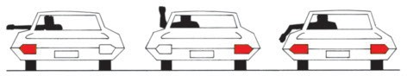

LEFT TURN RIGHT TURN SLOW DOWN OR STOP

* Signals must be given for at least 100 feet (30.5m) before you change lanes, turn or stop. This is about five car lengths. It is advisable to signal for a greater distance when driving at higher speeds.
* Hand signals must be used when the vehicle turn signals are not operating.
* Signaling does not give you the right to make the indicted maneuver; you must check to insure that it can be safely completed without interfering with other traffic.
* Do not rest your foot on the brake pedal when you are not braking to avoid giv- ing following drivers a false stop lamp signal.

### RAILROAD CROSSINGS

You must stop your vehicle not less than 15 feet (4.6m) from the nearest rail when:

* An installed electric or mechanical signal is giving warning of an approaching train;
* A crossing gate is lowered or a flagman is signalling the approach of a train;
* A train approaching within 1,500 feet (460m) gives audible warning of its approach; or
* When the approaching train is visible and so close as to constitute a hazard.

### SPEED RESTRICTIONS

Excessive speed for conditions is the major cause of most accidents.

*Basic Law:* You must not drive at a speed that is greater than is reasonable and prudent.

You must drive at a safe appropriate speed depending on the area in which you are driving, the type and condition of the road traffic, the presence of pedestrians, the weather, and light conditions.

*Speed Limits:*

* You must not drive at a speed that is greater than the posted maximum limit.
* You must not drive at a speed that is less than the posted minimum speed limit.
* You must not drive so slowly that you hold back other traffic. If you cannot keep up with traffic, pull off the roadway and let other traffic pass or change to another route. If you drive more slowly than traffic on a multilane road, drive in the right-hand lane so others can pass you on your left side.
* You must not engage in any race, speed contest or speed exhibition of any kind on a public street or highway.

Speed limits are indicated by posted signs. Reduced speed limits are required in the following areas:

* On streets near schools and playgrounds and at locations marked with a “School Crossing” sign when children are present.
* On streets in residential or business areas.

### PARKING

Many times it is difficult to find a parking place. When parking your vehicle you should be considerate of others. Parking in a prohibited place can be an inconvenient and costly experience. Parking is prohibited in the following locations:

* At any place where your vehicle is hazardous to other traffic on the roadway; your vehicle will be towed away.
* On a sidewalk or sidewalk area.
* In front of or so close to a public or private driveway that your vehicle inter- feres with the use of the driveway.
* Within or so close to an intersection that your vehicle interferes with traffic.
* In front of or so close to a fire hydrant that your vehicle could interfere with the use of the hydrant.
* On or so close to a crosswalk that your vehicle blocks other drivers’ view of pedestrians.
* At any place during the times when official signs or markings prohibit stand- ing or parking.
* On a bridge, elevated structure, or within a tunnel.
* On the roadway side of another car stopped at the edge of the road (double parking) whether you remain in the vehicle or not.
* More than 12 inches (30cm) from the curb.
* In a passenger or freight loading zone.
* At any place where less than 10 feet (3m) of the width of the street remains for the free movement of traffic.
* On any public road to repair (except emergency), wash, or display any vehicle for sale. 28
* When your vehicle extends outside of a marked parking space except when your vehicle is larger than the marked space.
* On a public street or highway for a continuous period of more than 24 hours.

Parking in a prohibited place can be an inconvenient and costly experience. Parking is prohibited in the following locations:

* In a space identified by the international symbol for accessibility, unless you display the placard or license plate issued to the disabled person being transported in the vehicle.
* In an access aisle next to an accessible parking space. The access aisle must be kept clear to allow for the deployment of a wheelchair lift/ramp and other mobility assistance devices.

### TOW-AWAY ZONES

You must not park or stop your vehicle, even momentarily except when blocked by other traffic, at any place during the hours stated on official signs which indicate that a tow-away regulation is in effect. The police will have your vehicle towed away. If your vehicle is towed away, contact the police for recovery information.

### INTERFERENCE WITH DRIVER

Driving with more than three persons in the front seat of your vehicle may consti- tute interference with the driver. Such interference is prohibited.

### UNATTENDED MOTOR VEHICLE

When you leave your vehicle unattended, you must:

* Stop the engine;
* Lock the ignition and remove the ignition key;
* Set the parking brake; and
* When the vehicle is on a grade, turn the wheels toward the curb.

### EMERGENCY VEHICLES

When you hear the warning signal (siren, bell or horn) or see the warning lamps (flashing red or blue) of an emergency vehicle, you must provide a clear path for the emergency vehicle and STOP. DON’T PANIC AND JAM ON THE BRAKES. The following steps indicate the procedure:

* Reduce your speed.
* Determine where the emergency vehicle is coming from.
* Move your vehicle out of the path of the emergency vehicle toward the edge of the road and stop.
* If the emergency vehicle is directly behind your vehicle when you are in heavy traffic, keep moving slowly until you can get out of the way.

### FUNERAL PROCESSIONS AND CONVOYS

Funeral processions and convoys have the right of way at intersections. Vehicles in a convoy or procession will usually use headlamps for identification. The first and last vehicles will usually have a distinctive marking. You should not drive your vehicle between the vehicles in a funeral procession.

### SLOW MOVING VEHICLE EMBLEM

This highly reflective 18 inch (46cm) triangular emblem is required to be displayed on the rear of vehicles designed to operate at speeds of 25 mph (40 km/h) or less. When you see this emblem, reduce speed and approach cautiously.

29

### NO PASSING RULES

The following diagrams illustrate the basic no passing situations you will encounter while driving. In the illustrations below the red vehicle must not pass.

DO *NOT* PASS UNDER THE FOLLOWING CONDITIONS:

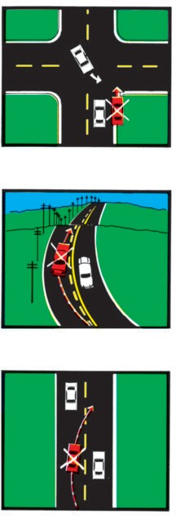

**SHOULDER**

**HILL**

* 1. On the right shoulder of the highway.
  2. On approaching a hill or curve where there is not 700 to 1000 feet (213m to 305m) clear distance ahead.
  3. When the pass cannot be completed without interfering with the safety of the oncoming vehicle and before yel- low line appears in your traffic lane.

Note: When you are being passed, it is unlawful to increase your speed.

## ONCOMING CAR

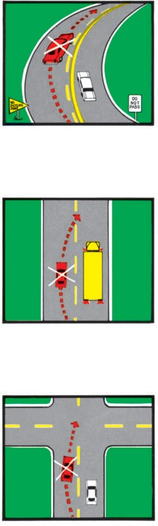

**CURVE**

**SCHOOL BUS**

* 1. When there is a solid yellow line in your lane. (Look for the yellow “NO PASSING ZONE” sign on the left side of the road ahead.)
  2. When there is a school bus on the same roadway when the flashing lights are operating.
  3. When approaching within 100 feet (30m) of or when traversing any inter- section or railroad crossing, approach- ing within 100 feet (30m) of any post- ed narrow bridge, viaduct or tunnel.

Note: The end of a “no passing zone” does not mean it is safe to pass. It means there is increased visibility ahead.

## INTERSECTION

### THE RULES OF RIGHT-OF-WAY

The following diagrams illustrate the basic right-of-way rules you will encounter at intersections. In the illustrations below the red vehicle must always yield the right- of-way.

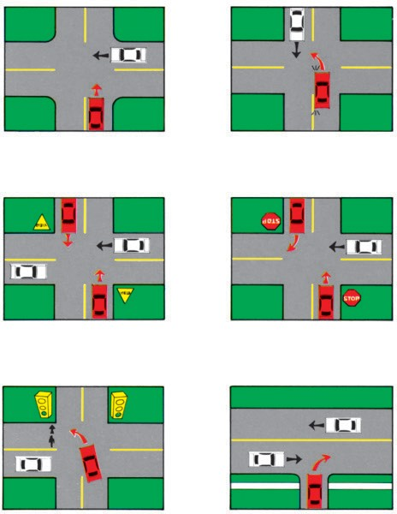Yield to the car on the right when vehicles approach at the same time.

Yield to all traffic on the protected route.

Yield to pedestrians and cars caught in intersection when light turns green.

Yield to all oncoming traffic that is so close as to be a hazard when turning left.

Stop and yield to all traffic on the protected route.

Stop and yield when entering any public street or road from alley, drive- way or farmyard.

### CHAPTER VI

**TRAFFIC SIGNS, SIGNALS AND MARKINGS**

Traffic flow is controlled by the use of pavement markings, traffic islands, signals and signs. These devices inform you of conditions concerning the roadway and help guide you safely to your destination.

There are three categories of traffic control devices:

*Regulatory Devices* instruct you to stop, proceed in a certain direction, or limit your speed. All regulatory devices indicate action required by you. Failure to comply is subject to penalty.

*Warning Devices* advise you of hazardous conditions or the possibility of haz- ardous conditions. For your own safety, obey warning devices. Disregarding the infor- mation given by a warning device may result in an accident due to your negligence.

*Guide and Information Signs* assist you in finding your way safely or provide information to make your trip more comfortable.

### PAVEMENT MARKINGS

Pavement markings are lines, words or figures marked on the pavement with paint, reflectors or other markers.

*Centerlines:*

Yellow centerlines are used to separate traffic moving in opposite directions.

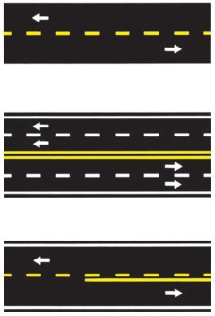*Single Broken Yellow Lines* are used to mark the centerline when there are only two lanes of traffic. You must drive to the right of this centerline but when it is safe you may cross this line to pass another vehicle.

*Double Solid Yellow Lines* are used to mark the center of the roadway where passing is prohibited in both directions. You may cross these lines ONLY TO MAKE A LEFT TURN INTO OR FROM AN ALLEY, PRIVATE ROAD OR DRIVEWAY.

*No Passing Lines* are single solid yel- low lines used on two-lane roads to indi- cate zones where passing is prohibited. You may cross the line ONLY to make a left turn into or from an alley, private road or a driveway.

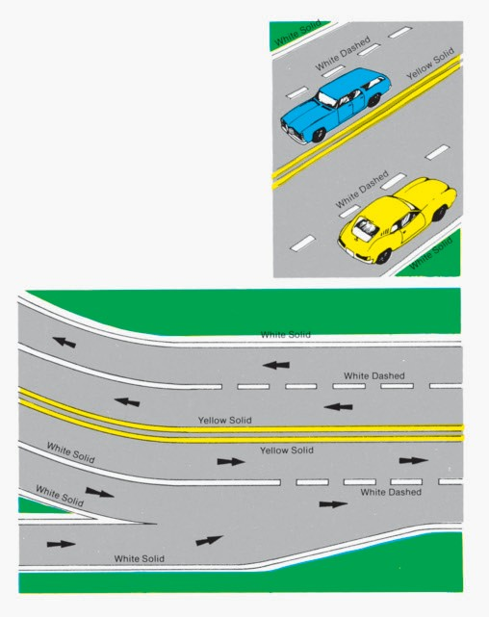*Lane Markings:*

White lines separate lanes of traffic moving in the same direction. You are required to drive between these lane lines.

*Single Dashed White Lane Lines* may be crossed when you can do so safely.

*Single Solid White Lines* indicate that movement from lane to lane is hazardous. The wider the line, the greater the hazard. You may cross a solid white line ONLY IN UNUSUAL CIRCUMSTANCES AND THEN ONLY WITH GREAT CARE.

*Double Solid White Lines* indicate that movement from lane to lane is prohibited.

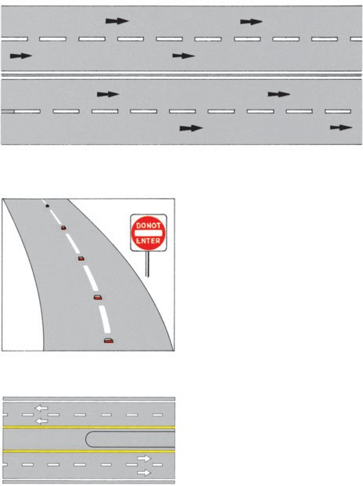You MUST NOT CROSS A DOUBLE SOLID WHITE LINE.

*Red Pavement Markings* or reflectors indicate a roadway that must not be entered or used.

*Edgelines* are solid white or yellow lines along the edge of the roadway to be used as a safety guide. White lines are used along the right edge of the roadway and yellow edge lines may be along the left edge of the roadway on divided streets and highways.

*Crosswalk Lines* show pedestrians where to safely cross the road or street, and they supplement signs to warn drivers of the possibility that pedestrians may be crossing at a specific location. YOU MUST STOP FOR PEDESTRIANS IN CROSSWALKS.

*Stop Lines* are solid white lines painted across the traffic lanes at intersections and pedestrian cross- walks indicating the exact place at which to stop.



*Two-Way Left Turn Channelization Markings* are a combination of a yellow solid and dashed lines in the center of a roadway which mark a lane in the center of the roadway which may be used by vehicles travelling in either direction for left turn maneuvers ONLY. The lane must NEVER be used for passing.

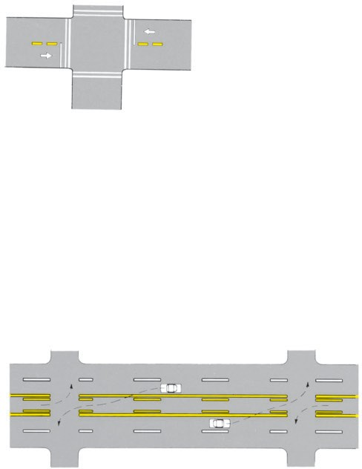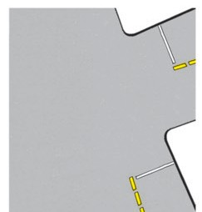

36



*Obstruction Markings* are solid lines painted in the traffic lanes to guide you around obstructions, such as bridge supports, in the road. The markings may be yel- low or white. You may pass to either side of white obstruction markings but you must pass only to the right of the yellow markings.

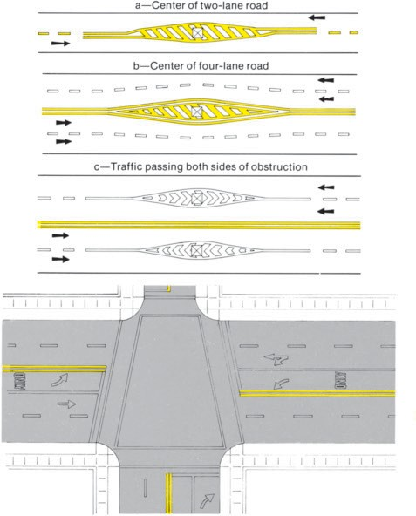

*Directional Markings* are white arrows or words painted in the traffic lane to indi- cate the direction in which you must go. You must move ONLY IN THE DIRECTION INDICATED BY THE ARROW. Where arrows indicate more than one direction, you may choose any direction indicated.

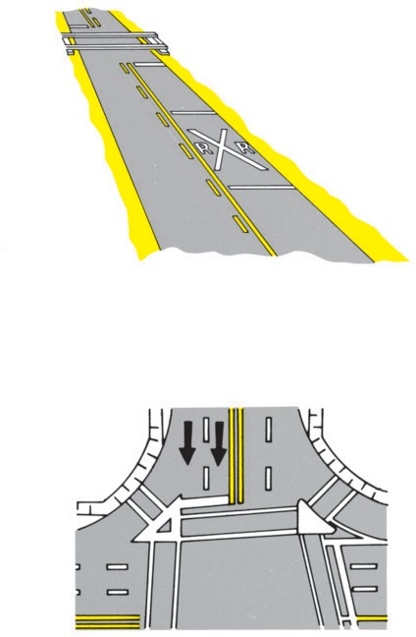*Railroad Crossing Markings* are white markings painted in the traffic lane before railroad crossings. The pavement is marked with a large “X” and two “R’s”. A solid yellow centerline extends the entire distance to prevent passing, and a white stop line is painted across the traffic lane.

*Traffic Island Markings* are of many different designs. They may be only painted markings on the roadway or any combination of curbing, paving or landscaped areas. Traffic islands are used to direct you into separate traffic lanes. Traffic islands are called “Safety Islands” when they are used to protect pedestrians who may have to stand in the roadway. YOU SHOULD NEVER DRIVE INTO OR ACROSS A TRAFFIC ISLAND.

### TRAFFIC SIGNALS

Traffic signals serve primarily to direct and regulate traffic. They are used at inter- sections and other locations where it is necessary to interrupt the flow of traffic.

*Standard Three-Color Signals:*

These signals are used primarily to stop and permit movement of traffic at loca- tions where there is considerable conflict in the movement of vehicles.

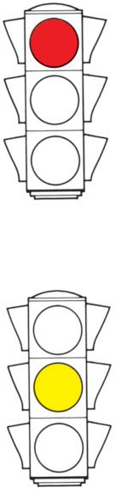A *Red Light* means that you must stop:

* + 1. At the stop line; or
    2. When there is no stop line, before entering any cross- walk, or
    3. When there is no stop line or crosswalk before enter- ing the intersection; and
    4. Remain stopped until the signal changes to green.

After stopping, you may turn right except when a sign prohibits such movement. You must yield to all pedestrians and all vehicles when making such a turn.

After stopping you may also turn left on a red light from a one-way street into a one-way street where traf- fic is moving to the left, except when a sign prohibits such movement.

A *Yellow Light* means that the red light is going to be shown immediately thereafter. You should avoid enter- ing the intersection when the yellow light is shown. YOU MUST NOT ENTER THE INTERSECTION AFTER THE RED LIGHT IS SHOWN.

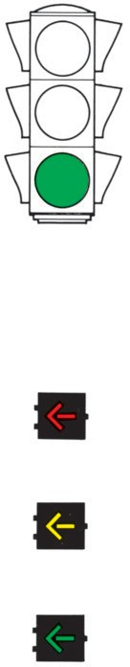

A *Green Light* means go straight ahead or turn except when signs prohibit turns. You must yield to all pedes- trians and vehicles already in the intersection.

*Lighted Arrows*

Lighted arrows are sometimes used to control turns from a specific traffic lane.

A *Red Arrow* has the same meaning as a red light for the indicated lane of traffic.

A *Yellow Arrow* has the same meaning as a yellow light for the indicated lane of traffic.

A *Green Arrow* has the same meaning as a green light for the indicated lane of traffic BUT YOU MUST TURN OR PROCEED IN THE DIRECTION INDICATED BY THE ARROW.

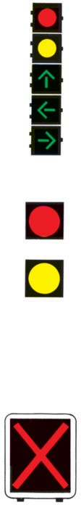*Combination Signals*

Arrow signals combined with standard signals control the movement of vehicles in all traffic lanes.

The colored lights and arrows have the same meanings as indicated previously for signal lights and arrows. YOU MUST MOVE ONLY IN THE DIRECTION INDICAT- ED BY THE GREEN ARROW WHEN IT IS LIGHTED.

*Flashing Signals*

Flashing signals are sometimes used to warn you of danger.

A *Red Flashing Signal* has the same meaning as a stop sign. A stop sign will also be posted where this sig- nal is located.

A *Yellow Flashing Signal* means that you may pro- ceed only with caution.

When regular traffic signals show flashing lights they have the same meanings as described for the flashing red or yellow signals.

*Lane Control Signals*

Sometimes it is desirable to have traffic in a lane in one direction at certain times and the opposite direction at other times. Lane control signals are used to control the direction of traffic movement in the lane. The signal is placed over the traffic lane it controls.

*The Red “X”* means you must not use that lane because the lane is being used by traffic proceeding in the opposite direction.

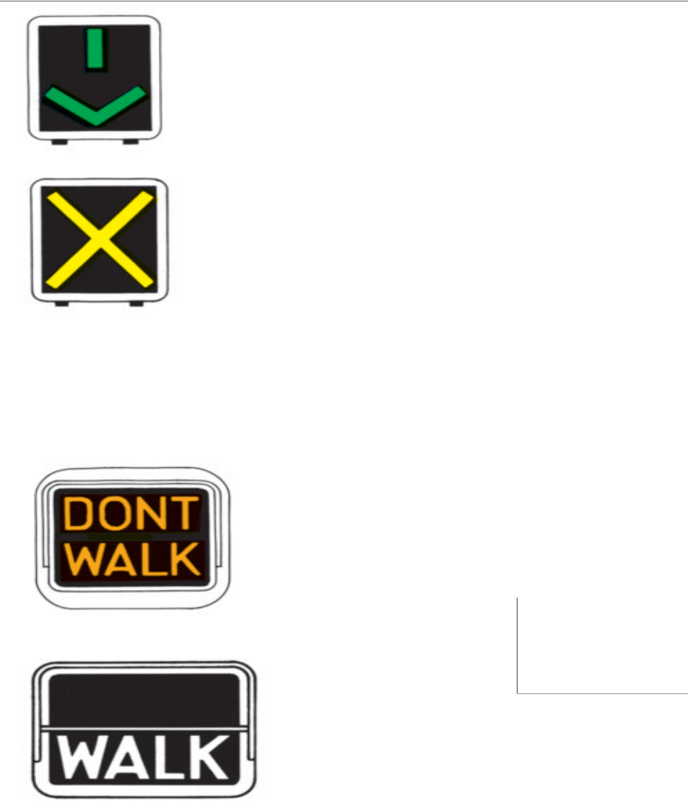

*The Green Arrow* means you may use that lane.

*The Yellow “X”* means that you must move out of that lane of traffic because it is going to be used for traf- fic moving in the opposite direction. When the Yellow “X” signal is flashing you may use that lane only when preparing to turn left.

*Pedestrian Signals*

Pedestrian signals are special types of traffic signals used only to control pedestri- an movements. These signals consist of the lighted words “WALK” and “DON’T WALK” and the symbols of a walking person and an upraised palm.

*DON’T WALK or upraised palm symbol*. A steady sig- nal means that pedestrians must not enter the roadway toward the signal. A flashing “DON’T WALK” or up- raised palm signal means that pedestrians may not start to cross the roadway but those already crossing may con- tinue to the nearest sidewalk, traffic island or safety zone.

*WALK or walking person symbol*. A steady signal means that pedestrians may cross the roadway towards the signal. A flashing “WALK” or walking person sig- nal is sometimes used to indicate that there is a possible conflict between pedestrians and vehicles.

### TRAFFIC SIGNS

Traffic signs provide you with information on actions you must take; warn you of possible hazards and dangers; and provide you with route and location identification. The meaning of traffic signs is indicated by color and shape in addition to words,

letters, numbers and silhouettes.

*Colors and Shapes*

*The Color Red* indicates that an action is prohibited. The color red appears on signs of various shapes.

*The Color Yellow* indicates a warning of hazardous or dangerous conditions. This color almost always appears on a diamond shaped sign.



*The Color Orange* indicates a warning concerning road work. This color appears on rectangular or diamond shaped signs.

*The Colors Black and White* indicate a required action. Black and white signs are always rectangular in shape.

*The Colors Green, Blue and Brown* are used on guide and information signs. These colors appear mostly on rectangular shaped signs.



*Regulatory Signs*

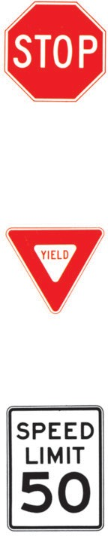*A STOP SIGN* is an 8-sided white on red sign indi- cating that other traffic has the right-of-way. You must always bring your vehicle to a complete stop and yield to approaching traffic before proceeding. The stop must be made at the “stop line”. If there is no “stop line”, you must stop before crossing any marked or unmarked crosswalk. When you cannot see other traf- fic from the first stop, move ahead slowly and stop again where you can see approaching traffic.

*A YIELD SIGN* is a triangular red and white sign indicating that other traffic has the right-of-way. Be ready to stop when you approach a “YIELD SIGN”. You need to stop only when there is other traffic that has the right-of-way.

*SPEED LIMIT SIGNS* are rectangular black and white signs which are used to show the established max- imum and minimum speed limits. These signs may indi- cate special speed limits which apply at certain times, or under certain conditions, or to certain kinds of vehicles. YOU MUST NOT DRIVE FASTER THAN THE POSTED MAXIMUM SPEED LIMIT NOR SLOWER THAN THE POSTED MINIMUM SPEED LIMIT.

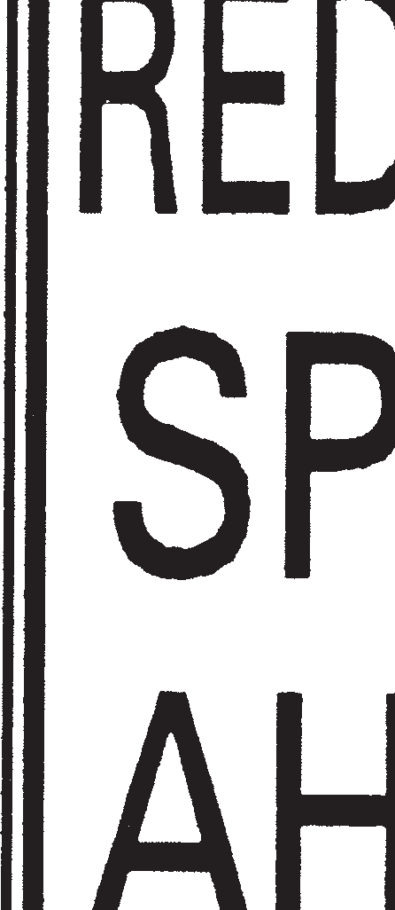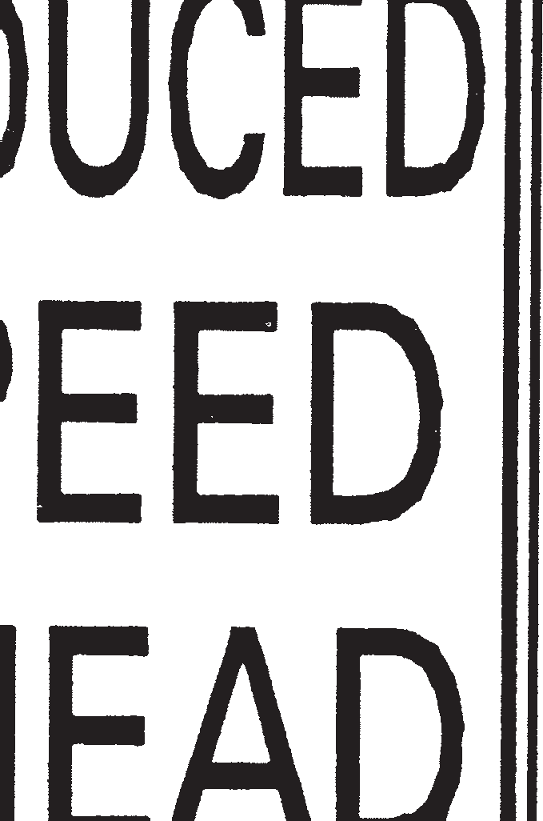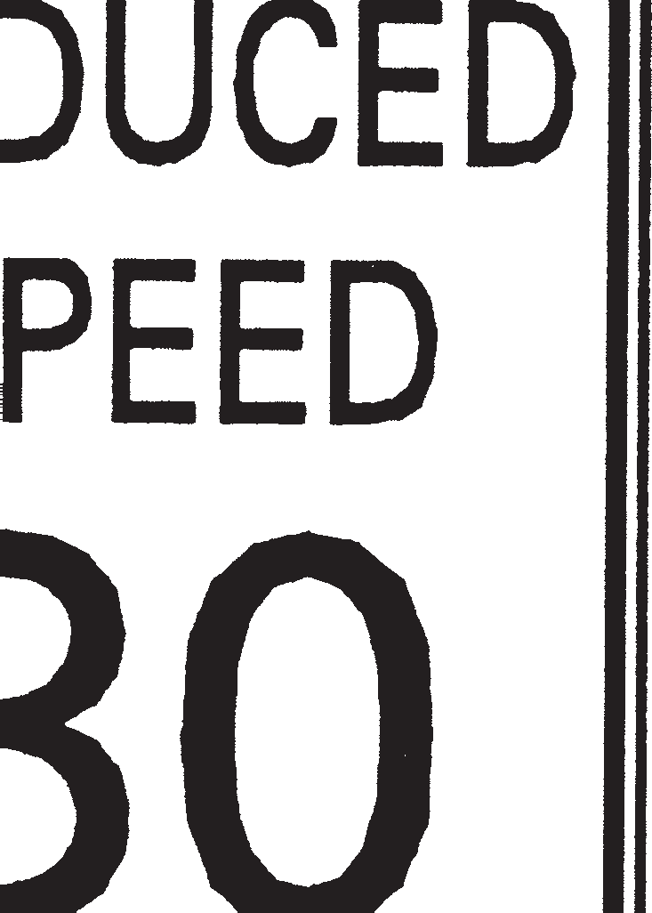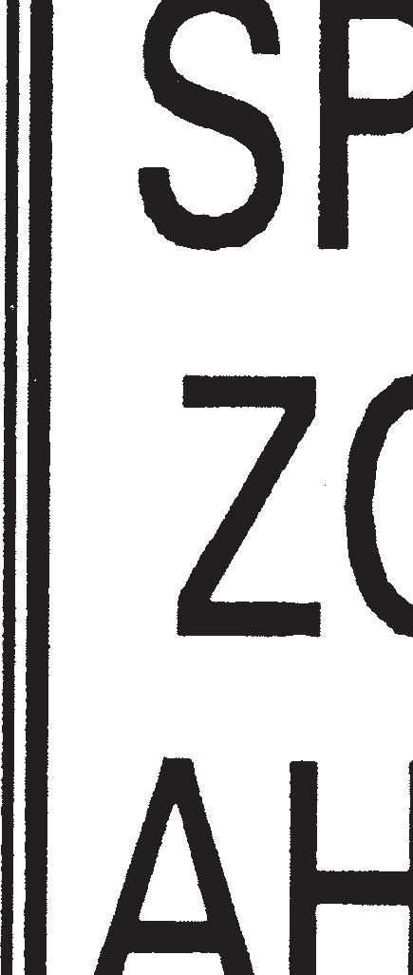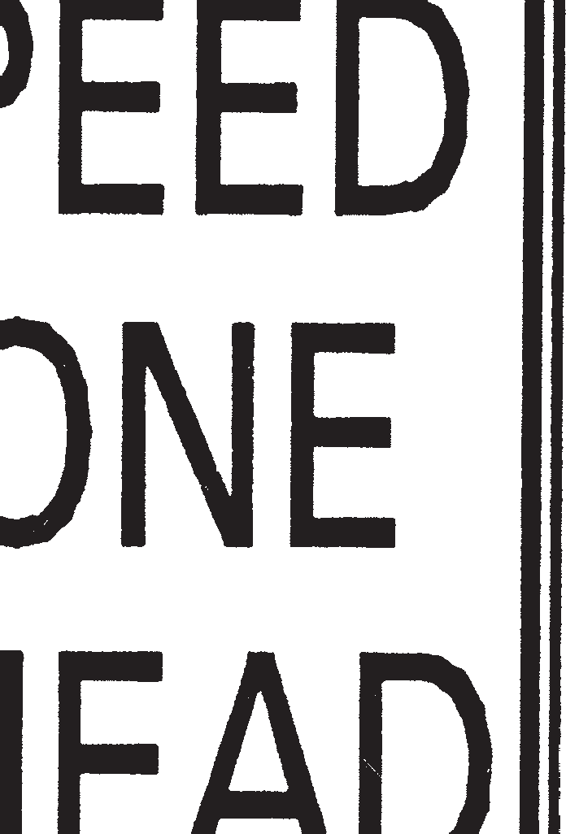

*REDUCED SPEED AHEAD SIGNS* are the same color and shape as speed limit signs and give you advance notice to slow your vehicle to a lower speed limit posted ahead. These signs inform you that you should begin to reduce your speed. The new speed limit begins at the next speed limit sign.

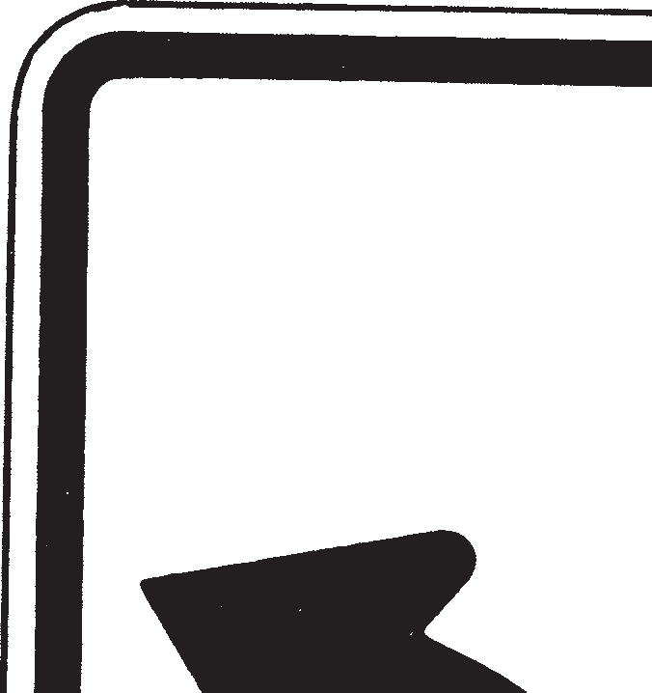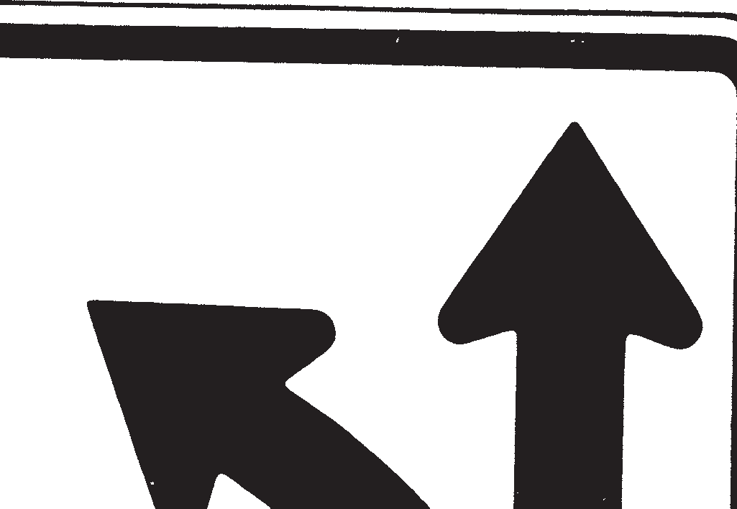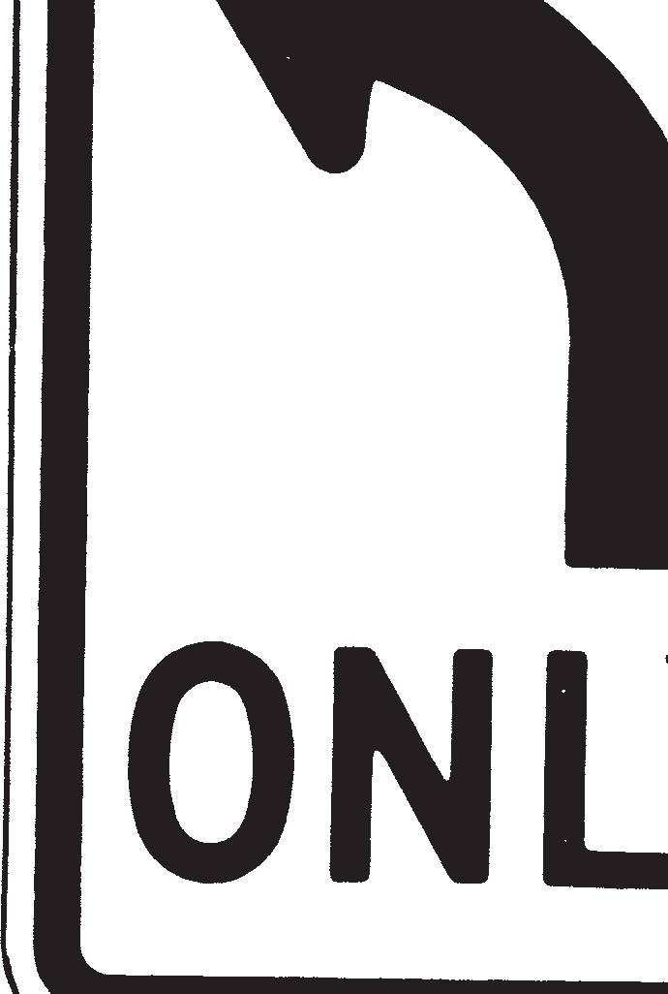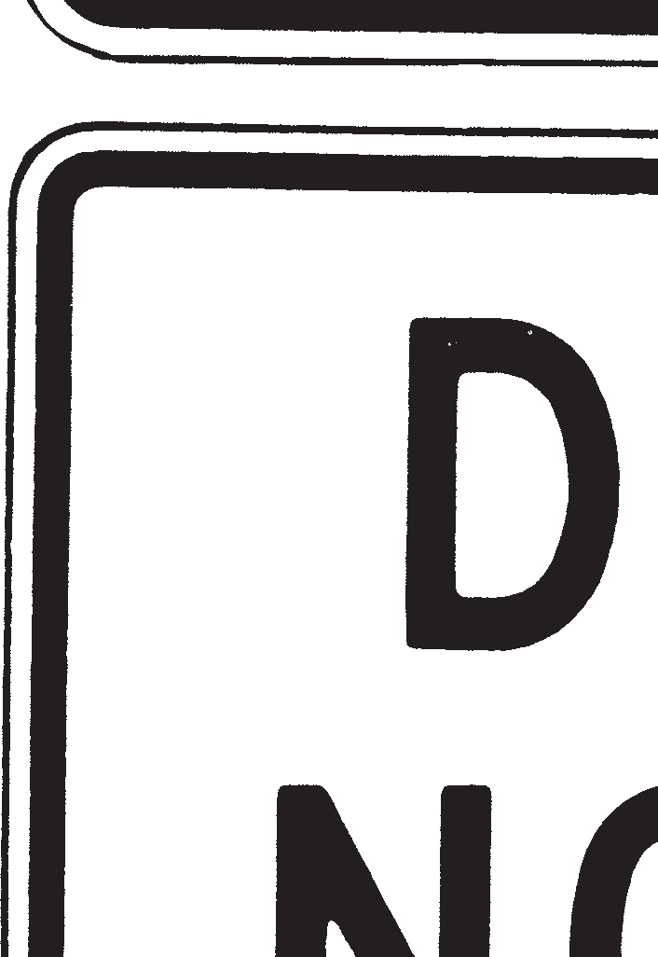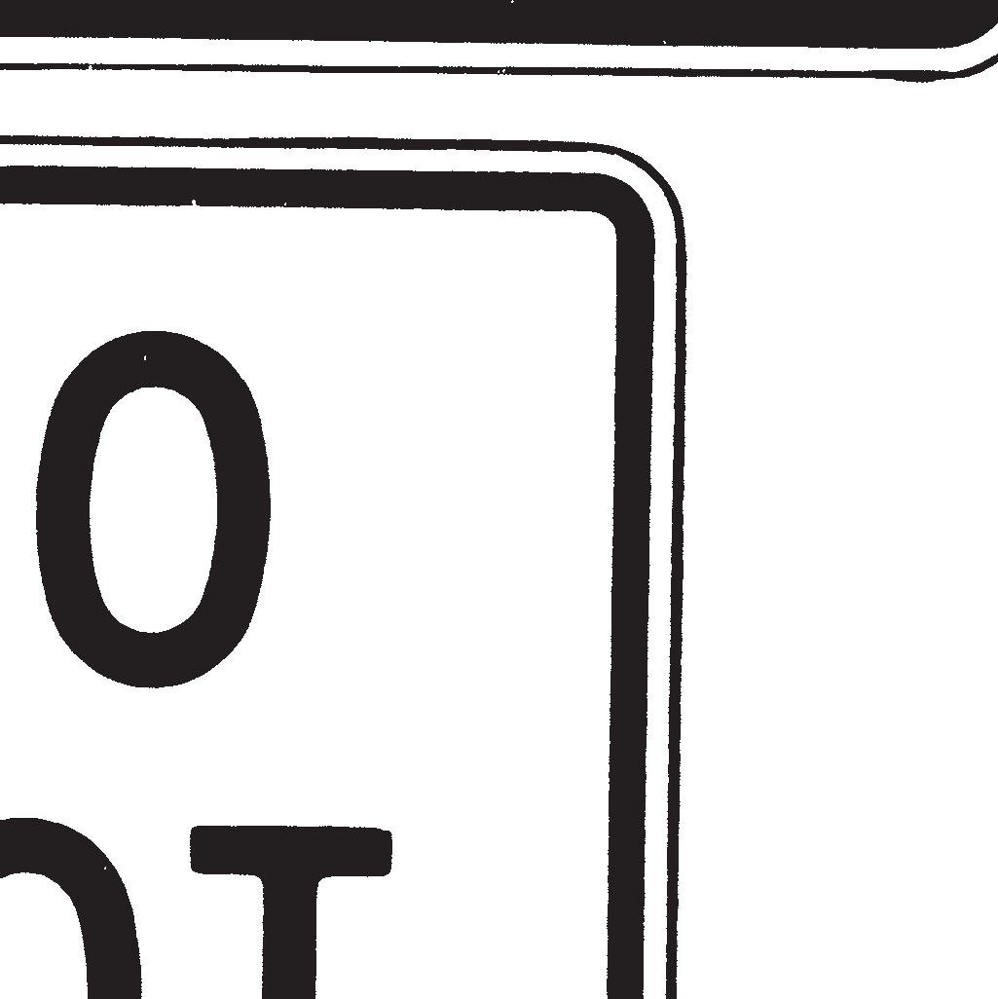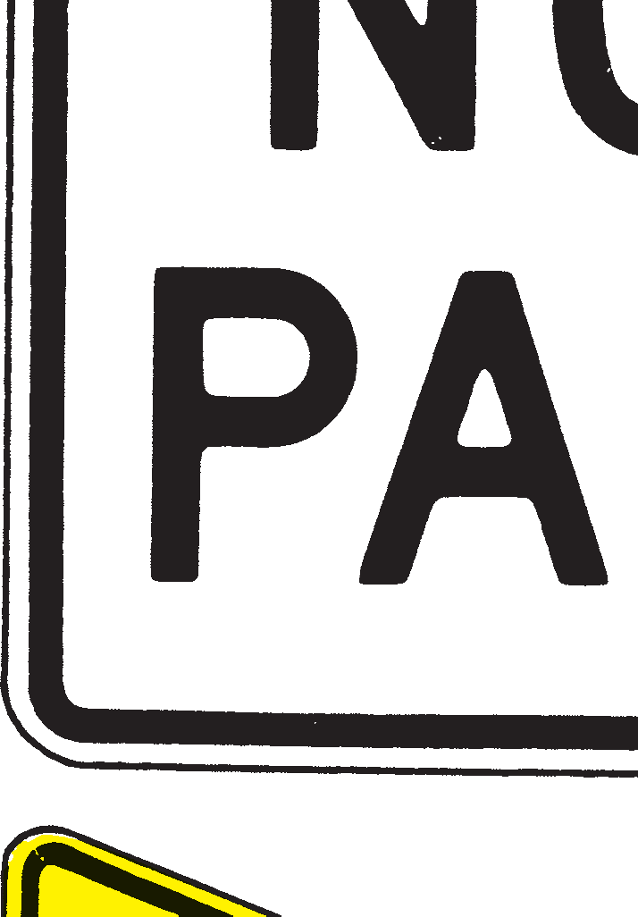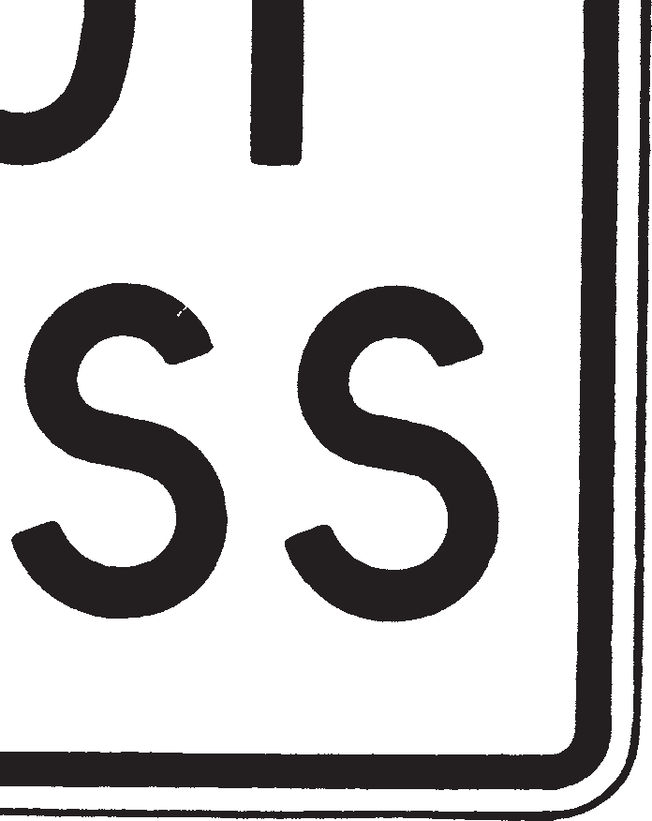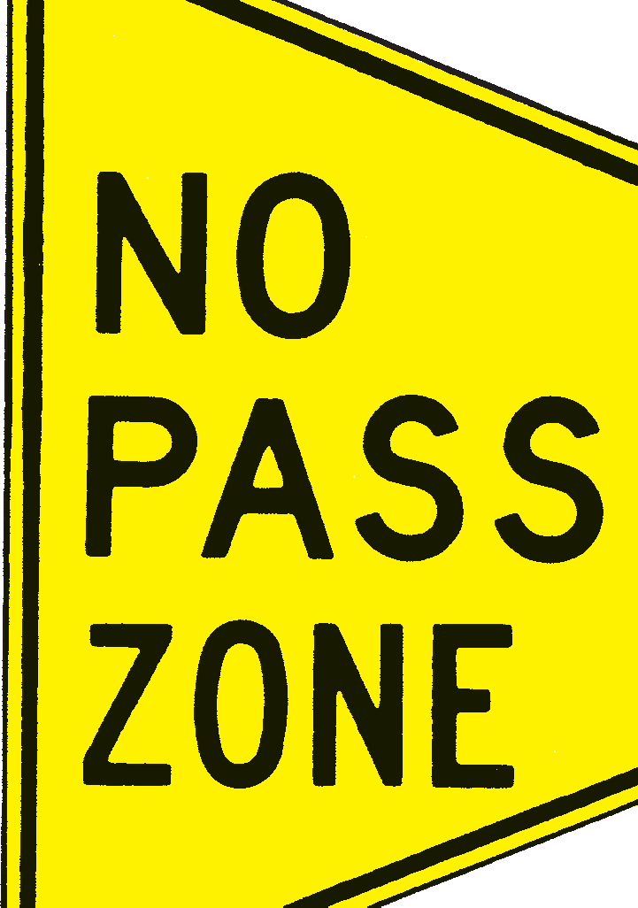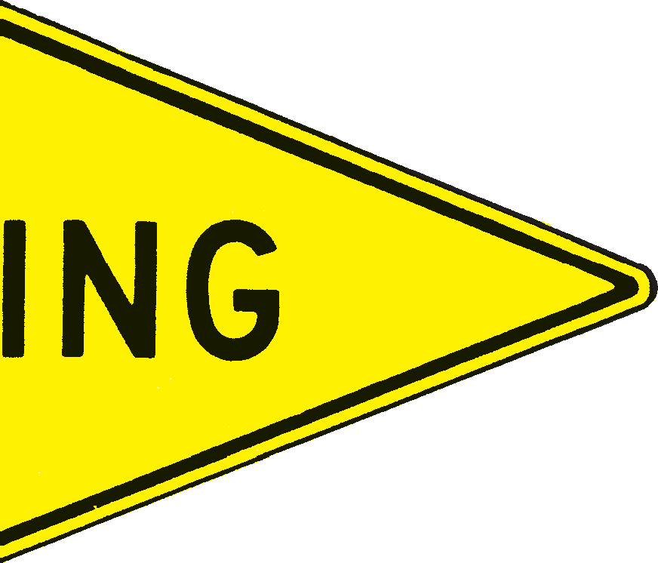

*LANE USE CONTROL SIGNS* are rectangular, black and white signs indicating that turning movements are required or the unusual turning movements are permit- ted from specific lanes at an intersection. You must move your vehicle only in the direction indicated for your traffic lane.

*DO NOT PASS SIGNS* are rectangular signs indi- cating locations where you must not pass on two- or three-lane roads. YOU MUST NOT PASS ANOTHER VEHICLE WHERE THESE SIGNS ARE POSTED.

*NO PASSING ZONE SIGNS* are pennant-shaped yel- low and black signs that supplement the “Do Not Pass” signs. The pennant is located at the left side of the road and points to the beginning of the no-passing zone.

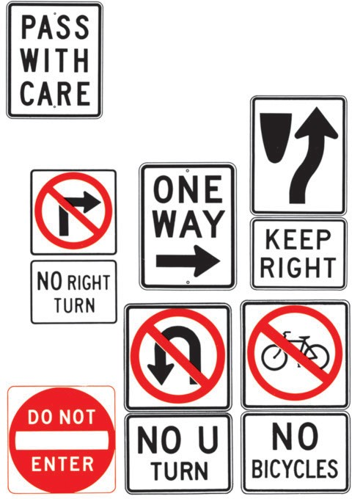*PASS WITH CARE SIGNS* are rectangular, black and white signs indicating the end of a no-passing zone.

*OTHER ALIGNMENT SIGNS* are rectangular, black and white signs indicating where you must drive to permit traffic to move safely and smoothly.

*EXCLUSION SIGNS* are rectangular signs and contain either a red circle on a white background or a red circle with a red diagonal on a black and white background. These signs restrict or prohibit vehicles or vehicle movements or prohibit some other activity.

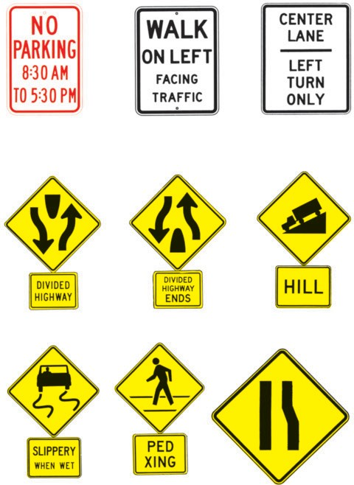

*OTHER REGULATORY SIGNS.* There are many other regulatory signs; all are rectangular with black or red lettering on a white background. These signs restrict people, vehicles, weights and types of vehicles, parking, etc.

### WARNING SIGNS

These signs warn you of dangers that exist or may be found on or near the road. You should be prepared to take safe and proper action when you see these signs. Warning signs are usually diamond-shaped with a black legend and border on a yel- low background.

Divided Highway Divided Highway Ends Hill

Slippery When Wet Pedestrian Crossing Lane Ends or

Road Narrows

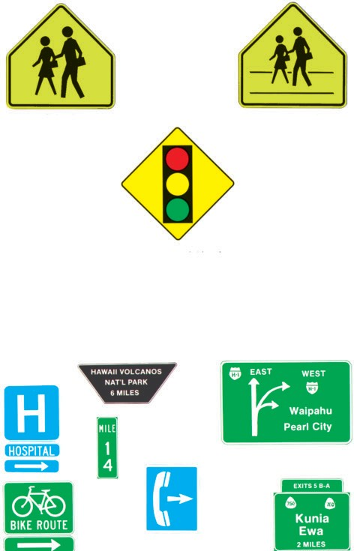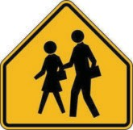

This sign can mean either School Crossing or School Zone

Traffic Signal Ahead

### GUIDE AND INFORMATION SIGNS

These signs include all signs containing information for you regarding your loca- tion and the location of places and services. Typical signs are: route markers, location and distance signs, park signs, recreation signs, and service information signs.



### CONSTRUCTION AND MAINTENANCE DEVICES

Various traffic control devices are used in construction and maintenance work areas to direct drivers or pedestrians safely through the work zone and to provide for the safety of the highway workers.

The most commonly used traffic control devices are signs, barricades, drums, cones, tubes, flashing arrow panels and flagpersons. Orange is the basic color for these devices.

### Construction and Maintenance Signs:

Construction and maintenance signs are used to notify drivers of unusual or poten- tially dangerous conditions in or near work areas. Most signs in work areas are dia- mond shaped. A few signs are rectangular.

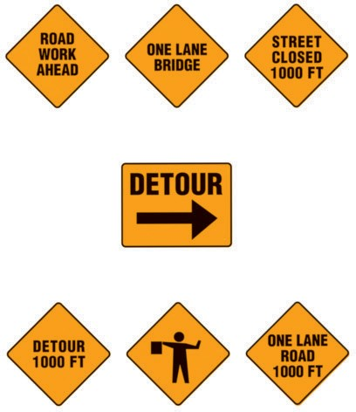

### Channelizing Devices:

Barricades, vertical panels, drums, cones and tubes are the most commonly used devices to alert drivers of unusual or potentially dangerous conditions in highway and street work areas and to guide drivers safely through the work zone. At night they are often equipped with flashing or steady burn lights.

The diagonal stripes on the barricade or vertical panel guide the driver towards the direction to which traffic is to pass. Stripes sloping downward to the right mean the driver should bear to the right. Conversely, stripes sloping downward to the left mean bear to the left.

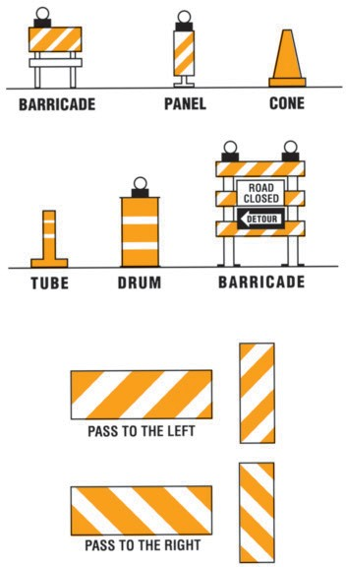

### Flashing Arrow Panels:

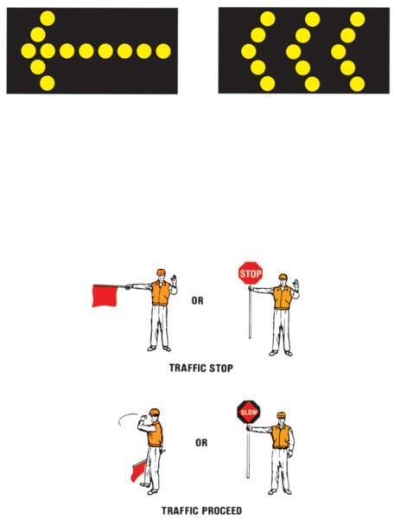Large flashing or sequencing arrow panels may be used in work zones both day and night to guide drivers into certain traffic lanes and to inform them that the part of the road or street ahead of them is closed.

### Flagpersons:

Flagpersons are often provided in highway and street work zones to stop, slow or guide traffic safely through the areas. Flagpersons wear orange vests, shirts or jackets and use red flags or stop/slow paddles to direct traffic through work zones.

### CHAPTER VII ACCIDENT PROCEDURES

*What you must do if you are involved in an accident.*

Traffic accidents resulting in personal injury to any extent, or death, or property damage of $3,000 or more must be reported to the police immediately by the quick- est means of communication.

If involved in an accident:

1. Stop immediately. If possible move your vehicle off the travelled portion of the roadway. Do not leave the scene of an accident without identifying yourself and rendering assistance.
2. Help the injured.
   1. Call the nearest police agency. Ask for an ambulance if needed.
   2. Act promptly, but carefully. Do not move the injured unnecessarily. Unskilled handling can make serious injuries out of minor ones. Keep the injured warm until skilled help arrives. If there is severe bleeding, attempt to stop the flow of blood with direct pressure. Protect the victim from the oncoming traffic.
3. Warn passing traffic. Have someone warn approaching cars to prevent further damage from oncoming traffic. Keep a flashlight and flares in your vehicle for emergency use.
4. Exchange information. Drivers must give their name, address, and vehicle reg- istration number, and if requested, exhibit their driver’s license to any person injured in the accident or to the driver or occupant of or person attending any vehicle or other property damaged in the accident.
5. 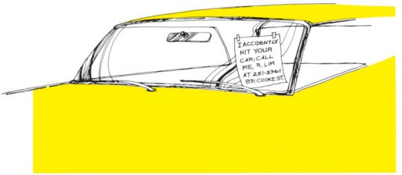Upon striking an unattended vehicle, stop and locate the owner, or leave a writ- ten notice containing your name and address and circumstances of the accident. If you damage other property along the highway, notify the owner.

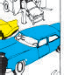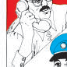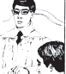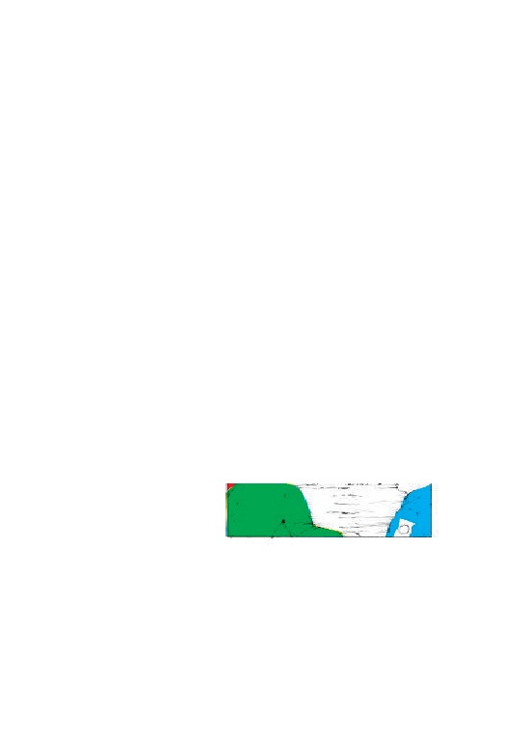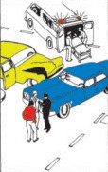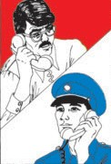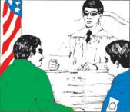

### CHAPTER VIII

**MOTOR VEHICLE SAFETY RESPONSIBILITY LAW**

**WHOM DOES IT AFFECT?**

All drivers involved in traffic accidents resulting in death, injury or property dam- age in excess of $3,000, and all persons convicted by court of certain offenses involv- ing vehicles.

**WHAT MUST YOU DO AFTER THE ACCIDENT?** (See Chapter VII, page 52)

Report the accident to the Police Department and insurance company and: File evidence of insurance (Form SR-21).

### WHAT MUST YOU DO UPON CONVICTION OF CERTAIN OFFENSES INVOLVING VEHICLES?

File and maintain proof of financial responsibility for a period of three (3) years from conviction date;

File evidence of insurance (Form SR-22).

### WHAT IS THE PENALTY FOR NON-COMPLIANCE?

Driver’s license will be suspended.

53

### MOTOR VEHICLE INSURANCE LAW

**WHO NEEDS MOTOR VEHICLE INSURANCE?**

Every owner of a car, bus or truck must have motor vehicle insurance in order to register or operate a vehicle in the State.

### WHAT ARE THE MINIMUM MANDATORY COVERAGES?

The basic benefits include up to $10,000 per person for: Medical and rehabilitative expenses;

It includes liability coverage of $20,000 per person with an aggregate limit of

$40,000 per accident for bodily injury and $10,000 for property damage per accident. (NOTE: Damage to your own car will not be covered unless you have additional insurance coverage.)

### WHEN CAN I SUE OR BE SUED?

You can sue or be sued for recovery of property damage at any time but not for bodily injury unless:

Medical bills exceed $5,000; or

Injury is such that the use of a part or function of the body is lost or permanent and serious disfigurement results; or

Injury results in death.

### WHAT IS THE PENALTY?

Any person who violates any applicable provision of the motor vehicle insurance law will be subject to citation for such violation and each violation shall be deemed a separate offense and shall be subject to a fine not to exceed $5,000 or thirty (30) days imprisonment, or suspension of motor vehicle operator’s license, or forfeiture of motor vehicle certificate of registration, or any combination of such penalties.

### THE PROBLEM:

### CHAPTER IX ALCOHOL AND OTHER DRUGS

One of the most significant problems in driving is the great number of drivers who are under the influence of alcohol. The use of alcohol is a factor in over 18,000 (about 40%) of the fatal motor vehicle accidents that occur every year in the United States. This is your problem as a driver, whether you drink or not.

The problem is not limited to the alcoholic or chronic drunk that drives. It involves everyone who uses alcohol to a lesser degree and drives; including those decent, law- abiding, responsible persons with homes and families who just overindulge occasion- ally. It is a few extra martinis during lunch, or a few with friends after work on pay- day, or driving home from a party.

### THE SOLUTION:

A large share of the responsibility for solving the problem rests with you, the driver.

* You must understand what alcohol does to you;
* You must know your limits and not exceed them; and
* You must refrain from driving when you have been drinking.

### ALCOHOL:

There are several things you should remember about alcohol:

* Alcohol is a depressant, not a stimulant. It slows normal reflexes, interferes with judgment, reduces alertness and impairs vision. If you feel stimulated after drinking, it is simply because your inhibitions are lowered, causing loss of caution and self-control.
* It doesn’t matter whether you drink beer, wine, whiskey or any other alcoholic beverage; it’s the amount of alcohol that enters your blood that causes the problem.
* Alcohol can affect you differently at different times. A small amount on an empty stomach will affect you more rapidly than it would if you had recently eaten a quantity of food.
* Once the alcohol enters your blood there is nothing you can do to lessen the effect. Black coffee, food or a cold shower might wake you up, but they will not sober you up. Alcohol is burned up by your liver and eliminated from your body through your kidneys and lungs. This process takes time.

### THE LAW

*Operating a motor vehicle while under the influence of intoxicants.* Driving a motor vehicle while under the influence of intoxicants is prohibited in Hawaii.

*Implied Consent.* Any person who operates a motor vehicle on the public highways in Hawaii is deemed to have given his or her consent to be tested to determine the amount of alcohol in his or her blood.

*Administrative License Revocation.* Your license will be taken away and you will be given a 30-day temporary driving permit if a test shows that you have a blood alco- hol content of .08 or more or if you refuse the test. Anyone whose license is revoked may request a hearing.

*Zero Tolerance.* Drivers under 21 are prohibited from operating a motor vehicle with a blood alcohol content level of .02 or more.

A police officer who believes a driver is under the influence of alcohol, may request the driver to take a test. Refusal to take the test may result in the revocation of your license for one year, two years or four years depending upon the driver’s prior alcohol enforcement contacts. In addition, the driver may be charged with driving under the influence of alcohol even though he refuses the test. The test can also prove that you are not under the influence of alcohol.

When the test shows alcohol in the driver’s blood, the driver may be considered to be:

* *Impaired* if the blood alcohol content is more than .05 percent but less than .08 percent.
* *Under the influence of alcohol* if the blood alcohol content is .08 percent or more.

IT IS AGAINST THE LAW TO CONSUME OR POSSESS ANY ALCOHOLIC BEVERAGE ON ANY PUBLIC HIGHWAY OR ANY PUBLIC SIDEWALK.

Storing an opened alcoholic beverage container in the area of a motor vehicle nor- mally occupied by the driver or passengers is prohibited on any public road.

### OTHER DRUGS

There are many drugs which also interfere with a person’s ability to drive safely. Some are found in medicine prescribed by your doctor, and others are found in medicine you can buy without a doctor’s prescription.

Here are a few things you should remember:

* Before taking medicine, it is important to ask your doctor about any possible effects which might relate to your driving ability.
* Some allergy remedies and cold pills which you can buy without a prescription may contain ingredients which can affect your driving ability.
* Amphetamines are used in stimulants and diet pills, known in the illegal trade as “pep pills” and “speed”. Over-dosage of these and other drugs, such as tran- quilizers or sedatives (“downers”), not only greatly impair your ability to drive, but can be the sole cause of death.
* The combination of alcohol and drugs, in some cases, can have a much more pronounced effect than either taken separately. Never mix alcohol and drugs.
* Some of the most dangerous types of drugs can be obtained only illegally. LSD, heroin and cocaine are examples. They have the power to make users com- pletely unaware of or indifferent to their surroundings. Anyone under the influ- ence of such drugs must not try to operate a motor vehicle.
* All types of drugs on the “illegal” market are dangerous because there is no way to be certain of their strength or purity.

### CHAPTER X

**SAFE DRIVING TECHNIQUES**

**NORMAL DRIVING PROCEDURES DRIVING HABITS**

A habit is usually formed when you do the same thing so many times that it becomes so easy that you do it automatically without any conscious thought as to how you did it.

You form driving habits because the same physical actions are required to be per- formed over and over again. Your normal tendency is to reduce these required actions as much as possible. This reduction takes place without thought, and results in the formation of “bad” driving habits.

“Bad” driving habits are caused by: (1) Laziness, (2) Impatience, (3) Inattention,

1. Arrogance, and (5) Ignorance. Typical examples of these habits and how they are formed are:

### LAZINESS

* + When you learned to drive, you should have been taught that the proper pro- cedure was to look for other traffic before you changed lanes, drove away from the curb or got out of your vehicle on the traffic side. The procedure always required you to turn your head and look behind you for oncoming traffic before taking any action. As you gained proficiency as a driver, you may have inad- vertently allowed this check to be reduced to only looking in the rear view mirror and finally to only an occasional check.
  + A related “bad” habit is that of failing to always signal your intentions before changing lanes, or driving away from the curb. Allowing the combination of these two “bad” habits to develop could be the cause of your first accident.

### IMPATIENCE

* + Everyone knows that you must always come to a *complete* stop at a stop sign or at a red light, even when making a right turn, regardless of traffic. Pressure from following vehicles and the lack of cross traffic may tempt you to just make a “good try” at stopping. This “bad” habit may grow to a point that you may find yourself just “slowing down” for a stop sign.
  + It’s easy to spot an impatient driver. He’s the one who speeds from stop to stop, weaving in and out of traffic, and when he can’t, he tailgates other drivers. He may be paying close attention to what he is doing but doesn’t seem to realize that he is disrupting traffic and increasing his chances of becoming involved in an accident. Don’t permit yourself to develop this dangerous “bad” habit.

### INATTENTION

* + A new driver on the road sits up straight, has a firm grip on the steering wheel, is aware of where he is, and pays attention to the developing traffic problems. As he gains experience, he relaxes and leans back, releases his grip on the wheel and may allow his attention to wander. His vehicle then may also wan- der. This driver can easily be identified. He is driving with one arm out the

window and talking to a passenger, gesturing with his other hand and paying very little attention to the traffic flow. His passengers are often uncomfortable because of his lack of control of his vehicle. When he is alone, he daydreams or gazes at objects off of the roadway. His inattention forfeits his safety.

### ARROGANCE

* + Where the impatient driver is simply in a hurry, the arrogant driver is purposely in a hurry. He competes with his vehicle. His vehicle is an extension of his ego. He has little or no respect for traffic laws or the rights or right-of-way of other drivers or pedestrians. Never allow yourself to become involved in competition with an arrogant driver, or become one. There is nothing to gain and too much to lose.

### IGNORANCE

* + A driver may not know the meaning of traffic signs, roadway markings, the rules of right of way and of safe driving procedures. You may notice this per- son turning from the wrong lane, driving too slowly because he is unsure, stopped at the end of a freeway on-ramp or crossing pavement markings which prohibit crossing. Usually the ignorant driver doesn’t realize that he is ignorant and may think that all other drivers are “out to get him.”

Sometimes a driver has a combination of these “bad” driving habits, and when he has or is involved in a traffic accident, he is sure that the accident just “happened” to him and was unavoidable.

Listed below are more bad habits which fit in one or more of the five “bad” driv- ing categories:

* + Failing to yield to pedestrians or other vehicles having the right of way.
  + Not always wearing safety belts and not insisting that passengers also wear them.
  + Having one or more alcoholic drinks prior to driving home from work. The excuse usual- ly given is to “miss the traffic.”
  + Backing a vehicle without first making certain that the area is clear.
  + Allowing yourself to be distracted by passengers in your vehicle.
  + Allowing your attention to be diverted by looking at maps, or lighting smoking materials while driving, etc.

“Good” driving habits can be formed just as easily as the “bad” habits just dis-

cussed. All you have to do is to deliberately accomplish the proper action over and over again until the good habit is formed. Your trips will become more enjoyable for yourself and more comfortable for your passengers.

### DISTRACTED DRIVING

Being distracted from, or not giving your full attention to your driving, could result in serious consequences. Anything that takes your attention away from driving can lead you to make a poor choice when driving.

Avoid eating, drinking, talking on a cell phone, writing, reading, smoking, per- sonal grooming, changing your CDs or radio station, looking at people or objects outside your vehicle, looking for things inside your vehicle, talking to passengers, dealing with children or pets, applying makeup, shaving, etc. Plan ahead and take care of these things before you start driving. If you need to read a map or directions, pull over to the side of the road in a safe place. Stop until you are ready to give your complete attention to driving.

Keep your stereo or radio at a volume low enough so you can hear things outside

of your vehicle. If it is turned up too loud, you may not be able to hear a siren, horn honking, screeching of tires or other things that would lead you to react to an emer- gency or hazard in order to prevent a crash. Do not drive with headsets or earphones that cover or go in both ears. They make it too hard to hear emergency horns or sirens.

Talking on a cell phone is distracting because your attention is directed more toward your conversation than your driving. Avoid using your phone or CD radio when the vehicle is in motion. Even with “hands free” equipment, talking on a phone or radio take your attention away from driving and can cause you to be less likely to notice a dangerous situation. If you need to talk on a cell phone, pull over to the side of the road in a safe place until you are finished with your call. Pets can be distracting and should be in a carrier.

### DEFENSIVE DRIVING

Defensive driving is a driving technique in which you identify dangerous driving situations and take action to defend against the danger before an accident situation develops. Your “defensive” action will be applied in avoiding vehicles driven by aggressive, offensive, discourteous, careless, inattentive, impulsive, ignorant, and intoxicated persons as well as pedestrians who have some of the same characteristics. If you display any of these characteristics, you must first DEFEND AGAINST YOURSELF. The basic idea of defensive driving is to recognize possible hazards associated with various driving situations and to adjust your driving to allow you to

avoid hazards when they develop.

To avoid accidents, you, as a defensive driver, should:

1. Stay alert, keep your eyes moving in order to be aware of developing traffic situations around you at all times.
2. Look well ahead of your vehicle and anticipate the possibility of a chain reaction traffic situation.
3. Have an alternate plan of action ready in case an unexpected event develops. (Always leave yourself a way out.)
4. Always maintain the proper following distance.
5. Always maintain the proper speed for all highway conditions.

### ATTENTIVENESS

Almost all of the information you require to drive a vehicle safely is obtained by looking and SEEING. You must be aware of and be alert to any hazards that appear. You should have a constant awareness of conditions in the vicinity of your vehicle. Special attention should be devoted to conditions at a considerable distance ahead of your vehicle.

### SPEED REDUCES YOUR FIELD OF VISION

The SEEING task should occupy your entire attention while driving. Develop a scanning pattern with most of your attention devoted to the situation ahead but with glances to either side, in the rear view mirror, and at the instrument panel at regular and frequent intervals. Do not become distracted by looking at passengers, attempting to find something within the vehicle, looking at reading material, sightseeing or day- dreaming while driving. Many drivers’ statements about accidents begin with “I did- n’t see ....” In many cases this means “I wasn’t paying attention.”

### DRIVER’S CONDITION

A poor physical or mental condition limits your capabilities as a driver. Do not drive if you are ill, injured, emotionally upset or under the influence of intoxicants. If you are taking medication, you should obtain and follow your physician’s advice about driving. If you must make the trip, seek assistance from friends or neighbors or use some form of public transportation.

If an emergency exists, call the police for assistance.

### VEHICLE CONDITION

*Your Own Vehicle.* Any defect which may affect the safe operation of the vehicle should be corrected as soon as possible. If the status of the engine coolant, engine oil, battery water, tire condition and pressure and vehicle lamps have not been checked within the previous week, you should check them or have them checked at a service station before you continue your trip. The windshield and all windows should be clean. INSURE THAT THE VEHICLE CONTAINS ENOUGH FUEL TO COM- PLETE THE TRIP.

*An Unfamiliar Vehicle.* Take a few minutes to familiarize yourself with the loca- tion and operation of the turn and hazard warning signals, head lamps and beam selec- tor, windshield wipers and washers, brakes, gear selector and horn. Any defects should be corrected before the vehicle is driven.

### TRIP PLAN

When driving to an unfamiliar area, you should plan your trip.

*Destination Location.* You should know the exact location of your destination; don’t start with only a hazy idea of where you are going. If your destination is in an unfamiliar area, check the location on a map before you start.

*Route Plan.* Choose the most appropriate route. Consider traffic conditions, road conditions, weather conditions and light (daylight or darkness) conditions. Avoid trou- blesome conditions wherever practicable. Allow sufficient time for the trip. If you are doubtful as to whether you are able to comfortably cope with any undesirable condi- tions, POSTPONE OR CANCEL THE TRIP.

### PRE-STARTING

Equipment warning lamps on the vehicle instrument panel should all be illuminat- ed when the ignition switch is turned on. A warning lamp that is not illuminated indi- cates that the lamp is not functioning.

### POST-STARTING

Within a few moments after starting the engine no warning lamps except brake and safety belt lamps should be visible. If other lamps are visible, the vehicle should not be driven until the condition is corrected.

The brake warning lamp should go out when the parking brake is released. If it illuminates when the foot brake pedal is pressed, the brake system is defective and the vehicle should not be driven.

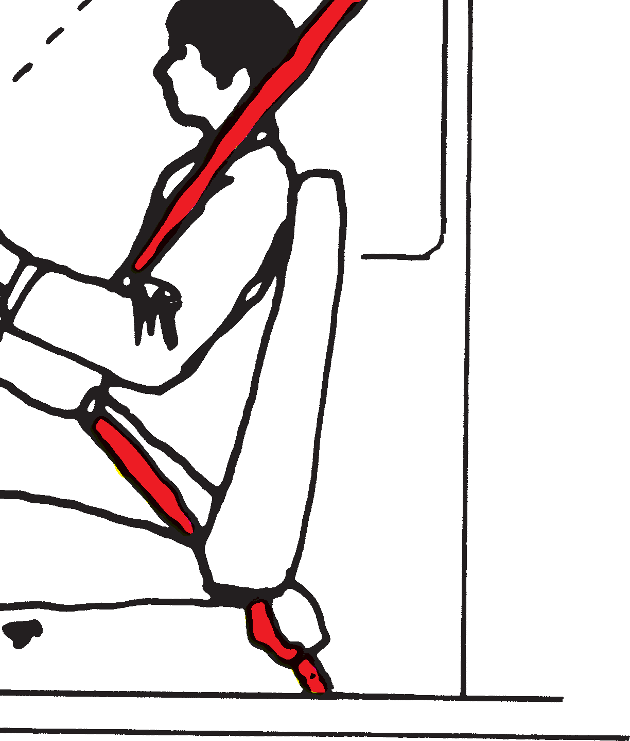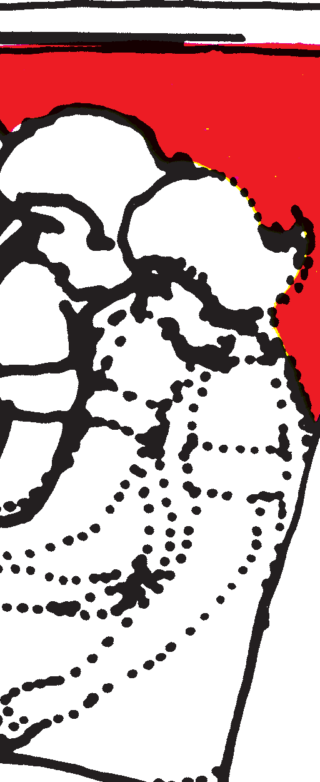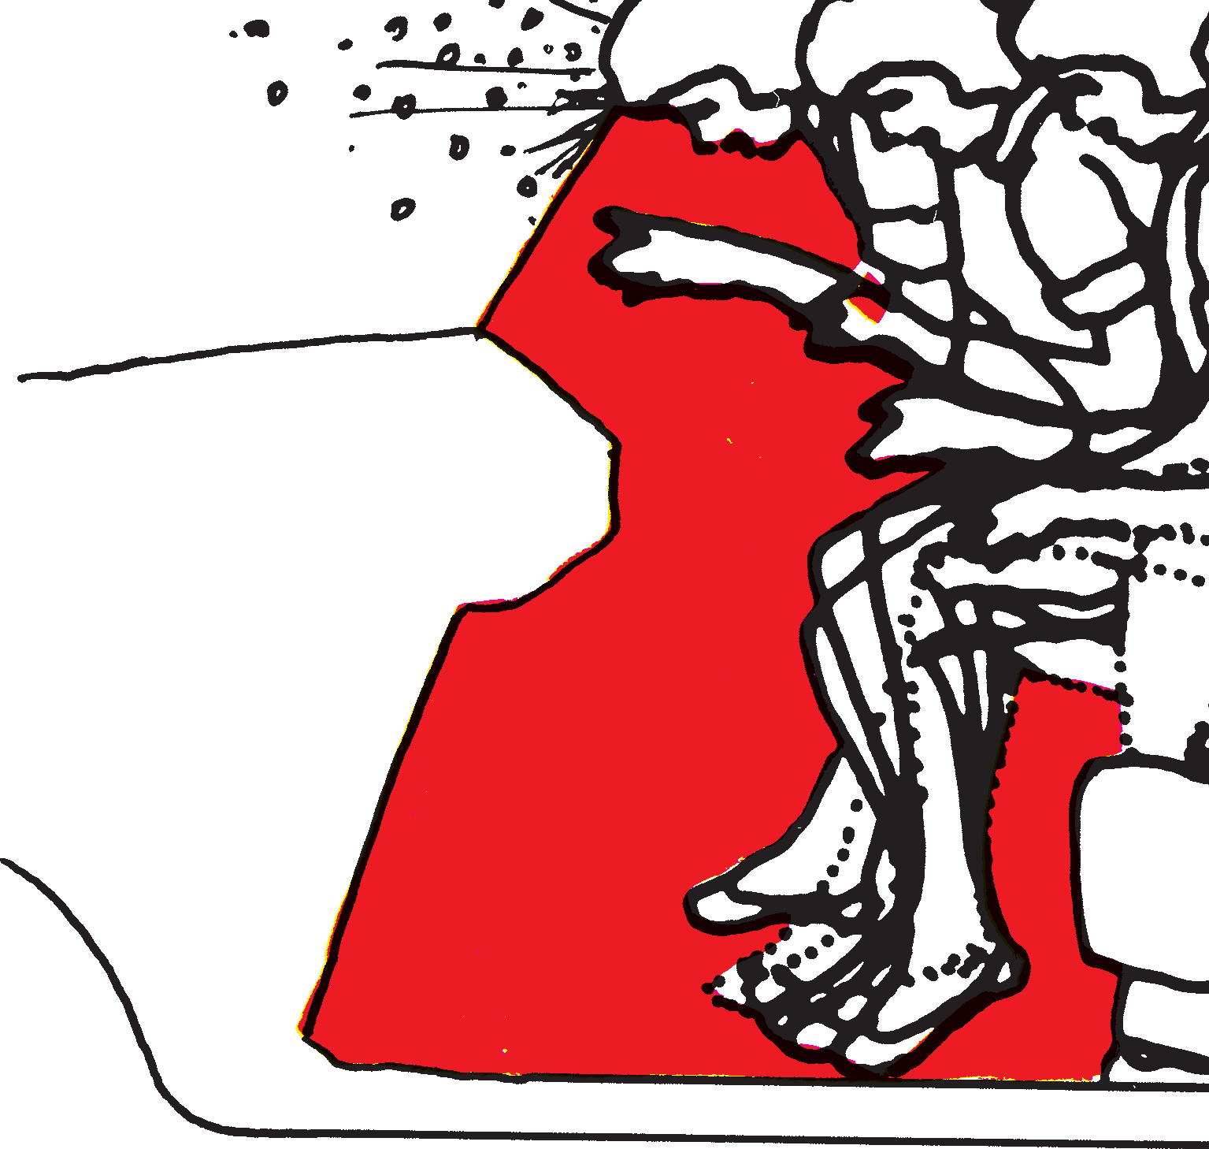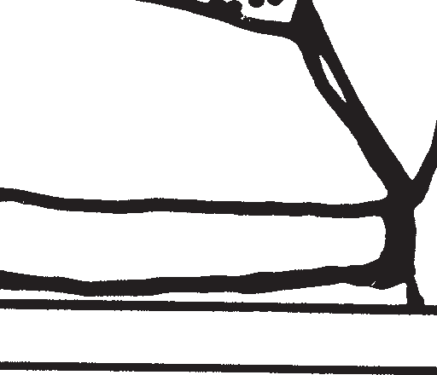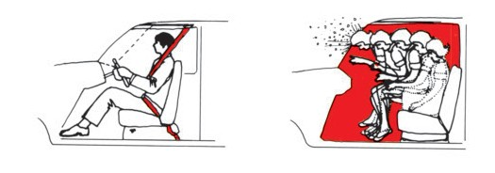

### SAFETY BELTS

Safety belts are life belts. They must be worn at all times when driving or riding in a vehicle. They are the most important personal safety item available in

1. From being thrown from your car.
   * Your chances of being killed are five times greater if you are thrown from your car.
2. From being injured by striking the windshield or other interior parts of your car.
   * You can survive a crash at speeds up to 60 miles per hour (97 km/h) if using lap and shoulder belts.
   * If not buckled up, it is possible to be killed in a crash at speeds as low as 12 miles per hour (19 km/h).
3. From injuring another person in the car by being thrown against them.
   * In an accident infants and small children may be crushed to death by occu- pants not wearing seat belts.
4. In the driver’s position so you can keep control of your car.
   * The first impact in a crash frequently throws the driver away from the vehi- cle controls thus preventing any possibility of controlling the vehicle.

Lap belts should fit snugly across your hip bones and the lower part of

your abdomen. The shoulder belt should be not quite so tight—so that you can insert your fist between the belt and your chest. All belts in late model vehicles are designed to allow body movement and only lock up upon impact.

Don’t forget your passengers. There are special child seats available for children who are too small to wear regular safety belts. No person is strong enough to hold onto even a small infant in accidents or sudden stops. NEVER ALLOW A CHILD TO RIDE STANDING ON A SEAT.

ANY EXCUSE FOR NOT WEARING SAFETY BELTS IS INEXCUSABLE.

61

### Safety Belts Prevent the Human Collision WHAT HAPPENS IN A COLLISION

**Unbelted Belted**

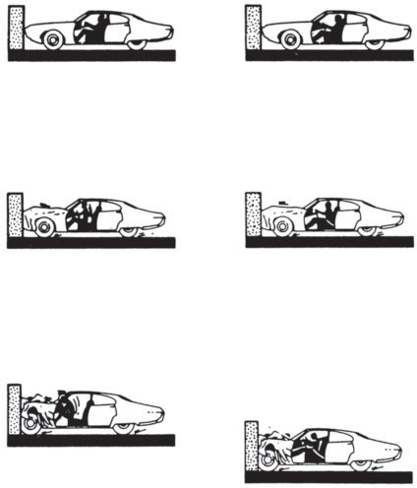**0.000 Seconds - Car Hits Barrier**

On impact, the car begins to crush and to slow down. The person inside the car has nothing to slow him down so he continues to move forward inside the car at 30 mph.

**0.050 Seconds - Car Crushes**

The car slows down as the crushing of the front end absorbs some of the force of the collision. The person inside is still moving forward at 30 mph.

**0.100 Seconds - Car Stops**

* 1. **Seconds - Person Hits Car Interior** One-fiftieth of a second after the car has stopped, the person slams into the dash- board and windshield. This is the human collision. In the car’s collision it takes 1/10 of a second to stop; in the human collision it takes only 1/100 of a second.

On impact, the car begins to crush and to slow down.

As the car slows down, the person moves forward until the seat belts restrain him. The belts keep him in his seat and keep his head and chest from striking the car inte- rior.

Being fastened to the framework of the car, belted occupants are able to “ride down” the collision as part of the car. They are able to take advantage of the car’s slower stop, as it crushes and absorbs energy. For belted people there is no human collision.

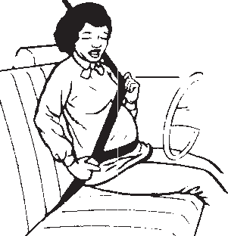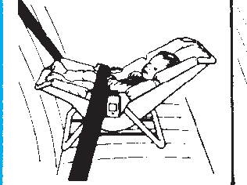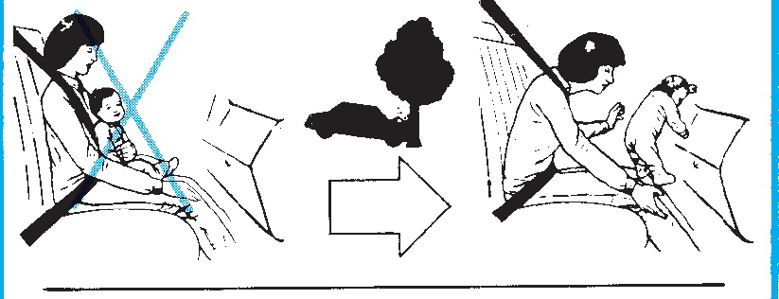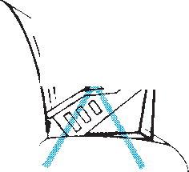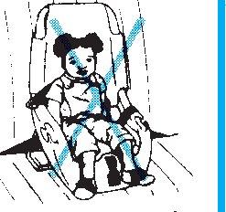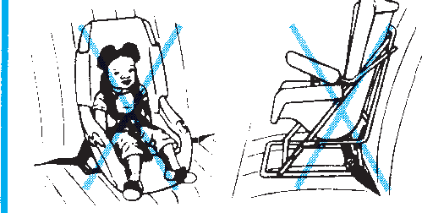PROTECT YOUR BABY IN THE CAR

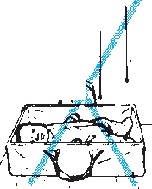

|  |  |  |  |  |
| --- | --- | --- | --- | --- |
| 1. Before Your Baby Is Born | | 2. After Your Baby Is Born  Baby rides in car safety seat  \Infant positipn·Toddler position  Infant Seat or Convertible  Never carry baby in your arms | | |
| U.e lap shoulder belt Low and snug | |
| 3. Making Your Ba b)' Comfortable    Papoose bunting Sack sleeper | |
| t  Household carrier | Do not use  ]/ 7-  - I "  · ,  '  Travel bed | Cloth car rier |
| Position of baby in car seat Support baby's  head and body  *c!li# I)*I  Rolled  dia per s , blankets  Back flat - Back curved -  baby comfortable baby uncomfortable;  In cold weather | | | **4.** Common **Mistakes**  k,  ,  '  \  Infant facing forward Harness not used | |
| e:◊J[ ·>  **Do not wrap baby** Causes bad fit  ln blanket of harness | ;fn  Cut holea In blanket, Buckle harness.  pull strap& through k,ld blanket owr | | Harness not snug  Seat beh not tight | Seat belt in wrong place  Seat belt not used |

### WARNING! Do not leave children unattended.

Hawaii law prohibits you or any adult passenger from leaving a child, under nine years of age, unattended in a motor vehicle for five minutes or longer. Leaving a child unsu- pervised in a vehicle can have tragic consequences, such as the child suffering from extreme heat exposure or injury when the car is stolen or when parts of the car, such as the emergency brakes, power windows, and trunk releases, are used inadvertently.

### BACKING YOUR VEHICLE

Backing is a dangerous maneuver because of restricted visibility and should be done with great caution. You should use the following procedures to back a vehicle with safety:

* + - Visually check the area to the rear of the vehicle before entering.
    - Turn around and look to the rear; do not rely on rear-view mirrors. The view through rear-view mirrors is too small to use for this purpose.
    - If you cannot see to the rear, have someone outside of the vehicle guide you.
    - When the backing movement is first started, apply the brakes gently to insure proper operation
    - Always back at a slow rate of speed.
    - Watch the front of the vehicle for clearance if you are backing and turning at the same time.
    - Avoid backing into traffic. Try to park the vehicle so that you will enter traffic in a forward direction. Always back into the lane nearest the edge of the road- way when traffic is clear.
    - 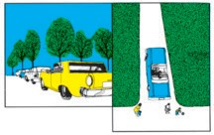Avoid backing across or into a roadway whenever possible.

LOOK BACK BEFORE DRIVING FROM CURB LOOK. SIGNAL. YIELD

The chief responsibility for avoiding a collision lies with the driver who is leaving a parking space.

Exercise extraordinary caution when backing up in residential areas. Children often play behind and between parked vehicles.

### ENTERING TRAFFIC

Entry into traffic is usually made from a driveway or a roadside parking position.

You should use the following procedures to enter traffic safely:

*Entry from a Driveway*

* + - Always stop before entering the roadway. The stop should be made before crossing the sidewalk area. Failure to stop is unlawful.
    - Move forward slowly. Watch for pedestrians and oncoming vehicles.
    - Insure that the traffic lane is clear of oncoming vehicles.
    - Enter the nearest lane in a right turn whenever possible.
    - After you are in the traffic lane, accelerate to traffic speed.

*Entry from a Roadside parked Position*

* + - If parallel parked, move forward into the nearest traffic lane when there is suf- ficient space in oncoming traffic.
    - If diagonal parked, you will have to first back into the traffic lane. This is a much more dangerous and difficult maneuver and requires more time to complete.

### ROUNDABOUT

A roundabout is designed to meet the needs of all roadway users---drivers, pedestrians, pedestrians with disabilities, and bicyclists. A roundabout is a one-way circular intersection in which entering traffic must yield the right-of-way to circulat- ing traffic. Each road approaching the roundabout is marked with a yield sign and may also have yield line markings on the pavement.

Tips for driving through a roundabout:



* + - Slow down as you approach the roundabout.
    - Yield to pedestrians and bicyclists as you enter and exit the roundabout.
    - Look to the left for traffic and yield to traffic, including bicyclists, already in the roundabout.
    - Drive to the right of the central island and proceed in a counterclockwise direction.
    - Keep your speed low while in the roundabout.
    - Use your right turn signal to exit the roundabout.
    - If you miss your exit, drive through the roundabout again until you reach your exit.

### CHOOSING A PROPER TRAFFIC LANE

*One Lane in the Direction of Travel.* You have no choice; you must use that lane. In congested areas you must use great care to avoid conflicts with other vehicles and pedestrians.

*Two Lanes in the Direction of Travel.* In open area when traffic is free-flowing, use the right lane; use the left lane for passing or when vehicles are entering from the right. In heavy traffic or in congested areas use either lane but keep up with traffic. Move at a steady speed. Avoid continual lane changing (lane hopping).

*Three or More Lanes in the Direction of Travel.* Choose the center lanes as there will be less traffic conflicts. Leave the right and left lanes available for vehicles enter- ing and leaving the roadway. Maintain a steady speed with the flow of traffic and keep lane changes to a minimum. Use the right lane if you are moving slower than other traffic.

### LANE CHANGING

Lane changes should be kept to a minimum as it is a movement that could conflict with other traffic.

When a lane change is necessary, use the following procedures:

* + - Check highway and traffic conditions ahead, to the sides, and to the rear. Use your rear-view mirrors and physically check the blind spots (turn your head and look).
    - Signal your intention well in advance. The law requires that you signal for at least 100 feet (30m) before you start the lane change.
    - When there is ample clearance in the other lane, make a gradual, steady move-

ment into the other lane. AVOID ABRUPT MOVEMENTS: YOU MAY OVERCONTROL OR LOSE CONTROL OF YOUR VEHICLE. It may be

necessary to adjust the speed of your vehicle slightly to avoid conflict with traf- fic. It is best to slow slightly and move in behind a vehicle than it is to speed up and cut in ahead. When you move in behind a vehicle, you always have that vehicle in sight and there is less annoyance to its driver.

* + - Don’t force your way into the space between vehicles that have the minimum safe following distance or less. This is a discourteous and dangerous action which causes other drivers to reduce the spacing interval between vehicles to deny you space to change lanes. If you allow ample time and signal properly, other courteous drivers will be inclined to allow you space to make the change.
    - ALWAYS YIELD TO VEHICLES IN THE OTHER LANE WHEN CHANG- ING LANES. If the desired lane is congested, enter at the end of the line; don’t run up ahead and crowd in. If you cannot make the lane change at the desired location, remain in your lane until you can safely make the change; even if you are inconvenienced.
    - NEVER CHANGE LANES WHEN APPROACHING OR MOVING THROUGH INTERSECTIONS AND CROSSWALKS.

### VEHICLE SPEED

“Excessive speed for conditions” is most often listed as the cause of accidents. The cause of the excessive speed is seldom determined but whether it is due to intoxication, inattention, competition, etc., it is directly controlled by the driver. Unfortunately, most vehicles can attain speeds that are far beyond the capabilities of the driver, the road, and the vehicle itself.

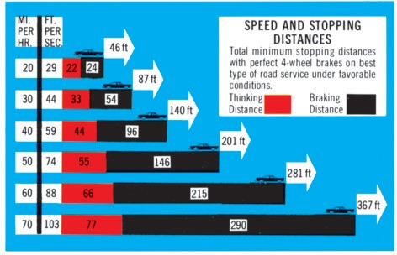The proper safe vehicle speed must be adjusted to traffic, weather, and road con- ditions and should always be within the posted speed limits.

You should use the following procedures in maintaining a safe vehicle speed:

* + - Keep pace with traffic. Vehicles moving in the same direction at the same speed never collide. If you move faster than other traffic, you constantly cause addi- tional conflicts with other vehicles. If you cannot keep up with traffic, move as far to the right as possible.
    - Maintain a safe following interval. One of the most common types of accident, striking the vehicle ahead, is usually caused by following too closely. To insure adequate interval, note when the vehicle ahead is opposite a tree, a telephone pole or other marker, then start counting at a normal rate “one thousand one, one thousand two, etc.” If you get to the word two before your vehicle reaches the marker, you have at least a two second interval. You should never have less. Following too closely reduces your ability to see road and traffic conditions ahead and you will be unable to avoid trouble when it develops.
    - Maintain a steady speed. Constantly changing speed confuses other drivers as to your intentions. Bursts of speed and heavy braking are both wasteful and dangerous.
    - Reduce your speed when you encounter poor road or weather conditions. At slower speeds you can maintain better control of your vehicle and you will have more time to avoid dangerous situations.
    - Never let your emotions determine the speed of your vehicle. Never be in a hurry, you may never arrive at all.

### TURNS AND CURVES

Turns are changes of direction from a traffic lane made at intersections or drive- ways. Curves are changes in direction of the road or traffic lane. In some cases the safe procedures are similar:

* + - Get into the proper lane for a turn well in advance. Turn from the traffic lane nearest the direction of the turn and into the nearest traffic lane available. If you are not in the proper lane when you want to turn, continue on and make the turn elsewhere. Don’t force your way into the proper lane or make abrupt last minute lane changes.
    - Make precise turns; don’t swing wide or cut short.
    - Slow to a proper speed before you enter a curve or begin a turn. Maintain a steady speed while in the curve or turn. Braking or an abrupt change of speed in a turn or curve can cause you to lose control of your vehicle.
    - Avoid left and “U” turns whenever possible. These turns conflict more with other traffic, are much more hazardous than right turns and also impede other traffic.
    - While waiting to turn left at an intersection with a red traffic light; when the traffic light turns green, move slowly into the intersection, keep the wheels pointing straight ahead and turn when the intersection is clear and it is safe

to do so.

* + - Use great care in watching for pedestrians, bicyclists and motorcyclists when

making turns; they may be hidden by other vehicles, darkness or poor weather.

* + - Always bring your vehicle to a complete stop before making a right turn when facing a red traffic signal.
    - Use extra caution on curves and turns in poor weather conditions or when there is gravel, sand, or mud on the road.
    - When making a right turn at an intersection, do not drive in a bike lane.

### OVERTAKING AND PASSING

Overtaking and passing another vehicle is hazardous on two or three lane roads where a lane for traffic moving in the opposite direction must be used to complete the passing maneuver. Improper procedures can cause a head-on collision. Use the fol- lowing procedures for safe passing:

* + - Pass only if the vehicle ahead is moving below the safe speed.
    - Don’t attempt to pass a vehicle ahead simply because it is there.
    - Don’t attempt to pass vehicles merely to gain a few car lengths in moderate or heavy traffic.
    - In a line of vehicles, allow the vehicles ahead to pass the lead vehicle before you attempt to pass.
    - Pass on the left except when the vehicle you are overtaking is making or about to make a left turn. Pass vehicles making left turns carefully on the right. NEVER DRIVE ONTO THE ROAD SHOULDER TO PASS A VEHICLE MAKING A LEFT TURN.
    - Obey all signs and traffic lane markings which restrict or prohibit passing.
    - Allow ample following distance between your vehicle and the overtaken vehi- cle so that you can observe any opposing or conflicting traffic.
    - Check ahead to see that there is no opposing or conflicting traffic, then SIG- NAL that you intend to move to the left.
    - Physically check behind to see that there are no vehicles attempting to pass your vehicle.
    - Sound your horn so that the driver ahead knows that you are going to pass.
    - Accelerate to passing speed in your lane of travel. Then move left and begin to pass.
    - If a conflict appears before you have completed passing, brake sharply and return to the lane behind the overtaken vehicle. Do not attempt to increase your speed to complete passing. Speed can be reduced more quickly by applying the brakes than it can be increased by applying more power.
    - Move back into the proper traffic lane when you can see the overtaken vehicle in your interior rear-view mirror.

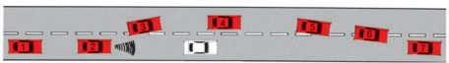On roadways where there are two or more lanes for traffic moving in the same direction, do not move into a lane for opposing traffic when attempting to pass. You may pass a vehicle on either side by using the proper lane change procedures. Be extra careful about passing on the right because you will approach the overtaken vehicle in the driver’s blind spot.

IN ALL PASSING SITUATIONS YOU SHOULD NOT ATTEMPT TO PASS ANOTHER VEHICLE WHEN APPROACHING OR MOVING THROUGH AN INTERSECTION OR CROSSWALK.

### PASSING PARKED CARS

Use care when passing cars parked by the roadside. These vehicles obstruct your view of possible conflict with other vehicles, bicycles and pedestrians. Be alert to the possibility that a parked car may suddenly move into your traffic lane or that a door may be opened into the path of your vehicle.

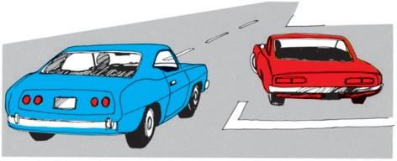

Watch for these clues:

* + - * Movement within the vehicle or within the vicinity of the vehicle.
      * Stop lamps, back-up lamps or signal lamps that are illuminated.
      * Smoke or visible vapor from the exhaust pipe.
      * A turning movement of the front wheels.

When you approach a vehicle that has just stopped in a parked position, assume that the driver will open the door as you approach.

### STOPPING IN TRAFFIC

Stopping unnecessarily in a traffic lane is dangerous, discourteous, inconsiderate and illegal. Stops make to load or unload passengers or cargo or to converse with other drivers or pedestrians must be made in a designated parking space, loading zone or other place out of a traffic lane.

You should not stop your vehicle within an intersection or a crosswalk. NEVER DRIVE YOUR VEHICLE INTO AN INTERSECTION OR A CROSSWALK UNLESS THERE IS SPACE FOR YOUR ENTIRE VEHICLE ON THE OPPOSITE SIDE OF THE INTERSECTION OR CROSSWALK.

### USE OF BRAKES

Brakes are devices used to stop and hold a vehicle in a fixed position. Brakes stop a vehicle by converting the vehicle’s energy of motion into heat and wasting it. Every time you use the brakes you waste the money you paid for fuel and cause wear on the brakes and tires. Careful use of the brakes can save considerable energy and money in replacing fuel, brakes and tires. Avoid bursts of speed followed by heavy braking.

A hard application of the brakes will cause one or more wheels to slide on the road. If the wheel(s), especially the front wheel(s), continues to slide, you will not have con- trol of the vehicle. If you are in danger of striking another vehicle, a person or object,

don’t just jam on the brakes and slide the wheels; you will almost certainly strike the thing you are trying to avoid. Instead, apply and release the brakes rapidly and STEER the vehicle toward a clear area. Steer off the road if necessary but avoid hitting peo- ple, trees, utility poles and substantial objects or structures.

Avoid braking while turning; slow down before you turn. Use the brakes very cau- tiously if there is water, ice, snow, frost, sand or gravel on the surface of the road.

Always test the action of the brakes after driving through water. If the braking action has been reduced, apply the brakes lightly several times until proper braking action has been restored.

Avoid resting your foot on the brake pedal while you drive. This causes the brake (stop) lamps to be activated and gives the following drivers an improper signal. It will also cause the brakes to be partly applied in many vehicles and result in excessive brake wear.

If the brake warning lamp on the instrument panel lights up when you apply the brakes, the brake system has partially failed and immediate repair is required.

Always start slowing your vehicle as soon as it becomes apparent that braking action will be required ahead. Make smooth steady brake applications. When stopping in traffic, stop far enough behind the vehicle ahead so that you can see the point where the rear tires of the vehicle ahead rest on the road.

Avoid prolonged brake applications as this causes the brakes to heat up and become much less effective. Usually prolonged brake use can be avoided by shifting to a lower gear and allowing the engine to assist in holding the vehicle speed down.

### DOWNSHIFTING

“Downshifting” is the procedure of selecting a lower transmission gear range while the vehicle is in motion. This procedure can be used with both manual and auto- matic transmissions. Downshifting is used for two purposes: (1) To obtain greater braking action from the engine when reducing speed or when maintaining a reduced speed on a downgrade; and (2) to obtain increased performance when accelerating to a higher speed.

1. Downshifting is a proper procedure when used to obtain additional braking effect from the engine when going down a steep grade. The down shift should be made before starting the downgrade because it is more difficult to downshift at higher speeds.

*Manual Transmissions.* All modern passenger car manual transmissions are “syn- chronized” so that any forward gear range may be selected when the clutch pedal is depressed with the car in motion. The downshift procedure is simply depress the clutch pedal, move the shift lever to the next lower gear, and SLOWLY release the clutch pedal.

On non-synchronized manual transmissions the technique is more difficult as it requires that the engine speed for the lower gear range be matched with the vehicle speed before the shift can be made. This procedure is sometimes called “double clutching” and should not be attempted without prior practice and experience.

*Automatic Transmissions.* On most automatic transmissions a downshift from the

“drive” position to the next lower gear can be accomplished at normal speeds by

merely moving the selector level to the next lower position. At high speeds (60+ miles per hour) (97+ km/h) most automatic transmissions will not downshift. In this case it is necessary to reduce the vehicle speed to allow the automatic transmission to downshift. The practice of downshifting as a regular routine IS NOT RECOMMENDED because it causes a rapid deceleration of the vehicle without a warning (stop lamp) signal to following drivers. Downshifting to reduce speed should be used only to sup-

plement brake action.

1. Downshifting to obtain increased acceleration performance with manual trans- missions is accomplished in the same manner as previously indicated except that after the shift is accomplished the engine speed is increased to obtain the desired acceleration.

At normal highway speeds all passenger car automatic transmissions will downshift automatically when the accelerator pedal is fully depressed. CAUTION: DOWN- SHIFTING AT HIGHER SPEEDS MAY ACTUALLY DECREASE THE ABILITY

OF THE VEHICLE TO ACCELERATE. Abuse of the downshifting technique subjects the engine and transmission to great stress and can lead to costly repairs.

Downshifting may properly be used as an emergency procedure to slow the vehi- cle in case of a partial or complete brake failure.

Use extra care when downshifting because the unequal forces developed may cause vehicle control problems on a slippery road surface.

### PARKING

Always park your vehicle at a location that is clear of traffic and where it is read- ily visible to the drivers of approaching vehicles. Avoid locations that are hidden, such as just beyond a curve or the crest of a hill.

### PARKING ON A HILL

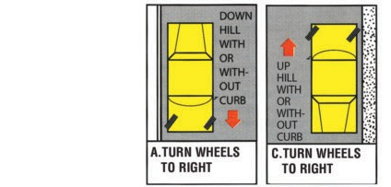

**B.TURN WHEELS TO RIGHT**

**A.TURN WHEELS TO RIGHT**

Make sure your car does not roll into traffic if the brakes do not hold when park- ing on a hill. Always set the hand brake. Shift to the PARK position if you have one. If not, shift to reverse or low gear. Always turn the front wheels towards the crub. This will maximize the amount of force required to make the vehicle roll free. That is, all four wheels will need to go over the crub before the vehicle is free.

Whether you park uphill or downhill turn the wheels to the right. This will ensure that the vehicle will roll away from traffic if something causes it to roll free.

### ANGLE PARKING

Keep safe clearance.

Drive forward into space—equal space on each side between lines.

### PARALLEL PARKING

STEP 1:

Signal, stop even with front car about 18 inches from it, rear bumpers even.

STEP 3:

When front bumper is even with other car’s back bumper, turn wheels sharply and rapidly to left as far as pos- sible. Back slowly to car behind without touching it.

STEP 2:

Back slowly, turning steering wheel sharp right until your car is at about 45- degree angle with the street. Quickly straighten front wheels and back slowly.

STEP 4:

Turn steering wheel sharply to the right and slowly pull forward. Center car in space.

Front and rear bumpers should not be closer than two feet from the other vehicles when in parked position unless the street is otherwise marked.

### PARKING RESTRICTIONS

Where angle parking is not clearly designated, a vehicle must be parked parallel to the curb, heading in the direction of traffic. When parallel parked, the vehicle’s curbside wheels shall be within 12 inches of the curb (30cm), or completely within the marked parking stall.

### TURN, STOP AND HAZARD WARNING SIGNALS

*Electric Signals.* Electric stop signals have been standard equipment on vehicles for more than 50 years and most vehicles manufactured since the early 1950s have been equipped with electric turn signals. Since 1968 all vehicles have been equipped with electric turn, stop, and hazard warning (4-way flash) signals. Most vehicles oper- ating today were originally completely equipped with electric signals.

*Advantages–Electric Signals*

* + - * Maybe be instantly operated from a closed vehicle.
      * Are readily visible in darkness or inclement weather.
      * Are visible from all angles except the immediate sides of the signaling vehicle.
      * Can seldom be misinterpreted or confused with other activities.
      * Allow the driver to use both hands to control the vehicle when signaling.

*Disadvantages–Electric Signals*

* + - * Failure to cancel the operation of a turn signal.
      * Failure of the signal to function properly.

Failure to cancel is usually caused by making a turn or lane change which is too small to cause operation of the self-cancelling mechanism and failure of the driver to observe the indicator on the instrument panel. Improper functioning of a turn signal should be readily apparent to the driver by observation of the indicator. Any abnormal function of the indicator lamp is a clue to improper operation of the signal system.

*Hand Signals.* Hand signals continue to be an accepted method by which the driv- er can indicate his intentions to other highway users. Knowledge of the proper hand signals is required if the electric signals fail.

*Advantages–Hand Signals*

* + - * Are usually not subject to failure.

*Disadvantages–Hand Signals*

* + - * Are difficult to distinguish from hand and arm motions which the driver does not intend as signals.
      * Are difficult to see in darkness and inclement weather.
      * Are not readily visible to drivers on the right of the signaling vehicle.
      * Require that the driver’s window be open.
      * Require the driver to use one hand to control the vehicle when signaling.

### HAZARD WARNING SIGNALS

Hazard warning signals (4-way flash) are intended to warn other drivers that a vehicle is in a hazardous position on the roadway. THIS SIGNAL SHOULD NEVER BE USED WHEN THE VEHICLE IS MOVING. Operation of this signal is shown by the flashing of all turn signal indicators. There is no hand signal designated for this purpose.

### STOP SIGNALS

Electric stop lamps are automatically operated when the service brake is used. At night the illumination of the stop lamps should be visible when you look to the rear of the vehicle while depressing the brake pedal. A hand signal may be used by the driver to indicate either braking or slowing of the vehicle.

### USE OF TURN SIGNALS

Turn signals are used to indicate your intent to other users of the highway. The use of a signal *does not* give you the *right* to make the intended movement. You alone are responsible for making the movement safely and in a manner that does not interfere with other highway users.

Traffic regulations require that you display a turn signal for at least 100 feet (30 meters) before making every turn or lane change. Always signal for a length of time sufficient to allow other highway users to see the signal and understand your intent.

If you must slow your vehicle before you can make the intended turn or lane change, it is important that you begin signaling before slowing your vehicle. This will alert other drivers to the possibility that you might reduce the speed of your vehicle.

Some common signaling errors are:

* + - * Failure to signal an intended turn when stopped at an intersection until the traf- fic signal changes.
      * Failure to signal, giving an insufficient signal, or signaling after the turn or lane change has been started. (Usually accompanied by abrupt turns or lane changes or forcing entry into a line of vehicles.)
      * Failure to signal for an intended right turn.
      * Failure to signal when in a lane that requires that you turn.
      * Failure to signal when it appears that there is no one to observe the signal.

Failure to use a turn signal properly is a frequent driver error. Failure to signal properly indicates driver ignorance, arrogance, or uncertainty and shows a lack of con- sideration and courtesy towards others. It may also indicate that the driver has no idea of what he is going to do next and is thus unable to indicate his intentions to anyone else.

THREE IMPORTANT RULES ABOUT TURN SIGNALS:

* + - * SIGNAL EVERY TIME YOU INTEND TO MAKE A TURN OR LANE CHANGE.
      * BEGIN SIGNALING WELL IN ADVANCE OF THE INTENDED TURN OR LANE CHANGE SO OTHERS HAVE TIME TO SEE AND UNDERSTAND WHAT YOU INTEND TO DO.
      * THE SIGNAL ONLY INDICATES YOUR INTENT; IT DOES NOT GIVE YOU THE RIGHT TO MAKE THE MOVEMENT.

The proper use of turn signals is an easily acquired good driving habit.

### TRAFFIC MIX

When driving, you must share the road with drivers of vehicles of all sizes; trucks, buses, passenger cars, motorcycles, bicycles and pedestrians. Larger vehicles afford more protection to occupants and are easier to see but are more difficult for the driv- er to operate. Small vehicles offer less protection to occupants and are less visible but

are more agile and easier to operate. When you drive you must recognize the capabil- ities and limitations of other vehicles as well as your own.

As a driver you should be very careful to look for smaller vehicles, especially motorcycles and bicycles, and insure that you can be seen by the driver of larger vehi- cles such as trucks and buses.

Give motorcyclists, bicyclists and pedestrians plenty of room on the road and use extra caution to look for them when making turns or changing lanes. A MOTOR- CYCLIST IS ENTITLED TO THE ENTIRE WIDTH OF HIS TRAFFIC LANE.

### SPECIAL DRIVING TECHNIQUES DRIVING IN INCLEMENT WEATHER

Hawaii does not experience the widely different kinds of weather that many other

areas do. Here weather problems associated with driving are primarily due to rain with some isolated fog on roads at high elevations and, occasionally, gusty winds.

*Rain.* Rain causes two basic driving problems; it reduces the driver’s visibility and changes the condition of the road surface.

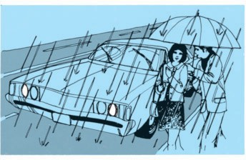

The first few drops of rain are a danger signal to a defensive driver. Roads are most slippery at this time because the oil dropped from passing cars has not been washed away. Driving on a road covered with oil and water can be like driving on ice. You should reduce speed, use extra caution, and allow at least twice the normal following distance. Prolonged or heavy rain will cause a layer of water on the surface of the road. At speeds up to 35 miles per hour (56 km/h), tires with good highway type tread will “wipe” the road surface the way a windshield wiper cleans the windshield. As speed increases, the water cannot be removed fast enough and the tires start to ride up on the

layer of water like a surfboard. This is called “hydroplaning”.

Partial hydroplaning may start at 35 miles per hour (56 km/h). The extent of hydroplaning increases with speed and with the amount of water on the highway. At 55 miles per hour (89 km/h) in a heavy rain the tires may lose all contact with the pavement. When this happens, you cannot brake, accelerate or turn; YOU HAVE NO CONTROL OVER YOUR VEHICLE.

To prevent hydroplaning you should:

* + - * Insure that the tires on the vehicle have good tread depth. Worn or bald tires will hydroplane at lower speeds.
      * Insure that the tires on the vehicle are inflated to the proper pressure. Under- inflated tires hydroplane at lower speeds.
      * Reduce the speed of the vehicle. Hydroplaning occurs most frequently at high- er speeds.

Brakes often become wet after driving through deep water or prolonged driving in heavy rain. They may pull to one side or the other, or they may not hold at all. Reduce speed and apply gentle pressure on the brake pedal until your brakes work properly again.

Rain reduces you ability to see clearly. Rain may be so heavy that you are unable to see clearly with the windshield wipers operating. When heavy rain reduces your visibility, reduce your speed; turn on your head lamps (low beam) so that others may see you. If the rain is so heavy that you are unable to see clearly, drive onto the road shoulder or other clear area and stop until the rain lets up.

Avoid driving through flooded areas; you may become stranded. Never drive through a flooded area where water over one foot deep (30 cm) is moving swiftly. The water will sweep your vehicle off the road.

*Fog.* In Hawaii fog almost never occurs at lower elevations. Fog may be encoun- tered on roads at higher elevations where low-lying clouds meet the ground surface. Patches of fog are particularly hazardous because you may encounter them suddenly without being aware of their presence.

It is best to avoid driving in fog but if you must, you should:*

* + - * Sharply reduce speed and turn on low beam head lamps. Never use the high beam because the reflection especially at night will reduce your ability to see and the light will reduce the approaching driver’s ability to see.
      * Be prepared for an emergency stop.
      * If you are unable to see at least two car lengths (40 feet or 12 meters), pull completely off the pavement and stop. Turn on the hazard warning signals.

*Winter Driving.* Winter creates additional driving hazards not encountered in Hawaii. If you plan to drive in other areas under winter conditions, the following sug- gestions will help. Unless you have experience, it is safest to avoid driving under these conditions.

* + - * Equip your car with snowtread tires.
      * Get the feel of the road. Start out slowly. Test the brakes gently after the vehi- cle is in motion.
      * Keep the car windows clear of snow, ice and frost.
      * Keep a safe distance from the car ahead. Watch for other vehicles that are hav- ing trouble with slippery road surfaces.
      * Drive at a reduced speed. Drive on the clear, dry portions of the road wherever possible.

*These precautions also apply when visibility is reduced for any reason; heavy rain, smoke, fog, heavy snow, etc.

* + - * Watch for danger spots. Ice may accumulate on or under bridges even when the rest of the road is clear. Snow and ice melt more slowly in shady areas. Watch for shiny spots in the road; they could be icy.
      * Use brakes very cautiously and intermittently if you must stop on packed snow or ice. If you lockup the wheels, you will lose control of your vehicle. Steer into a clear area if a collision seems imminent.

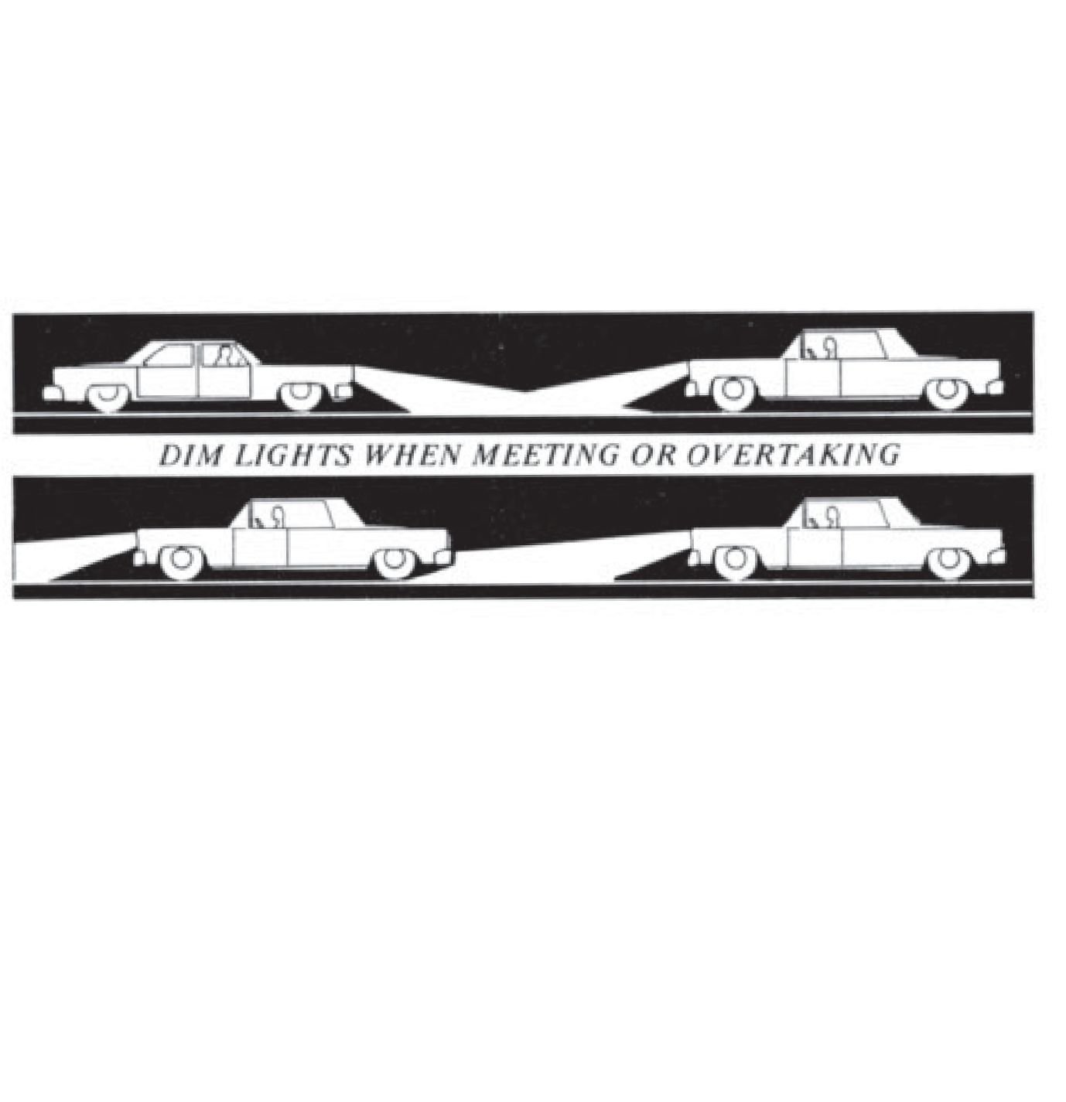*Dawn and Dusk Driving.* When driving towards the rising or setting sun, use sun visors and sun glasses. Insure that the windshield and windows of the vehicle are absolutely clean to reduce glare and improve vision.

For a short period before the sun rises and after the sun sets there is not enough light to see objects clearly. This condition is worse when the sky is cloudy. During this time of the day you should turn the head lamps on low beam so others can see you. Be alert for unlighted objects and pedestrians.

*Night Driving.* No one can see as well at night as they can in the daylight. In addi- tion, a driver’s exposure to alternate light and darkness prevents him from attaining his best seeing ability at night.

You should take the following precautions to insure safety when driving at night:

* + - * Protect your eyes from bright light for several hours before you drive.
      * Insure that the windshield and windows are thoroughly clean, inside and out.
      * Insure that all lamps on the vehicle are operating properly.
      * Reduce your speed so that you can stop within the distance you can see ahead.
      * Do not use your high beam head lamps when approaching or following other vehicles.
      * If the lights of an approaching vehicle are too bright, flash your high beams once and look at the right edge of the road and use lane markings or reflectors as a guide.
      * Recognize that red lane marking reflectors mean you are going the wrong direction in the traffic lane.

### FREEWAY DRIVING

Freeways are safe high-speed roadways. They are safe and efficient because there are no steep hills or sharp curves to restrict sight distance; there are no stop signs, no traffic signals, no railroad crossings, and no entrances or exits except at planned loca- tions. Driving on a freeway is different from driving on other highways. By adhering to the following special procedures and rules your trip on the freeway will be safer.

### PLAN YOUR TRIP

Use a Map

* + - * Plan exactly where you going to enter and leave the freeway.
      * Be sure that your vehicle is properly equipped with gasoline, oil, water and good tires. Service stations are located off the freeway.
      * A BREAKDOWN ON THE FREEWAY CAN CREATE AN EXTREMELY DANGEROUS SITUATION.

### ENTERING THE FREEWAY

* + - * Follow the signs directing you to the correct freeway entrance.
      * Observe traffic in the entrance lane. If it is congested, slow down or stop near the entrance (see illustration). DO NOT MOVE SLOWLY TO THE END OF THE ENTRANCE LANE AND STOP. It is very difficult and dangerous to attempt to enter freeway traffic when you are stopped at the end of the entrance lane.
      * When the entrance lane is clear, use your turn signal to indicate that you are going to merge into the freeway traffic lane; then increase the speed of your vehicle to match that of the freeway traffic.
      * Look to see if there are any oncoming vehicles in the freeway near lane. If not, move into the freeway near lane and maintain your speed. If there are oncoming vehicles, slow your vehicle slightly and move in behind the oncoming vehicle.

### DRIVING ON THE FREEWAY

* + - * Be attentive to all signs.
      * Through traffic should use the left or center lanes and move at or near the post- ed speed limit.
      * The right lane is used by vehicles that are unable to keep up with the through traffic.
      * The right lane should remain open for traffic entering and leaving the freeway as much as possible.
      * If you are in the right lane, allow space for entering vehicles.
      * Avoid lane changes.
      * Signal well in advance of any intended lane changes.
      * Use your rear-view mirrors.
      * 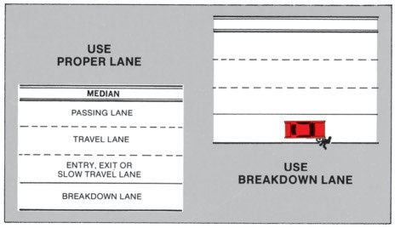Look back before changing lanes.
      * NEVER STOP ON THE FREEWAY UNLESS IT IS ABSOLUTELY UNAVOIDABLE.
      * Do not slow down unnecessarily.
      * Do not follow too closely. Rear end collisions are common on freeways and usually involve several vehicles.
      * Never cross the center divider of a freeway; never turn around on a freeway; never back up on a freeway.
      * If for any reason you must proceed in the opposite direction, go to the next exit, leave the freeway and re-enter in the opposite direction.

### EMERGENCY STOPS

* + - * Try to get off the freeway at the next exit if you can.
      * If you must stop, drive entirely off the roadway as far away from traffic as possible.
      * Never stand or walk on the freeway.
      * Do not stop to assist other drivers in trouble but report the situation to the proper authorities.

### LEAVING THE FREEWAY

* + - * Watch the exit signs so you can choose the proper exit.
      * Use your turn signal to indicate your intention to exit.
      * Move into the exit lane.
      * Maintain your speed until you are completely into the exit ramp, then slow down smoothly.
      * If you pass the place where you intended to exit, DO NOT STOP; DO NOT BACK UP! Continue on to the next exit.

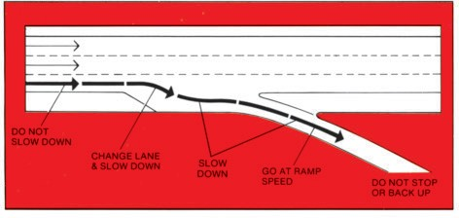

### EMERGENCY DRIVING PROCEDURES

Obviously a procedure cannot be given for every possible kind of driving emer- gency. Some of the more common driving emergency procedures will be covered in the following paragraphs. The basic factors involved in all driving emergencies involve the use of brakes, steering and power. Remember these basic points:

* + - * Try not to panic.
      * Avoid slamming on the brakes and sliding the wheels. You cannot control a vehicle when the wheels are sliding.
      * Try to steer into a less dangerous location. Apply maximum braking without sliding the wheels. If any wheel slides, release the brakes and reapply them when the vehicle is no longer sliding or skidding.
      * Wear your safety belts so you can remain in a position to control your vehicle.
      * Continue to try to control your vehicle even after striking another object.

### TIRE BLOWOUTS

A tire blowout is the sudden release of air from a tire resulting in its collapse, and can cause you to lose control of the vehicle. Tire blowouts are most often the result of improper tire care and maintenance.

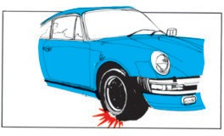

If you experience a tire blowout on your vehicle:

* + - * DO NOT APPLY THE BRAKES. This may cause your vehicle to become uncontrollable.
      * Grip the steering wheel firmly and steer to remain in your traffic lane. (There may be a strong pull to the right or the left, or the pull may be in one direction and then the other.)
      * Reduce speed gradually without using the brakes until you are moving very slowly, then
      * Apply the brakes lightly and pull off the road into a safe area. (You can drive for some distance with a blown out tire at a very slow speed without causing damage to the wheel rim.)

### LOSS OF WHEEL

This is a rather uncommon emergency but if it should occur, use the same correc- tive procedure as for a tire blowout. A total or partial brake failure is likely when a wheel is lost. Once stopped, you will be unable to move the vehicle; it must be towed.

### BRAKE FAILURE

Total brake failure is very unlikely on modern passenger cars. The service brake system is constructed so that partial braking is almost always possible. A partial fail- ure will result in reduced braking ability and will be indicated by a warning light on the instrument panel.

If your brakes fail completely:

* + - * Pump the brake pedal quickly; then
      * Shift to a lower gear.
      * Look for an escape route (a side road or a flat open area). Use lights and horn to warn others.
      * Apply the parking brake gradually and bring your vehicle to a stop. (Do not apply the parking brake rapidly or with a great force or you may lose control of your vehicle.)

### STEERING FAILURE

Complete steering failure is rather uncommon and almost never occurs on a prop- erly maintained vehicle. If your vehicle is equipped with power steering, a partial loss of steering control may occur. In this case you will have to exert greater effort on the steering wheel to control the direction of the vehicle.

DO NOT GIVE UP, APPLY WHATEVER FORCE IS NECESSARY TO THE STEERING WHEEL TO CONTROL YOUR VEHICLE.

If the steering fails completely:

* + - * Slowly reduce speed.
      * Apply brakes as necessary to avoid striking any object and try to stop as smoothly as possible.

### WHEELS OFF PAVEMENT

If your vehicle should slip off the edge of the road, loose gravel, dirt or the edge of the pavement may tend to keep the vehicle from returning to the paved surface smoothly. If this happens:

* + - * DO NOT ATTEMPT TO FORCE THE VEHICLE BACK ONTO THE PAVEMENT BY JERKING THE STEERING WHEEL.
      * Continue to drive with the wheels off the pavement and reduce speed.
      * Use the brakes gently.
      * When at a safe speed, turn the steering wheel to return to the pavement. Be pre- pared to make an immediate adjustment to remain in your traffic lane.

### OVERTAKING VEHICLE IN DANGER

If another vehicle is attempting to overtake and pass you but cannot complete pass- ing because of oncoming traffic, you can help avoid a collision by:

* + - * Steering your vehicle as far to the right as you can with safety, even onto the shoulder if possible.
      * If the passing vehicle continues to attempt to pass, slowing your vehicle so the passing vehicle may move into the lane ahead of you.
      * If the passing vehicle appears to be slowing in an attempt to return to the lane behind your vehicle, accelerate your vehicle to allow the passing vehicle to return to the lane in the rear of your vehicle. (In either case be certain of the intentions of the driver of the passing vehicle before you change the speed of your vehicle.)

### ONCOMING VEHICLE IN YOUR LANE

If you observe an oncoming vehicle in your traffic lane:

* + - * Flash your lights and honk the horn.
      * Quickly slow your vehicle and steer to the right out of the lane into any avail- able clear area. DO NOT ENTER THE ONCOMING TRAFFIC LANE.
      * Drive off the road if necessary. Avoid solid objects and pedestrians.

### ACCELERATOR STUCK OPEN

If your vehicle’s accelerator sticks open, your vehicle will continue to maintain speed or accelerate even though you remove your foot from the accelerator pedal. Quite frequently this situation develops immediately after the pedal has been fully

depressed. This causes the vehicle to continue to accelerate rapidly. In any case you should:

* + - * Slap the accelerator pedal hard with your foot.
      * Turn the ignition off. (Use care to move the ignition switch only far enough to stop the engine and not engage the steering wheel locking mechanism. Vehicles equipped with power steering and power brakes will require increased effort on these controls.)
      * Apply the brakes.
      * Pull off the roadway into a safe area.

### POWER STEERING FAILURE

This situation usually occurs in combination with engine failure or loss of the belt driving the power unit. In any case additional effort will be required to maintain steer- ing control.

* + - * Reduce speed.
      * Drive to a safe area and stop.

### SKIDS

Most skidding is caused by making sudden changes in direction or speed. Excessive speed for existing road and traffic conditions is the most common cause. Extra care should be used when driving on wet, slippery or gravel-covered road surfaces.

If your vehicle begins to skid, it is important to take immediate smooth corrective action before you lose control. Unless you have experienced a skid in a vehicle, prop- er corrective action may seem unnatural. It is important to remember that when you encounter a skid or control problem, you should stop or reduce whatever it was that you were doing when the problem started. To steer out of a skid:

* + - * Avoid using the brakes. If the skid started when you applied the brakes, release the brakes.
      * Ease off the accelerator. The skid may stop as soon as you do this.
      * Turn the steering wheel in the direction that the rear of the vehicle is skidding. Turn the steering wheel firmly but do not make a large sudden turn of the wheel. If skidding to the right, turn the wheel to the right. Turn left for a skid to the left. As the skid stops, turn the steering to the straight ahead position.
      * Overcorrecting may cause the vehicle to skid in the opposite direction. Steer gently into the skid again. Repeat this procedure until you have the vehicle under control.

### FIRE

Fire may occur in any part of the vehicle where there is combustible material. Usually fires occur as the result of an overheated engine, an electrical short, a fuel leak, or an oil leak. Any burning odor should be immediately investigated. If fire occurs or is suspected in the vehicle:

* + - * Drive to a safe area clear of traffic and stop.
      * Turn the ignition switch and all other electrical switches off.
      * Get all occupants out of and away from the vehicle and clear off the roadway. Poisonous fumes may rapidly fill the vehicle.
      * If the fire is small, use a fire extinguisher, dirt, sand or a blanket to smother the fire. DO NOT USE WATER ON GASOLINE, OIL, OR ELECTRICAL FIRES.
      * If a large gasoline or oil fire develops, you might not be able to extinguish it. Don’t try, seek assistance.

### BREAKDOWNS OR ENGINE FAILURE

Fortunately the occurrence of most vehicle breakdowns are not dangerous but may create a hazardous situation. Often the vehicle stalls in a hazardous position in rela- tion to other traffic.

* + - * If possible, move the vehicle to a safe location.
      * Keep vehicle occupants away from traffic. If the vehicle cannot be moved from a hazardous position but there is a safe location that can be reached by the vehi- cle occupants, move the occupants to the safe location.
      * In all other cases, occupants should remain in the vehicle.
      * Use hazard warning lights, flares, warning reflectors and a flashlight as required. These items should always be carried in your vehicle.
      * Be cautious about those that offer help. Remain locked in the vehicle until you are sure of the person’s intentions. If in doubt, ask that the police be notified.
      * Indicate the need for assistance by raising the hood of your vehicle. Tie a white cloth to the radio antenna or the door handle or use a sign made for the purpose if available.
      * If you must leave your vehicle, lock it securely and return as soon as practicable.
      * If you must walk along the highway, walk facing traffic and well clear of the roadway. Do not walk on freeways; stay with your vehicle until help arrives.

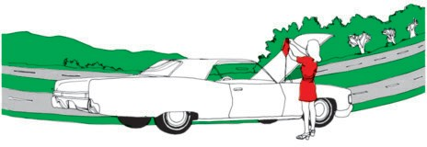

### CHAPTER XI

**TRUCKS, TRAILERS, BUSES AND MOTORCYCLES**

When you are driving on the streets and highways, you will have to share the road with vehicles that are much larger than ordinary passenger cars and light trucks. The operation of these trucks, tractor-semitrailers, truck trailers and buses requires special driving skill, attentiveness and consideration for other highway users. To insure your safety you and other highway users must also be aware of the limitations of these vehicles.

### DRIVERS OF LARGE VEHICLES

*Driver Licenses*

Drivers of large vehicles must hold a valid driver’s license for the category of vehi- cle being driven. Information concerning all types of driver licenses may be found in Chapter I, Licensing of Drivers.

*Professional Drivers*

Many, if not most drivers of large vehicles, earn their living by operating these vehicles; it is their profession. Because they spend much more time driving than other drivers, they should be the most skilled, knowledgeable and experienced drivers on the highways. They should demonstrate the mark of the true professional by setting the example of proper, safe driving. Also, they are exposed to the hazards of driving for much greater periods of time than ordinary drivers.

*Driver Responsibilities*

Due to their large size and heavy weight these vehicles can cause great damage and injury when involved in an accident. The drivers of these vehicles must be constantly aware of the limitations and potential of their vehicles and recognize their responsi- bility to give proper consideration to other highway users as well as to their passen- gers and cargo.

### LIMITATIONS OF LARGE VEHICLES

*Visibility*

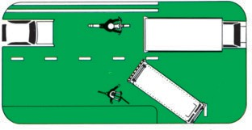Larger vehicles generally provide better forward visibility than other vehicles because the driver’s position is above most other vehicles. However, visibility to the sides and rear is severely limited; other traffic can only be seen by the use of mirrors and the area to the immediate rear of the vehicle is not visible to the driver.

* + - * Drivers of large vehicles must make allowances for the greater width and length of their vehicles when turning, changing lanes or backing.
      * Other drivers and highway users should allow the large vehicle driver addi- tional space to make the maneuvers safely.

*Maneuvering Space*

Large vehicles require more space for turning movements.

* + - * Drivers of large vehicles should use great caution when turning or backing to insure that the movement can be made without interference with other highway users.
      * When near large vehicles, the drivers of other vehicles and other highway users should remain in a location where they can be seen by the driver of the large vehicle and where their view of other traffic is not blocked.

*Stopping Distance*

Large vehicles require greater stopping distances than other vehicles.

* + - * Drivers of large vehicles must make allowances for the additional distance required to stop.
      * When changing lanes or at intersections other drivers and highway users must make allowances for the increased stopping distance required by the large vehicles.

*Acceleration and Agility*

Large vehicles accelerate very slowly and cannot make maneuvers as quickly as other vehicles.

* + - * Drivers of large vehicles should make allowances for the free movement of other vehicles when in traffic and avoid blocking several traffic lanes.
      * Drivers must be aware that large vehicles may be travelling at a speed less than the posted speed limit and should use caution when approaching or passing.

*Downgrade Speed Control*

The continuous application of brakes to control speed on downgrades will cause the brakes to become ineffective. This condition is more dangerous with large vehicles.

* + - * Drivers of large vehicles should use an appropriate lower gear to control speed on downgrades. Use the brakes only when stopping the vehicle.
      * The drivers of other vehicles should be alert to overtaking large vehicles; move out of their way.

*Slipstream*

Large vehicles moving at or near maximum speeds cause wind gusts with a force great enough to cause direction changes in smaller vehicles. Drivers of smaller vehi- cles should be prepared to take proper corrective steering action when approaching or passing large vehicles that are moving at or near maximum speeds.

### HAZARDOUS MATERIALS

Many times large trucks carry material that is dangerous to persons or property. This material may be explosive, flammable, radioactive, poisonous, etc. Drivers of these vehicles are responsible for insuring that these materials are properly packaged and marked and that the vehicle is marked to indicate the type of material carried so that proper protective action can be taken in case of an accident.

### EMERGENCY EQUIPMENT

Most large vehicles are required to carry emergency equipment such as fire extin- guishers, flares, emergency reflectors, first aid kits, etc. Drivers of these vehicles must know what equipment is required and how and when to use it.

### TOWING TRAILERS

Many passenger car and small truck drivers tow trailers of various types with their vehicles. You will find that many of the limitations that apply to large vehicles also apply when you are towing a trailer; particularly large trailers.

*Rear-View Mirrors*

If your trailer is large enough to obstruct your view through your inside rear-view mirror, you must have outside rear-view mirrors of proper size on both sides of your car.

*Brakes*

If your loaded trailer weighs more than half the weight of the towing vehicle or is 3,000 pounds or more, the trailer must be equipped with brakes, and breakaway pro- tection.

*Passengers*

You should not permit passengers to ride in trailers. Riding in house trailers is pro- hibited.

*Safety Chains*

Your trailer must be equipped with safety chains. Safety chains must be attached to the frame of the towing vehicle and the trailer and not connected to a part of the trailer hitch.

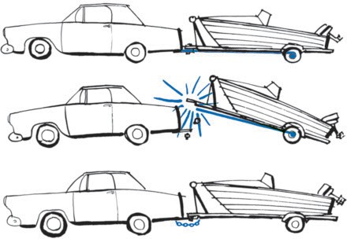

*Trailer Hitches*

Insure that your vehicle is equipped with a proper hitch for the size and type of trailer being towed. Large trailers require special hitches. Don’t rely on bumper hitch- es for any trailer.

*Trailer Load*

Insure that the trailer load is properly balanced. About 10% to 15% of the trailer weight should be on the vehicle’s trailer hitch. If the weight is too great, you will have difficulty steering the vehicle. If the weight is too small, the trailer will “fishtail.” Don’t overload the trailer.

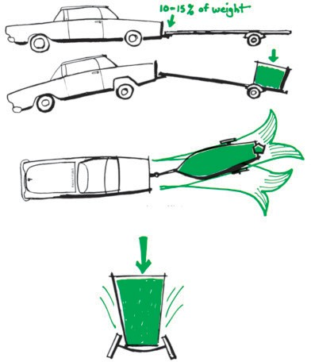

Insufficient weight on hitch causes a trailer to “fishtail.”

Do not overload trailer.

Be sure that the load is held securely in place.

*Equipment*

Insure that the trailer has:

* + - * Wheels properly mounted and lubricated, and covered with fenders or mud guards.
      * Good tires properly inflated.
      * Tail, stop, turn signal, license plate, and, if required, side marker lamps and reflectors.

### MOTORISTS AND MOTORCYCLES IN TRAFFIC

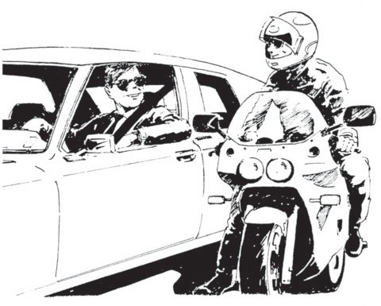

**SHARING THE ROAD WITH MOTORCYCLES**

Today’s motorcycle riders are friends, relatives, and neighbors, but many car driv- ers still have not adjusted to motorcycles appearing in traffic. Travelling by motorcy- cle is appealing to some people; they are fuel and space efficient and can be just plain fun to ride. But there is a flip side: motorcyclists are more vulnerable to injury than a car driver if involved in an accident. Research shows that over two-thirds of the car/motorcycle accidents are the result of a car driver turning in front of the motorcy- clist. Motorcycles and cars need to mix in traffic without causing harm to each other. To do so, we need to understand more about motorcycles, and why riders do some of the things they do.

### SIZE

Motorcycles present a narrow silhouette and are usually much shorter in length than an automobile. The small profile of the motorcycle may make it appear farther away and travelling slower than it actually is. Because it is difficult to judge the motor- cycle’s distance and speed, car drivers need to take a second look, and then a third. Its small size also makes it more difficult to spot in traffic than another car. Some motor- cycles take advantage of their small size and maneuverability. They may cut between cars and put themselves in places where drivers cannot see them. Be alert for a motor- cycle to appear unexpectedly.

MAKE SURE YOU SEE THE MOTORCYCLE AND KNOW ITS SPEED BEFORE YOU START TO TURN OR ENTER AN INTERSECTION.

### LANE POSITION

Because of a motorcycle’s size, its position within a lane of traffic will change as traffic conditions change. The motorcyclist will position himself in the lane to see and be seen. Often, this means riding in the left portion of the traffic lane to allow a bet- ter view of some traffic and road situations. It also makes the motorcycle more visi- ble to other traffic. However, as traffic and road conditions change, the rider may move. This move could be

to the center of the lane or even to the right side to avoid traffic or to be seen by others on the road.

Most drivers take for granted the ability of their automobile to handle minor road hazards such as potholes or railroad tracks. Minor problems for the four-wheeled vehicle can be major problems for motorcycles. The cyclist will change position with- in the lane to increase the

distance from potential hazards. These lateral movements sometimes occur suddenly. Motorists need to be alert for these sudden changes in position and direction, and drive accordingly. Respect the vehicle space of a motorcycle and its position in traffic. Motorcycles are allowed the full width of a lane in which to maneuver. Refrain from sharing a lane with a motorcyclist. It restricts the rider’s ability to avoid hazardous sit- uations.

### INTERSECTIONS

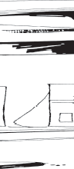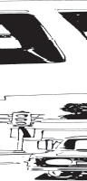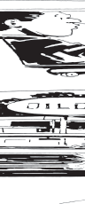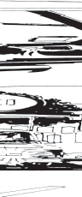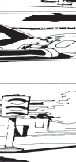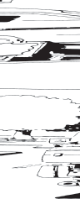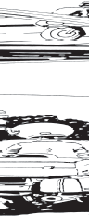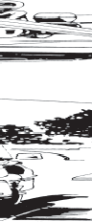

**Intersections are the most likely places for car/motorcycle collisions to occur.** As stated earlier, this usually is the result of a car driver NOT SEEING the motorcycle and turning into the motorcycle’s path. Misinterpreting a rider’s intentions can also lead to problems. A cyclist will change lane position to prepare for upcoming traffic conditions. The rider will move to one side of the lane in preparation for a turn or pos- sibly to move away from a hazard unseen by other motorists. Do not assume the rider’s intention until the maneuver is unmistakably started, such as a turn into an intersection or driveway. Also, turn signals do not automatically shut off on a motor- cycle and riders occasionally forget to cancel them after a turn is completed. Make sure you know what the rider is going to do before you move into the motorcycle’s path.

### FOLLOWING DISTANCE

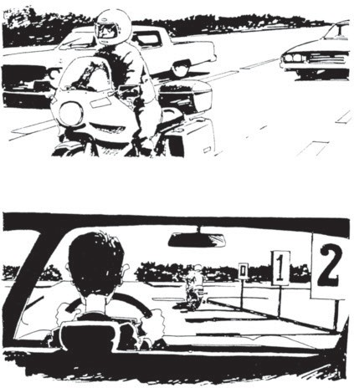

When driving behind a motorcycle, allow at least a 2-second following distance. This provides the cyclist enough room to maneuver or stop in an emergency. Due to its vulnerable nature and the difficulty motorists have in judging a motorcycle’s speed and distance, space between the two vehicles should be increased to avoid sudden braking. Both riders and drivers are more likely to make incorrect decisions if there is not enough stopping distance or ability to see and react to conditions. This leads to accidents. A rider’s chance of injury is greater if forced to avoid obstacles ahead, as well as a driver following too closely.

### PASSING AND BEING PASSED

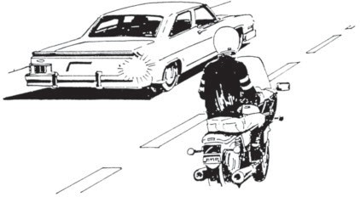

The rules for passing other vehicles are similar for motorcycles. The motorist being overtaken by a cycle should maintain lane position and speed. Allow the cyclist to complete the pass and assume proper lane position as quickly as possible. When passing a motorcycle, allow a full lane to the motorcycle. Never crowd into the same lane as the cycle. Returning to the original lane too soon can force a rider to swerve to the right into traffic or off the road.

### OPERATOR’S LICENSE

Motorcycles are different to operate than an automobile; they require special knowledge and skills. It only makes sense that a motorcycle operator license be required. Most states now have a separate knowledge and skill test that must be com- pleted for motorcycle operation. Passing both tests qualifies the rider for a license allowing motorcycle operation. Also, motorcycles must be registered and insured to the same standards as an automobile.

What all this means is, motorcycles are a full partner in the traffic mix and must be treated with the same courtesies. Watch for the unexpected and give them their share of the road; a rider may be the neighbor next door.

### CHAPTER XII PEDESTRIAN SAFETY

**SUMMARY OF FACTS**

* + - * In Hawaii 20% of all traffic fatalities are pedestrians.
      * Most of those killed are non-drivers.
      * Almost half of those fatally injured are under age 15 or over age 65.
      * Almost 90% of the fatal accidents occur in the roadway; over 50% while cross- ing the roadway.
      * Only slightly more than 10% of the fatalities occur off the roadway.

Upon reviewing this summary it is obvious that the roadway is the domain of the motor vehicle. A pedestrian entering the roadway has no physical protection against the motor vehicle. His safety depends entirely upon his and the driver’s alertness and actions.

The summary also shows that accidents happen most often to the young and the elderly. Children are quick and see well but they are not familiar with traffic and underestimate the danger and destructive force of a motor vehicle. Older persons are often handicapped by poor vision, slow reaction time, the inability to move fast, and are more easily injured or killed.

To reduce or eliminate your chances of becoming involved in Hawaii’s pedestrian accident statistics, put the following rules into practice when you DRIVE and when you WALK:

*Your Responsibility as a DRIVER*

* + - * Slow down and be prepared to stop whenever you see persons walking on or crossing the roadway and whenever you observe children near the roadway. Sound your horn, as necessary, to give warning to any pedestrian upon a road- way. (Required by law)
      * Stop for all blind persons in the roadway (identified by a white cane or guide dog) regardless of the traffic signal indication or traffic situation.
      * Never drive through a pedestrian safety zone. (Prohibited by law)
      * Never pass a vehicle stopped to allow a pedestrian to cross the street. (Prohibited by law)
      * Be especially watchful for children near schools, parks, playgrounds and in res- idential areas. Stop upon the signal of any school crossing guard.
      * Watch for pedestrians when turning at intersections and when entering or leav- ing driveways. (Required by law)
      * Look for approaching vehicles before you or your passengers alight from your vehicle. Get out of your vehicle on the side away from traffic whenever possible.

*Your Responsibility as a Pedestrian*

* + - * Cross only at crosswalks. Jaywalking is illegal.
      * Obey all traffic laws and signals. (Required by law)
      * Watch for cars at all times when you are walking in the roadway. Don’t assume that the lines on the pavement or the traffic signals guarantee your safety.
      * Never start across the street on a green light that has been showing for some time. Wait for the green signal on the next cycle.
      * Never enter the street or crosswalk when there are vehicles approaching close by. They may not be able to stop. (Prohibited by law)
      * Look for turning vehicles before crossing the street.
      * Never run alongside of or across a street.
      * Walk on the left side of the street facing oncoming traffic.
      * Do not walk or stand upon the travelled portion of the roadway to solicit for any reason or to guard a vehicle or parking place. (Prohibited by law)
      * Wear bright colored clothing when walking on or alongside the roadway.
      * Do not walk on or near the road if you are under the influence of alcohol or drugs.
      * Insure that your children do not play in the street.

### STOPPING FOR A SCHOOL BUS

Whenever a school bus is stopped on a highway with alternating red signal lamps flashing, the driver of any motor vehicle on the same highway in the lane occupied by the school bus and all lanes adjacent to the lane occupied by the school bus shall stop the driver’s vehicle before reaching the school bus and shall not proceed until the school bus resumes motion or the flashing red signal lamps are turned off.

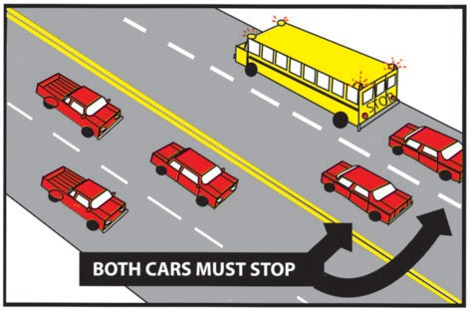

However, vehicles proceeding in the opposite direction on a divided highway are not required to stop. A divided highway is two roadways separated by a strip of land or other space not intended for vehicular travel.

Motorists travelling at the time school buses make their runs should be on the alert. The presence of school children waiting along the roadway in the morning indicates a school bus is in the area. In addition, there is a possibility of waiting children dart- ing in front of traffic.

### CHAPTER XIII BICYCLES

**MOTORISTS**

As our roads and highways become more crowded, it is increasingly important to safely share the road with bicyclists. Bicycles are legally considered vehicles, and as such have all of the rights and responsibilities that other vehicles have. However, motorists should be extra alert for bicyclists because they are often not as easy to see as other vehicles. In addition they may ride unpredictably, or not have the knowledge or skills to ride in traffic. You will see a wide range of riding ability among bicyclists. Drivers should be alert for the following:

* + - * Bicyclists swerving into the travel lane. Although bicyclists are required to ride as near to the right-hand edge of the roadway as practicable, there are exceptions when the bicyclist moves into the lane. These include preparing to make a left turn, pass- ing another bicycle or avoiding an obstacle in the edge of the road. Bicyclists may legally ride on the left-hand edge of a one-way road.
      * Bicyclists riding the wrong way. Although it is illegal to ride against traffic, many inexperienced bicyclists ride this way at times. This behavior leads to approximately 25% of all bicycle-car crashes. Drivers should be on the lookout for this behavior especially when turning.
      * Exercise care when passing a bicyclist. Motorists should maintain at least 3 feet of space between the bicyclist and their vehicle until they have safely passed. Also, the bicyclist may be moving faster than you think. A significant number of crashes occur when a motorist passes a bicyclist, and immediately slows down and turns right, without leaving enough space for the bicyclist.
      * Remain clear of bike lanes, especially when making a right turn at an intersection. Look for and yield to bicyclists when crossing bike lanes. If you plan to make an immediate right turn, it is better not to pass the bicyclist. Train yourself to look for overtaking bicyclists every time you make a right turn even when you think there is no bicyclist around.
      * Look before you open your car door. It is a traffic violation to open a car door unex- pectedly so as to create a hazard for moving traffic, including bicyclists.
      * Treat bicyclists with aloha. Each bicycle on the road means one less car on the road, that much less pollution and potentially one more open parking space at your desti- nation.

**BICYCLISTS**

Like motorists, bicyclists are required to obey all traffic signs, signals and other traffic reg- ulations. It is the law, but it also goes a long way in gaining respect for bicyclists and show- ing that they belong on the road. In addition bicyclists should be aware of the following:

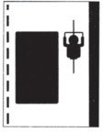**Traffic Regulations**

* + - * Always ride with traffic, even if you are riding a short distance. Motorists are not looking for fast moving bicyclists coming from the “wrong” direction. When making a right turn, it is not un- common both for motorists and bicyclists to be so preoccupied with searching for traffic coming from the left that they forget to check for pedestrians coming from their right.
      * When travelling slower than the normal speed of traffic, ride as close to the right edge as practicable. On one-way roads, it is legal to ride on the left edge.
      * Bicyclists may move into the travelway when making a left turn, avoiding hazards in the roadway, moving the same speed as traffic or if it is too narrow for a bicycle and motor vehicle to safely share a lane.
      * 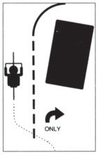On the roadway, bicyclists must ride single file. They may ride two abreast on a bicy- cle lane or path if it is wide enough not to impede traffic.
      * Obey all traffic signs and signals. Bicyclists caught vio- lating traffic laws are subject to the same penalties as drivers.
      * Follow lane markings. Move out of a right-turn-only lane if you are going straight through.
      * If you ride at night you must have a headlight and rear reflector. A rear light and pedal reflectors are recom- mended, as well as light-colored clothing.
      * Don’t carry passengers unless the bicycle is equipped to do so.
      * Bicycles are not allowed to ride on the sidewalk in busi- ness districts. In other areas, bicyclists may ride on the sidewalks provided they stay at 10 MPH or less and always yield the right-of-way to pedestrians.

**Safety Tips**

* + - * Wear a bicycle helmet every time you ride. Although you may not be legally required to wear a helmet, it is a good idea. You don’t have to be going fast or far to risk seri- ous head injuries.
      * Be predictable. Don’t do anything that would surprise drivers, such as swerve in and out of parked cars or traffic.
      * Look behind you, and make sure it is clear, before making a left turn or moving into the travelway. Also, let motorists know what you are doing by using proper hand sig- nals for turning and stopping.
      * Don’t ride too close to parked cars. Leave at least 3 feet so that if the driver suddenly opens the door you won’t be hit. Also be alert for cars that may be pulling out into the road.
      * Don’t wear headphones when riding. You need to hear the traffic around you and be alert to what is going on. This includes watching the road for potholes, broken pave- ment and slippery surfaces.
      * Make sure your bicycle is safe. Before you ride make sure the brakes work, the seat and handlebars are tight and the tires are properly inflated and in good shape.
      * Be visible. Wear bright-colored clothes when you ride. Do not assume that drivers see you, even if you make eye contact. Elicit a response from the driver, so you are sure that you are seen.
      * Choose the best way to turn left. Experienced bicyclists will make a left turn like a motor vehicle: signal, move into the center of the lane turning left when it is safe to do so and complete the turn. Others may opt to cross like a pedestrian: ride to the crosswalk, walk their bicycle across the intersection, continue riding from there.
      * Don’t pass vehicles on the right. Drivers may not expect or see you when you ride pass them on the right. When stopped in traffic, it is safer and more courteous to take your place in line.

**GENERAL DRIVING TEST QUESTIONS**

Ref. Pg.

## 15

**16**

**16**

**17**

**15**

**20**

**18**

### GENERAL TEST QUESTIONS

1. When you take a road test for a driver’s license:
   1. You must provide the vehicle.
   2. The vehicle must be in safe operating condition free of safe- ty defects.
   3. You must be accompanied to the testing station by a licensed driver.
   4. All of the above.
2. When you change your address you must notify the County Examiner of drivers:
   1. In writing, within 30 days.
   2. In writing, within 10 days.
   3. In person, within 10 days.
   4. By telephone, within 30 days.
3. When you change your name you must notify the County Examiner of drivers in person with proof of the change within:
   1. 60 days.
   2. 20 days.
   3. 10 days.
   4. 30 days.
4. When driving a vehicle upon any public street or highway you must:
   1. Show your driver’s license upon demand.
   2. Carry your license with you.
   3. Have a valid driver’s license.
   4. All of the above.
   5. When your driver’s license expires you may:
      1. Drive during the grace period of 90 days.
      2. Drive as long as you are accompanied by a licensed driver.
      3. You may not drive but you may renew your driver’s license within a year after the expiration following normal license renewal steps.
      4. Drive to and from work only.
   6. All head lamps on your vehicle must work properly and be cor- rectly adjusted:
      1. When driving in city traffic.
      2. At all times.
      3. When driving on freeways.
      4. When approaching other vehicles.
   7. Which of the following equipment may you have installed on your private vehicle?
      1. A red light showing the front, or a blue light visible outside of the vehicle.
      2. A bell, exhaust whistle or siren.
      3. A muffler cut-out or by pass if used only on country roads.
      4. None of the above.

Ref. Pg.

## 19

**19**

**20**

**21**

**21**

**24**

**24**

* 1. A copy of the vehicle inspection certificate:
     1. Should be kept in the vehicle.
     2. Filed with your State income tax return.
     3. Be kept in a safe place in the home
     4. Will be sent to you by the County Department of Finance.
  2. The mechanical condition of the vehicle is the responsibility of:
     1. The legal owner of the vehicle.
     2. The garage mechanic.
     3. The vehicle driver and registered owner of the vehicle.
     4. The insurance company.
  3. A leaky exhaust system in your vehicle is dangerous because it can cause:
     1. A loss of hearing.
     2. Pollution.
     3. Carbon monoxide poisoning.
     4. Poor engine performance.
  4. The agencies responsible for *Vehicle* Registration and Licensing are:
     1. The County Police Departments.
     2. The County Departments of Public Works.
     3. The State Department of Transportation.
     4. The different county agencies.
  5. When you as a registered owner of a vehicle change your address from that shown on the registration certificate you:
     1. Must notify the County Department of Finance when renew- ing the license.
     2. Must notify the County Department of Finance within 30 days after the change.
     3. Must make the change only when selling or trading the car.
     4. Do not have to do anything.
  6. The most important thing in any driving situation is:
     1. The vehicle.
     2. The environment (the highway and traffic).
     3. The driver (you).
     4. The time of day.
  7. The boss chews you out just before quitting time. You don’t say much, but you think he is unfair and you are angry! When you get to your car you should:
     1. Play the radio loud so you won’t think about it.
     2. Drive fast on the Interstate so you can let off steam.
     3. Take a few minutes to cool off before you drive home.
     4. Stop in at your favorite bar and have a few drinks before driving home.

Ref. Pg.

## 25

**25**

**26**

**24**

**26**

**26**

**26**

* 1. As a driver, you may be challenged by other drivers to demon- strate your driving capabilities and your vehicle’s capabilities on the highway. You should:
     1. Resist the desire to exhibit and compete.
     2. Decline all challenges to prove you or your vehicle’s capa- bilities.
     3. Take on only those challenges which you know you can *safely*

win.

* + 1. Both 1 and 2 above.
  1. To insure that your physical condition does not cause you to drive in an unsafe manner you should:
     1. Keep physically fit and have regular physical examinations.
     2. Know the effect of any medicine on your driving ability.
     3. Drive within your physical limitations.
     4. All of the above.
  2. A police officer directing traffic directs you to go through a red light, what should you do?
     1. Stop, and then go. 3. Go on as directed.
     2. Wait for the green light. 4. Make a right turn.
  3. Which of the following influences your driving actions most?
     1. Your height. 3. Your attitude towards driving.
     2. Your age. 4. Your reaction time.
  4. Traffic signs and pavement markings must be:
     1. Always obeyed.
     2. Used as a guide only.
     3. Followed only when there is other traffic.
     4. Followed only when a police officer is present.
  5. You are driving on a narrow road and you meet an oncoming vehicle. You must:
     1. Pull completely off the road and stop.
     2. Allow the on-coming vehicle at least one-half of the main travelled portion of the road.
     3. Make the other vehicle pull over as you were there first.
     4. Turn on your headlights to make sure the other vehicle sees you.
  6. You are passing a car when you see the sign on the picture. You should:
     1. Speed up and finish passing as soon as you can.
     2. Pass on the right.
     3. Drop back and pass after the intersection if it’s safe.
     4. Stay beside the car until passing the intersection.

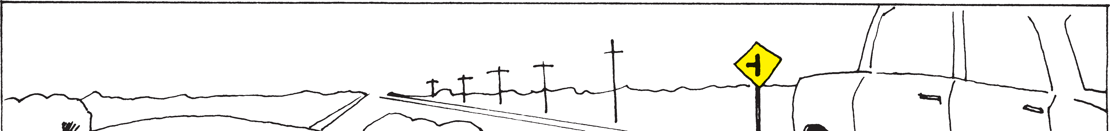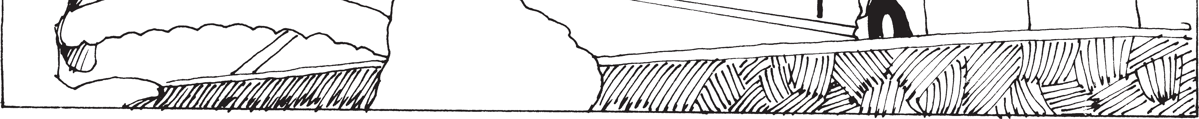

Ref. Pg.

## 29

**68**

**27**

**27**

**28**

**29**

**29**

* 1. You are following the slow moving vehicle in the picture on a two lane road. You may:
     1. Not pass the vehicle.
     2. Pass on the left if no traffic is coming.
     3. Pass on the right using the paved shoulder.
     4. None of the above.
  2. You are driving on a street marked for one-way traffic. You may pass the vehicle in the picture:
     1. On the left only.
     2. On the right only.
     3. On either the right or the left.
     4. You must always use the lane fur- thest to the left to pass.
  3. When turning or changing lanes you must:
     1. Always signal your intentions even when there is no traffic visible.
     2. Signal only if there is traffic.
     3. Signal only when driving at night.
     4. Signal only when driving in traffic at night.
  4. You are coming to a railroad crossing and the crossing signals are flashing. You should:
     1. Stop and look for a train.
     2. Slow down and look for a train.
     3. Look for a train, then speed up.
     4. Do what the approaching vehicle does.
  5. You must not drive your vehicle at a speed greater than:
     1. The posted maximum speed limit.
     2. A speed that is greater than is reasonable and prudent.
     3. A speed that is safe for existing conditions.
     4. All of the above.
  6. When you leave your vehicle unattended, you must:
     1. Stop the engine.
     2. Lock the ignition and remove the ignition key.
     3. Set the parking brake.
     4. All of the above.
  7. You are driving on the roadway and hear a siren behind you. You should:
     1. Stop. 2. Pull over to the right and stop.

3. Speed up to get out of the way. 4. Slow down.

Ref. Pg.

## 29

**30**

### &

**31**

**31**

**32**

**32**

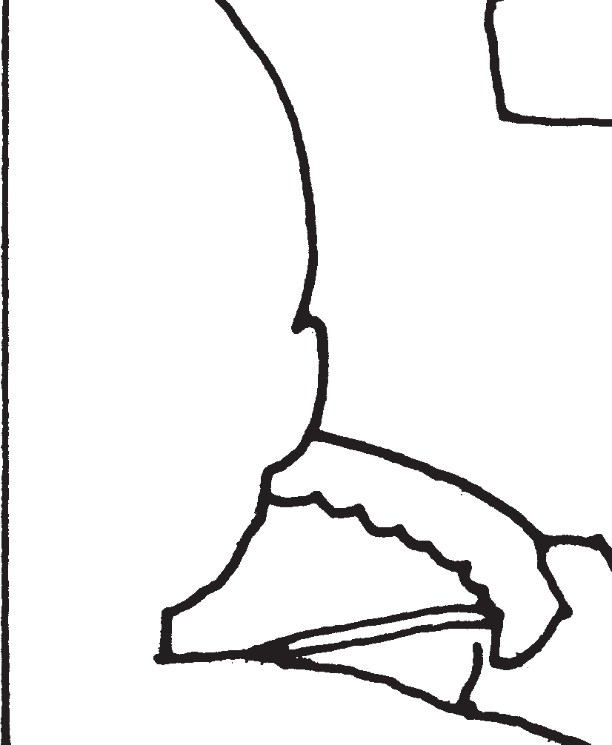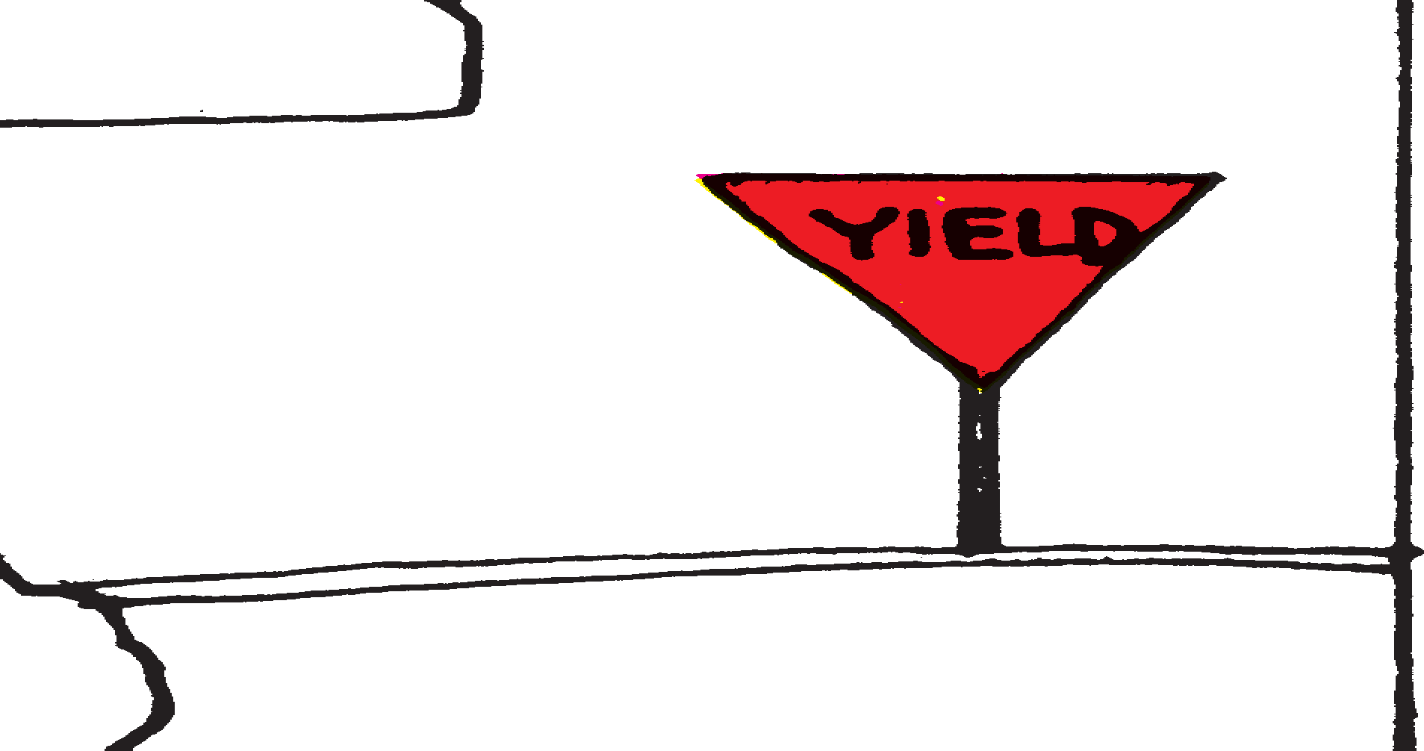

**32**

* 1. You are driving on the roadway and there is an emergency vehi- cle with siren and flashing lights directly behind you. You are in heavy traffic and cannot get out of the way. You should:
     1. Stop.
     2. Blow your horn.
     3. Force your way into traffic in the adjoining lane.
     4. Keep moving slowly until you can get out of the way.
  2. You may pass another vehicle:
     1. On a curve or a hill because the chance is small that another vehicle is coming.
     2. On the shoulder of the highway.
     3. When there is a solid yellow line in your lane if it’s clear ahead.
     4. None of the above.
  3. You may pass a school bus from the front or rear on an undivid- ed roadway:
     1. Never.
     2. When the red lamps on the school bus are flashing.
     3. When the red lamps on the school bus are not flashing.
     4. At anytime, if you go slow.
  4. An intersection has no traffic signs or signals. You arrive at the same time as another vehicle. You should:
     1. Speed up and get through the intersection.
     2. Slow down and yield to the vehicle on the right.
     3. Drive into the intersection and make the other vehicle stop.
     4. Honk your horn and drive through the intersection.
  5. You are coming to this intersection. You should:
     1. Stop.
     2. Slow down, stop if necessary and let all other crossing vehicles go first.
     3. Speed up to clear the intersection.
     4. Keep going as the sign is for the other vehicle.
  6. You are coming to this intersection. You should:
     1. Slow down and look for other vehicles.

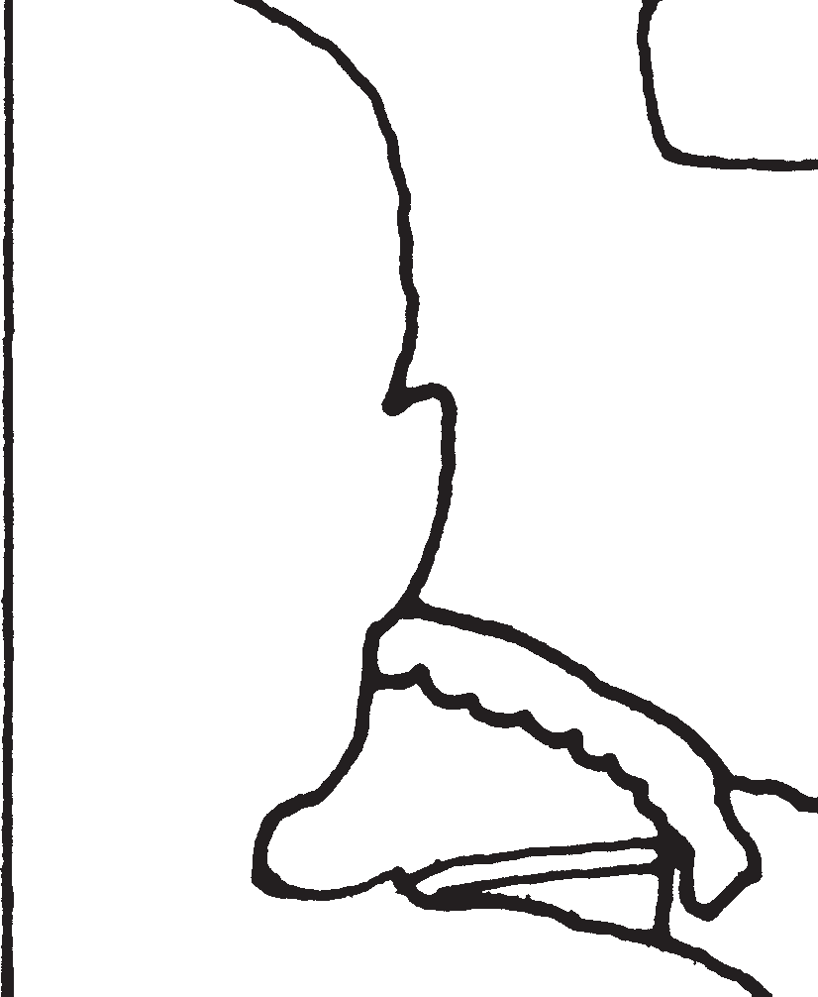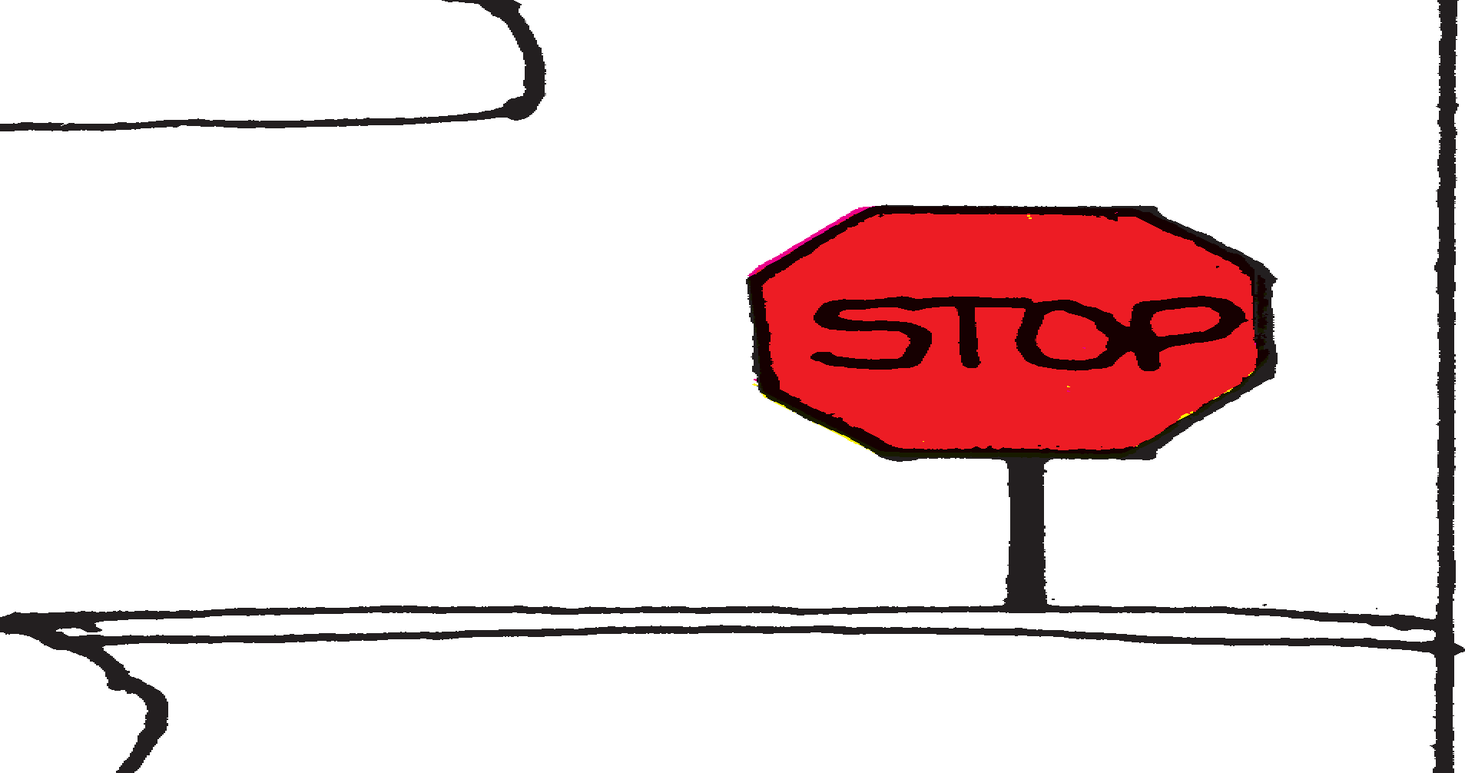

* + 1. Come to a complete stop and let all crossing traf- fic go.
    2. Stop only if there are other vehicles coming.
    3. Stop only if you are going to make a left turn.

Ref. Pg.

## 32

### &

**41**

**32**

**32**

**32**

**44**

**29**

* 1. You are coming to an intersection and have a green light. Pedestrians are crossing against the red. You should:
     1. Honk your horn.
     2. Speed up and pass in front of the pedestrians.
     3. Stop to let the pedestrians cross safely.
     4. Drive close and frighten the pedestrians so they’ll think twice before crossing against a red light.
  2. When you drive into the street from any driveway you:
     1. Must drive slowly so approaching vehicles and pedestrians can get out of your way.
     2. Must honk the horn so approaching vehicles and pedestrians can allow you room.
     3. Must stop and proceed only when there are no pedestrians or vehicles approaching.
     4. Can disregard pedestrians if there is no sidewalk.
  3. You and another vehicle are approaching an intersection that has no traffic signs or signals. Which vehicle has the right of way?
     1. The vehicle on the left.
     2. The vehicle on the right.
     3. The vehicle with the greatest speed.
     4. The vehicle that enters the intersection first.
  4. When turning left at an intersection or into any driveway you:
     1. Should leave room on the right for other vehicles to pass.
     2. Must yield to vehicles approaching closely from the opposite direction.
     3. Must not cross any solid yellow line.
     4. Must not block vehicles approaching from the rear.
  5. You are stopped behind other vehicles waiting at a stop sign. When the intersection is clear:
     1. You may proceed through the intersection without stopping again.
     2. You must stop again at the stop sign or stop line.
     3. You may go through the intersection slowly without stopping if there is no other traffic.
     4. You may follow the vehicle ahead without stopping again.
  6. You are driving on a divided multi-lane highway when you see or hear the signal of an approaching emergency vehicle. You should:
     1. Disregard the signal if there are other lanes available for the emergency vehicle.
     2. Stop as quickly as you can.
     3. Slow down, move your vehicle to provide a clear path for the emergency vehicle and stop.
     4. Increase your speed to provide a clear path for the emergency vehicle.

Ref. Pg.

## 29

**29**

**33**

**33**

**33**

**33**

**26**

### &

**33**

* 1. A vehicle using emergency signals is approaching from the opposite direction on a two-lane street or highway. You should:
     1. Stop as quickly as you can.
     2. Slow down, move as far to the right as possible and stop.
     3. Disregard the emergency vehicle as it is going the other way.
     4. None of the above.
  2. On a two-lane street your vehicle is being followed by a fire engine that is not using emergency signals. You should:
     1. Continue to drive in a normal manner.
     2. Stop as quickly as you can.
     3. Speed up to get out of the way.
     4. Slow down, move as far to the right as possible and stop.
  3. Certain highway signs and markings require that you *must* obey the indicated instruction. Such signs are known as:
     1. Regulatory signs. 3. Information signs.
     2. Warning signs. 4. Guide signs.
  4. Certain highway signs and markings contain information about hazardous conditions. Such signs are known as:
     1. Regulatory signs. 3. Information signs.
     2. Warning signs. 4. Guide signs.
  5. You are turning onto a two-lane road divided by a broken yellow line. You know immediately that:
     1. You are on a two-way road. 2. You are on a one-way road.

1. That the road is under repair.
2. That you must stay to the left of the broken yellow lines.
   1. You are driving on a highway divided by two solid yellow lines. You know that:
      1. You may cross these lines only to make a left turn into or from an alley, private road or a driveway.
      2. You may cross these lines to pass other vehicles only if there is no on-coming traffic.
      3. You may never cross these lines.
      4. You may cross these lines only to make a U-turn.
   2. You are driving and have started to pass the other car. You should:
      1. Speed up and pass as soon as possible.
      2. Slam on your brakes.
      3. Slow down and move into the right lane behind the other car.
      4. Stay in the left lane until passing the intersection.

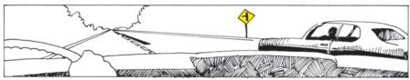

Ref. Pg.

## 34

**34**

**35**

**35**

* 1. You are driving on a four-lane divided highway. You should know that:
     1. White lane lines separate lanes of traffic moving in the same direction.
     2. White lane lines separate lanes of traffic moving in the oppo- site direction.
     3. Yellow lane lines separate lanes of traffic moving in the same direction.
     4. None of the above.
  2. You are driving on a four-lane divided highway. The traffic lanes are indicated by a solid white line. You should know that:
     1. The solid white line may not be crossed.
     2. The solid white line may be crossed at any time.
     3. The solid white line may be crossed only in unusual circum- stances and then only with great care.
     4. The solid white line separates traffic moving in opposite directions.

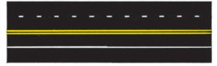

* 1. You are driving on a four-lane highway. You should know that a double solid white line:
     1. May not be crossed.
     2. May be crossed only with great care.
     3. Is used to separate traffic moving in the opposite direction.
     4. Are never used on highways.

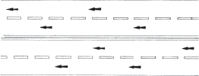

* 1. Edgelines are solid or lines along the edges of the roadway to be used as a safety guide to mark the limits of the travelled roadway.
     1. Yellow; white. 3. Orange; white.
     2. Red; white. 4. Green; white.

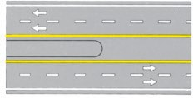

Ref. Pg.

## 36

**36**

**36**

**37**

**37**

* 1. Stop lines are solid white lines painted across the traffic lanes at and indicating the exact place at which to stop.
     1. Curves; hills. 2. Churches; schools.

1. Intersections; pedestrian crosswalks.
2. Freeway on ramps; fire stations.
   1. Crosswalk lines are two solid white lines painted across the traf- fic lanes. As a driver you should know that:
      1. Motor vehicles have the right of way over pedestrians in these crosswalks.
      2. When pedestrians are in these crosswalks, they have the right of way over motor vehicles.
      3. No one has the right of way in a crosswalk.
      4. Pedestrians are responsible to keep out of the way of all traffic.
   2. You are driving on a multi-lane roadway. The center lane is formed by a combination of yellow solid and dashed lines as shown in the picture. You as a driver should know:
      1. That this marked lane is used for passing only.
      2. That this marked lane is used only for left turns by traffic travelling in either direction.
      3. That this marked lane is a pedestrian safety zone.
      4. 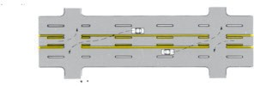That this marked lane is used for truck and bus traffic only.
   3. Obstruction markings are solid white or yellow lines painted in the traffic lanes to guide you around obstructions in the road. As a driver you should know:
      1. You may pass to either side of white obstruction markings.
      2. You may pass to either side of yellow obstruction markings.
      3. Both 1 and 2 above.
      4. None of the above.
   4. The painted markings in the picture mean that:
      1. Vehicles from both lanes can go straight or turn right.
      2. Vehicles in the left lane must go straight, and vehicles in the right lane can go straight or turn right.
      3. The signs are just advisory.
      4. Vehicles in the left lane may go straight or turn left and vehi- cles in the right lane must turn right.

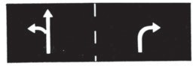

Ref. Pg.

## 39

**39**

**39**

**39**

**40**

**40**

* 1. A red traffic signal light means that you must:
     1. Stop at the stop line.
     2. When there is no stop line, stop before entering any cross- walk.
     3. Where there is no stop line or crosswalk, stop before enter- ing the intersection.
     4. All of the above.
  2. A stopped vehicle facing a circular red traffic light may if not prohibited by a traffic sign:
     1. Turn right after yielding to other traffic and pedestrians.
     2. It is illegal to turn right on red.
     3. Turn right at any time.
     4. Turn right only after blowing the horn.
  3. A stopped vehicle facing a circular red traffic light may turn left if not prohibited by a traffic sign:
     1. When there is no other traffic or pedestrians.
     2. Never.
     3. Only right turns on red are permitted in Hawaii.
     4. After yielding to pedestrians and traffic, when turning from a one-way street into another one-way street.
  4. A steady circular yellow light on a traffic signal means:
     1. You should speed up to beat the red light.
     2. That a red light is going to be shown immediately thereafter.
     3. You should avoid entering the intersection if possible.
     4. Both 2 and 3 above.
  5. A circular green traffic light means:
     1. That you always have the right of way.
     2. That you may go straight ahead or turn, except where signs prohibit turns.
     3. Traffic and pedestrians already in the intersection must get out of your way.
     4. Both 2 and 3 above.
  6. Lighted arrows are sometimes used to control turns from a spe- cific lane. A red arrow:
     1. Is never used as a traffic signal.
     2. Means the same as a circular red light for the indicated lane of traffic.
     3. Means that you may go in the direction indicated by the arrow.
     4. Means that the traffic the arrow is pointing toward must stop.

Ref. Pg.

## 40

**40**

**41**

**41**

**41**

**41**

* 1. Lighted arrows are sometimes used to control turns from a spe- cific traffic lane. A yellow arrow:
     1. Is never used as a traffic signal.
     2. Means the same as a circular yellow light for the indicated lane of traffic.
     3. Means that you may go in the direction indicated by the arrow.
     4. Is warning the traffic a green arrow is about to be shown.
  2. Lighted arrows are sometimes used to control turns from a spe- cific traffic lane. A green arrow:
     1. Is used only on one-way streets.
     2. Means the same as a circular green light, but you must go only in the direction the arrow indicates.
     3. Means that you may go only if the green arrow is accompa- nied by a green light.
     4. Points the way to the airport.
  3. A red flashing signal means the same as a:
     1. Red light. 3. Yield sign.
     2. Stop sign. 4. Caution sign.
  4. You are approaching a flashing red signal at this intersection. You should:
     1. Come to a complete stop. Check the traffic and go when it is safe.
     2. Slow down and yield the right of way.
     3. Stop only if turning left.
     4. 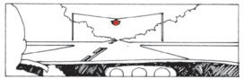Be prepared to stop.
  5. The yellow flashing signal in the picture means:
     1. That the roadway ends.
     2. That you must stop.
     3. That you may proceed only with caution.
     4. 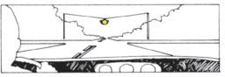That you must stop for cross traffic.
  6. A lighted red “X” over a traffic lane means:
     1. That you may use that lane.
     2. That you may *not* use that lane.
     3. That the lane is for traffic coming toward you.
     4. Both 2 and 3 above.

Ref. Pg.

## 40

**42**

**42**

**45**

**45**

**45**

* 1. A lighted green arrow over the traffic lane means:
     1. That you may use that lane.
     2. That you may *not* use that lane.
     3. That the lane is for traffic coming toward you.
     4. Both 2 and 3 above.
  2. A yellow “X” over the traffic lane means:
     1. That you must move out of that lane of traffic because it is going to be used for on-coming traffic.
     2. That you may use that lane.
     3. That the lane is for left turns only.
     4. That you may use the lane but with caution.
  3. Pedestrian signals consist of the lighted words “WALK” and “DON’T WALK” and the symbols of a walking person and an upraised palm. A steady “DON’T WALK” or upraised palm sig- nal means:
     1. Pedestrians must not enter the roadway toward the signal.
     2. Pedestrians already in the intersection facing the signal may continue to the nearest sidewalk, traffic island or safety zone.
     3. Pedestrians already in the intersection facing the signal must run to the nearest sidewalk.
     4. Both 1 and 2 above.
  4. 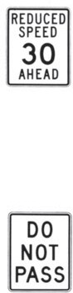This is a “reduced speed *ahead*” sign. You as a driver should know:
     1. That you should maintain your vehicle’s speed till you get to the slower speed zone.
     2. That you should begin to reduce your vehicle’s speed.
     3. That it’s dangerous to slow down because traffic starts to back up.
     4. That the sign is only there for poke-along drivers.
  5. While driving you come upon a sign which says, “reduced speed 35 MPH”. You as a driver should know:
     1. That the new 35 MPH speed zone begins at this sign.
     2. That the new 35 MPH speed zone begins at the next “speed limit” sign.
     3. That you have plenty of time to slow down before the speed zone.
     4. That the sign is put there to harass “good” drivers.
  6. This is a “do not pass” sign. You as a driver should know:
     1. That you must not pass another vehicle where these signs are posted.
     2. That you may pass a slow moving vehicle here if you can pass quickly.
     3. That it’s all right to pass here if you “know the road ahead.”
     4. That it’s all right to pass here at night when the head- lights of on-coming traffic can be seen.

Ref. Pg.

## 46

**46**

**46**

**48**

**47**

**47**

**47**

**47**

**47**

* 1. This sign means:
     1. No U turn.
     2. U turn permitted.
     3. Winding road.
     4. Sharp left turn.
  2. This sign means:
     1. No right turn.
     2. Right turn permitted.
     3. Stop before turning right.
     4. Sharp curve ahead.
  3. This sign means:
     1. Stop.
     2. Do not enter.
     3. Railroad crossing.
     4. Yield.
  4. This sign means:
     1. Lane signal.
     2. Lane closed for traffic.
     3. Railroad crossing ahead.
     4. Traffic signal ahead.
  5. This sign means:
     1. One-way traffic.
     2. Divided highway ahead.
     3. Two-way traffic.
     4. Keep left.
  6. This sign means:
     1. One-way traffic.
     2. Divided highway ends.
     3. Two-way traffic.
     4. Keep right.
  7. This sign means:
     1. Trucks only.
     2. Trucks entering highway.
     3. Hill.
     4. Trucks have the right of way.
  8. This sign means:
     1. Slippery when wet.
     2. Watch for drunk drivers.
     3. Dangerous curve.
     4. Bump in road ahead.
  9. This sign means:
     1. School.
     2. School crossing.
     3. Pedestrian crossing.
     4. Workmen in road.

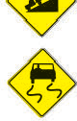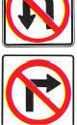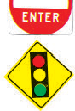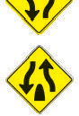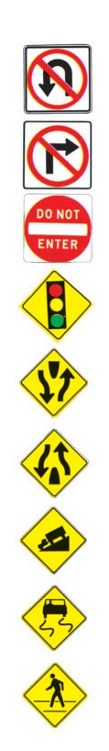

112

Ref. Pg.

## 47

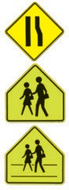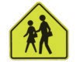

**48**

1. This sign means:
   1. Narrow bridge.
   2. Lane ends or roadway narrows.
   3. Industrial area.
   4. Freeway on ramp.
2. This sign means:
   1. Library.
   2. School crossing.
   3. Pedestrian crossing.
   4. Children in road.

**48** 86. This sign means:

1. School zone.
2. Library crossing.
3. Pedestrian crossing.
4. Children in road.

**55** 87. Persons driving under the influence of intoxicating liquor are:

1. Every driver’s problem whether they drink or not.
2. Only a problem to those who drink.
3. Not a problem in Hawaii.
4. A police enforcement problem only.

**55** 88. A few drinks after work before driving home:

1. Is good because you miss the rush traffic.
2. Is good because they help to release the day’s tension and make you a safer driver.
3. Should be avoided because they may make you a dangerous driver.
4. Never hurt anyone.

**55** 89. Alcoholic beverages will affect you:

1. More rapidly just after eating.
2. More rapidly on an empty stomach.
3. The same way at all times.
4. Only if you have more than two drinks.
5. 90. After the alcohol has entered your blood you can lessen its effect by:
   1. Taking a cold shower.
   2. Drinking black coffee.
   3. Both 1 and 2 above.
   4. There is nothing you can do to lessen the effect.
6. 91. A police officer stops you, charges you with driving under the influence of alcohol, and tells you, you must take a test to deter- mine the amount of alcohol in your blood. You as the driver:
   1. Don’t have to take the test if you can prove you weren’t drinking.
   2. Must take the test or risk losing your driver’s license.
   3. Don’t have to take the test if you have not violated any traf- fic rule.
   4. Don’t have to do anything.

Ref. Pg.

## 56

**56**

**56**

**56**

**55**

**57**

**57**

1. You have been charged with driving under the influence of alco- hol, and have refused to take the required test for blood alcohol. You may lose your driver’s license for twelve months:
   1. Only if you are convicted of driving while under the influ- ence of alcohol.
   2. Only if you are convicted of a traffic violation.
   3. Because you have refused to take the test.
   4. You won’t lose your license.
2. You may drink alcoholic beverages in a vehicle on a public highway:
   1. As long as you don’t drive.
   2. Only if you ride in the back seat.
   3. Only if you ride in the back of a pick-up truck.
   4. It is against the law to drink alcoholic beverages on a public highway.
3. Drugs may interfere with a person’s ability to drive safely:
   1. Only if the drugs are prescribed by a doctor.
   2. Only when taken while drinking.
   3. Only when driving at night.
   4. And it is important to ask your doctor about any effects that the prescribed drugs may have on your driving ability.
4. The consumption of alcohol while taking drugs can:
   1. Have a less pronounced effect than either taken separately and is always safe.
   2. Have a more pronounced effect than either taken separately.
   3. Help cure your illness.
   4. Improve your driving ability.
5. The effect that alcohol has on your reflexes and judgment:
   1. Is less if you were only drinking beer.
   2. Is less if you were only drinking wine.
   3. Is greater if you were drinking whiskey or hard liquor.
   4. Depends on the amount of alcohol in your blood stream.
6. When you are driving a vehicle the act of turning your head and looking before changing lanes, driving away from a curb or exit- ing your vehicle into traffic is:
   1. A bad driving habit.
   2. A good driving habit.
   3. Unnecessary.
   4. Not necessary if you use the rear-view mirror.
7. When you are driving, *failing* to turn your head to check for traf- fic before changing lanes, driving away from a curb or exiting your vehicle in traffic is:
   1. All right if you first check the rear-view mirror.
   2. A bad driving habit.
   3. Many times the cause of a traffic accident.
   4. Both 2 and 3 above.

Ref. Pg.

## 74

**67**

**39**

### &

**57**

**67**

**57**

**&**

**58**

1. When you are driving, signaling your intentions before turning, changing lanes or driving away from a curb:
   1. Is necessary only if other traffic is present.
   2. Is a good driving habit, and is required by law.
   3. Is necessary only during the maneuver, not before.
   4. Is not necessary if the maneuver is done slowly.
2. You are driving on a four-lane divided highway, two vehicles are driving side by side ahead of you, and you are in a hurry. You should:
   1. Drive closely behind the vehicle in the left lane and flash your headlights.
   2. Drive closely behind the vehicle in the right lane.
   3. Drive in either lane with at least a two-second time interval behind the vehicle ahead.
   4. Drive closely behind the vehicles ahead changing lanes fre- quently.
3. You are coming to this intersection, and are planning on turning right. There is a vehicle close behind you. You should:
   1. Signal, slow down, turn right.
   2. Signal, come to a complete stop, and turn right when the intersection is clear of pedestrians and vehicles.
   3. Signal, come to a complete stop, wait for a green light, turn right.
   4. Slow down, turn right.

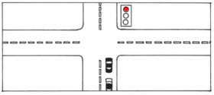

1. When driving in heavy traffic you should:
   1. Drive close to the vehicle ahead to keep other vehicles from cutting in.
   2. Drive close to the vehicle ahead being ready for a sudden stop.
   3. Both 1 and 2 above.
   4. Keep at least a two-second interval behind the vehicle ahead.
2. You are driving behind another vehicle. You notice that the driver is driving with one hand, talking to a passenger. You as a driver:
   1. Know that you should give the vehicle ahead extra room.
   2. Know that the driver in the vehicle ahead is reducing his safety margin by being an inattentive driver.
   3. Know that you should avoid this bad habit.
   4. All of the above.

Ref. Pg.

## 57

### & 58

**58**

**59**

**59**

**59**

**59**

**60**

1. An inattentive driver is a driver who:
   1. Daydreams or gazes at objects off the roadway while driving.
   2. Carries on an eye-contact conversation with a passenger while driving.
   3. Restricts his attention to only watching the vehicle ahead.
   4. All of the above.
2. An arrogant driver is a driver who:
   1. Is purposely in a hurry, competing with other traffic.
   2. Shows little or no respect for traffic laws, or the right-of-way of others.
   3. You should try to avoid when driving.
   4. All of the above.
3. Defensive driving is a driving technique in which you as a driv- er:
   1. Identify dangerous driving situations and take action to avoid an accident.
   2. Defend against poor drivers by getting ahead of them in traf- fic.
   3. Defend yourself against accidents by following close to the vehicle ahead.
   4. Defend against accidents by driving your vehicle fast enough to stay ahead of traffic congestion.
4. To practice defensive driving you should:
   1. Be aware of developing traffic situations around you.
   2. Look well ahead of your vehicle and maintain a proper fol- lowing distance.
   3. Have an alternate plan of action ready. (Always leave your- self a way out)
   4. All of the above.
5. Information you need to drive safely is gained primarily by:
   1. Seeing.
   2. Talking to yourself.
   3. Following other traffic.
   4. Turning the radio.
6. Increasing your vehicle’s speed:
   1. Increases your field of vision.
   2. Decreases your field of vision.
   3. Makes it easier to see cross traffic.
   4. Has no effect on your field of vision.
7. Your physical and mental condition as a driver:
   1. Are not important.
   2. Are very important safety factors when driving.
   3. Have no effect on your driving ability.
   4. Both 1 and 3 above.

Ref. Pg.

## 60

**60**

**60**

**60**

**61**

**61**

**61**

1. You notice a vehicle defect which may affect the safe operation of your vehicle. You should:
   1. Correct the defect as soon as possible.
   2. Correct the defect when you can afford it.
   3. Drive the vehicle slower.
   4. Not carry passengers until the defect is corrected.
2. You borrow your friend’s vehicle. You have never driven it before. You should:
   1. Drive away, all vehicles are similar.
   2. Don’t show your friend that you are unfamiliar with his vehicle.
   3. Disregard any obvious defects so as not to embarrass your friend.
   4. Take a few minutes to familiarize yourself with the operation and location of all the vehicle’s equipment.
3. When driving to an unfamiliar area you:
   1. Can depend on road signs to find your way.
   2. Should plan your trip.
   3. Only have to know generally where your destination is.
   4. Should always choose the most direct route.
4. Newer vehicles have equipment warning lamps installed on the vehicle’s instrument panel. Which of the following statements is correct?
   1. Before the engine is started the lamps should all be illumi- nated when the ignition switch is first turned on.
   2. No lamps should illuminate until the engine is running.
   3. The lamps should *never* illuminate unless there is a malfunc- tion.
   4. The lamps will only illuminate if the head lamps are turned on.
5. Newer vehicles are equipped with a brake warning lamp. This lamp:
   1. Should come on when the parking brake is released.
   2. Should not come on when the foot brake pedal is pressed.
   3. Should never come on.
   4. Indicates that the brake lights are operational.
6. Safety belts are life belts. They:
   1. Must be worn at all times when driving or riding in a vehi- cle.
   2. Should be worn only when driving at higher speeds.
   3. Should be worn loosely.
   4. Need to be worn only if riding in the front seat of the vehicle.
7. The seat belt should be adjusted so that it:
   1. Is loose.
   2. Is buckled snugly across your hip bones and lower abdomen.
   3. Is hidden beneath the seat.
   4. Keeps the seat belt buzzer or light from operating.

Ref. Pg.

## 61

**64**

**64**

**65**

**65**

### &

**66**

**67**

**75**

1. Small children when riding in a vehicle:
   1. May be safely held by a strong adult.
   2. Will be safe if standing on the floor in the front or back of an auto.
   3. Will not be hurt in an accident because they are small.
   4. Must never be allowed to ride standing on a seat.
2. You are late to work and in a hurry. Before you back into the street:
   1. Honk your horn.
   2. Check for children and other objects around your car.
   3. Always race your engine so that pets will get out of the way.
   4. Check for traffic before getting in the vehicle.
3. You are driving forward out of your driveway:
   1. You must come to a complete stop before crossing the side- walk area.
   2. You must slow down before crossing the sidewalk area.
   3. You have the right of way over pedestrians on a sidewalk area.
   4. If you honk your horn, you can cross the sidewalk area with- out stopping.
4. You are driving on a multi-lane highway and wish to change lanes. You *must* signal your intentions:
   1. Immediately before changing lanes.
   2. Only when actually changing lanes.
   3. At least 50 feet before beginning to change lanes.
   4. At least 100 feet before beginning to change lanes.
5. You are driving on a four-lane highway. A slow moving vehicle is in your lane. Traffic is moderate. Before changing lanes you must:
   1. Signal your intentions for at least 100 feet.
   2. Make sure your blindspot is clear.
   3. Make sure that there is sufficient room in traffic to make the move. (Never violate other traffics two-second interval)
   4. All of the above.
6. Following too closely is listed as the cause of many traffic acci- dents. To avoid this type of accident, the proper interval for fol- lowing is:
   1. Close enough so no one will cut in front of you.
   2. Found by spacing your vehicle at least 2 seconds behind the vehicle ahead.
   3. 100 feet.
   4. 75 feet.
7. You are driving and it begins to rain. You should:
   1. Drive faster than other traffic.
   2. Drive at least the speed limit.
   3. Slow down and allow for weather conditions.
   4. Drive close behind the vehicle ahead.

Ref. Pg.

## 26

### &

**70**

**69**

**69**

**74**

**73**

**74**

1. When driving along sharp curves and steep hills of mountain roads you should:
   1. Always allow an approaching vehicle at least one half of the paved surface.
   2. Use a lower gear to control speed while going down long steep hills.
   3. Stay close to the right edge of the road.
   4. All of the above.
2. When you approach a vehicle that has just stopped in a parked position, you should:
   1. Assume that the driver will open the door as you approach.
   2. Speed up.
   3. Slam on your brakes.
   4. Assume that the driver will wait till you pass before opening his door.
3. You are stopped at an intersection and the traffic ahead is stopped. You have a green light. You should:
   1. Drive into the intersection as far as you can.
   2. Wait until there is space for your entire vehicle on the oppo- site side of the intersection before proceeding.
   3. Honk your horn.
   4. Drive part way into the intersection.

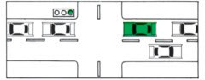

1. Traffic regulations require that you display a turn signal for at least feet before making every turn or lane change.

1. 50 feet. 3. 100 feet.

2. 75 feet. 4. 25 feet.

1. Hazard warning signals (4-way flash) are intended to warn other drivers that a vehicle is in a hazardous position on the roadway. The signal should be used when:
   1. Driving through a tunnel.
   2. Driving a heavy truck or bus up a hill.
   3. Performing emergency vehicle maintenance on the road shoulder.
   4. Both 2 and 3 above.
2. When signaling to make a turn or lane change you should:
   1. Signal *only* while making the turn or lane change.
   2. Signal *every time* you intend to make a turn or lane change.
   3. Know that after signaling for 100 feet that you have the *right*

to make the turn or lane change.

* 1. All of the above are correct.

Ref. Pg.

## 75

**75**

**75**

**77**

**78**

**80**

1. When passing a motorcycle you must:
   1. Give the motorcyclist the right hand part of his traffic lane.
   2. Give the motorcyclist his entire traffic lane as if his vehicle were a car.
   3. Pull to the left just far enough to miss the motorcyclist.
   4. Not let the motorcyclist know you are going to pass.
2. Heavy vehicles have been entering the roadway from a muddy area. You as a driver should:
   1. Slow down as you approach the area.
   2. Allow at least twice the following distance behind other vehi- cles.
   3. Know that rain will make the area extremely slippery.
   4. All of the above.
3. Hydroplaning occurs when the vehicle’s tires “ride up” on water in the roadway during heavy rains. To prevent hydroplaning you should:
   1. Insure that the tires on the vehicle have good tread depth.
   2. Insure that the tires on the vehicle are inflated to the proper pressure.
   3. Reduce vehicle speed when driving in the rain.
   4. All of the above are correct.
4. You are driving at night and another vehicle is approaching. Your head lamps:
   1. Should be on high beam. 2. Should be on low beam.
5. Should be off, use your parking lights.
6. May be on either high or low beam.
7. You are driving on the entry on-ramp of a freeway. You should:
   1. Drive to the end of the entry on-ramp, stop, check for on- coming traffic, signal and enter the near lane.
   2. Stop, check for vehicles in the near lane, speed up on the entry ramp, signal and enter the near lane.
   3. Check for vehicles in the near lane, adjust speed for approaching vehicles, signal and enter the near lane.
   4. Always stop before entering the freeway.
8. You wish to exit the freeway at this exit. The exit speed shown on the sign is the speed at which you should:
   1. Slow to before leaving the freeway.
   2. Slow to while on the freeway exit ramp.
   3. Never go slower than this speed on the exit ramp.
   4. Never go faster than this speed anywhere on the exit ramp.

Ref. Pg.

## 80

**81**

**82**

**82**

### &

**83**

**83**

**85**

**&**

**86**

1. You wish to exit the freeway but have missed your exit ramp. You should:
   1. Back up on the shoulder to get into your exit ramp.
   2. Turn around on the shoulder and drive on the shoulder to your exit.
   3. Cut across the grass to your exit.
   4. Continue driving to the next exit.

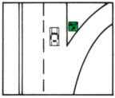

1. You are driving and have a blow out. You should:
   1. Slam on your brakes.
   2. Hold your steering wheel tight, and steer to stop on the shoulder.
   3. Keep going.
   4. Turn on your emergency flashers.
2. While driving your wheels slip off the road edge. You should:
   1. Jerk the steering wheel to force the vehicle back onto the pavement.
   2. Speed up and steer back onto the pavement gradually.
   3. Slam on your brakes and stop.
   4. Slow down using the brakes gently, when at a safe speed, turn the steering wheel to return to the pavement.
3. You are driving on a busy street and your vehicle’s accelerator sticks open. You should:
   1. Blow your horn.
   2. Slam on your brakes.
   3. Turn on your hazard warning lamps.
   4. Turn off your ignition, taking care not to engage the steering wheel locking mechanism.
4. You are driving and suddenly your power steering is gone. You should:
   1. Honk the horn and turn off the ignition.
   2. Turn on your hazard warning lights and brace yourself.
   3. Work hard to steer, reduce speed, drive to a safe area and stop.
   4. Slam on your brakes.
5. When you are driving you should give heavy trucks and buses extra room because:
   1. Trucks can stop in a shorter distance than cars.
   2. Trucks require more room to maneuver than cars.
   3. Trucks require a greater distance to stop than cars.
   4. Both 2 and 3 above.

Ref. Pg.

## 85

**85**

**85**

**86**

**86**

**86**

**86**

1. You wish to drive a heavy truck in Hawaii. You must:
   1. Be at least 21 years old.
   2. Have a valid driver’s license for the category of vehicle you wish to drive.
   3. Have no special qualifications.
   4. Drive the truck only on truck routes.
2. When you drive a heavy truck or bus on the highway you:
   1. Have the added responsibility to give the proper considera- tion to other highway users.
   2. Are larger and can use that extra size to your advantage in traffic.
   3. Can expect smaller vehicles to stay out of your way.
   4. Are responsible only for your truck and its cargo.
3. When driving directly behind a heavy truck or bus extra caution must be taken because:
   1. The heavy truck or bus driver may not be able to see you.
   2. Your forward visibility is blocked by the truck or bus.
   3. Both 1 and 2 above.
   4. None of the above.
4. When changing lanes or at intersections near heavy trucks other drivers and highway users must make allowances for:
   1. The increased stopping distance required by large vehicles.
   2. The decreased stopping distance required by large vehicles.
   3. The increased noise made by larger vehicles.
   4. The increased speed of larger vehicles.
5. You are driving up a hill and are approaching a heavy truck from the rear. You should know:
   1. That the truck may be travelling at a speed slower than the posted speed limit.
   2. That you may not be able to safely pass the truck.
   3. That you may not be able to legally pass the truck.
   4. All of the above are correct.
6. You are driving down a hill and notice a heavy vehicle approach- ing from behind. You should:
   1. Pay no attention as heavy vehicles always speed down hills.
   2. Know that you have the right of way and it is the truck dri- ver’s responsibility to miss you.
   3. Know that you may have to move out of the heavy vehicle’s way.
   4. Drive on the right side of the highway and slow down.
7. When passing a large vehicle a driver of a small vehicle must be prepared for:
   1. A loud noise.
   2. Excess air pollution.
   3. Wind gusts produced by the large vehicle.
   4. Falling vehicle parts.

Ref. Pg.

## 87

**87**

**87**

**87**

**88**

**88**

**52**

1. When towing a trailer large enough to obstruct your inside rear- view mirror, you are required to:
   1. Have an outside rear-view mirror installed on the driver’s side of your vehicle.
   2. Have an outside rear-view mirror installed on the side of your vehicle opposite of the driver.
   3. Have outside rear-view mirrors installed on both sides of your vehicle.
   4. Have a person in the vehicle to clear you for right turns.
2. When towing a loaded trailer the weight of which is more than one-half of the towing vehicle’s weight, or is 3,000 pounds or more, the *trailer* must be equipped with:
   1. Brakes.
   2. Breakaway protection.
   3. Hub caps.
   4. Brakes and breakaway protection.
3. When towing a trailer or a house trailer, you should always:
   1. Have someone ride in the trailer to keep the load steady.
   2. Allow only adults to ride in the trailer.
   3. Never allow anyone to ride in the trailer.
   4. Allow persons to ride in house trailers only.
4. When towing a trailer you must make sure that:
   1. The trailer has a safety chain which is securely attached to the trailer hitch.
   2. The trailer has a safety chain which is securely attached to the vehicle’s bumper.
   3. The trailer has a safety chain which is securely attached to the frame of the towing vehicle.
   4. The trailer hitch is equipped with a fail-safe latch.
5. When towing a trailer load it is important to insure that the trail- er’s load is properly balanced. About to percent of the total trailer weight should be on the vehicle’s trailer hitch. 1. 5 to 10. 3. 15 to 20.

2. 10 to 15. 4. to 25.

1. When towing a trailer you must insure that it is equipped with:
   1. Wheels properly mounted and lubricated, and covered with fenders or mud guards.
   2. Good tires properly inflated.
   3. Tail, stop, turn signal, license plate and if required, side marker lamps and reflectors.
   4. All of the above.
2. You are involved in an accident. You should:
   1. Stop immediately.
   2. Help the injured.
   3. Call the police.
   4. All of the above.

Ref. Pg.

## 52

**52**

**52**

**52**

**95**

1. You are involved in an accident and your vehicle is blocking traffic. You should:
   1. If possible move your vehicle off of the travelled portion of the roadway.
   2. Not move your vehicle under any circumstances.
   3. Wait until the police arrive before you move your vehicle.
   4. None of the above.
2. You are involved in an accident and another person is injured. You should:
   1. Moved the injured away from the scene immediately.
   2. Always leave the injured where they are.
   3. Do not move the injured unnecessarily, keep the injured warm and administer first aid.
   4. Stay away from the injured.
3. When you are involved in an accident where the accident scene is not readily visible to on-coming traffic, you should:
   1. Have someone warn approaching traffic.
   2. Let on-coming traffic watch out for themselves.
   3. Let the police handle everything.
   4. Get off the roadway.
4. You inadvertently drive your vehicle into the side of an unat- tended parked vehicle and you cannot locate the vehicle’s owner. You as a driver:
   1. Have done as much as you can.
   2. Must stay until the police arrive.
   3. Must leave a written notice containing your name and address and circumstances of the accident.
   4. May go on your way.
5. The pedestrian in the picture starts to cross in front of your vehi- cle. You should:
   1. Honk your horn.
   2. Slow down.
   3. Speed up and pass in front of the pedestrian.
   4. Stop and let the pedestrian cross.

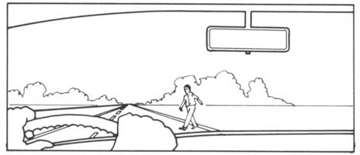

Ref. Pg.

## 95

**96**

**96**

**97**

**97**

**97**

1. You are driving on a multi-lane street. You notice a vehicle stopped in front of a crosswalk as depicted in the picture. You should:
   1. Pass the vehicle on the right.
   2. Pass the vehicle on the left.
   3. Not pass the vehicle.
   4. Blow your horn before passing.

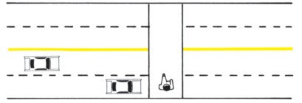

1. As a pedestrian you should know that:
   1. When you are in a crosswalk you should always insist on the right of way over a vehicle.
   2. You must never enter the street or crosswalk when there are vehicles approaching close by.
   3. You can enter a crosswalk at any time and it is the vehicle driver’s responsibility to stop.
   4. You have to use crosswalks only when they are convenient.
2. As a pedestrian you should know that:
   1. You should look for turning vehicles before crossing the street.
   2. You should never run alongside of or across the street.
   3. You should walk on the left side of the street facing traffic.
   4. All of the above.
3. As a driver you should give a bicyclist:
   1. The same rights and privileges as motorists.
   2. Twice as much room as you think he needs.
   3. The right of way when you are crossing bike lanes.
   4. All of the above.
4. Bicyclists are required to:
   1. Obey traffic signs, signals and other traffic laws except those which by their nature cannot apply.
   2. Ride on the sidewalk in business districts.
   3. Ride in the center of traffic lanes.
   4. All of the above.
5. Bicyclists:
   1. May ride side by side on roadways.
   2. May ride two abreast on bike paths except where signs indi- cate otherwise.
   3. Have the right of way over pedestrians.
   4. May ride attached to a vehicle.

Ref. Pg.

## 98

**27**

1. Bicyclists must refrain from:
   1. Carrying passengers unless the bicycle is equipped to do so.
   2. Riding on the sidewalk at any place.
   3. Riding at night.
   4. Riding in the roadway in a business district.
2. The driver in the vehicle in the picture is hand signaling that he is going to:
   1. Stop.
   2. Turn left.
   3. Turn right.
   4. Slow down.

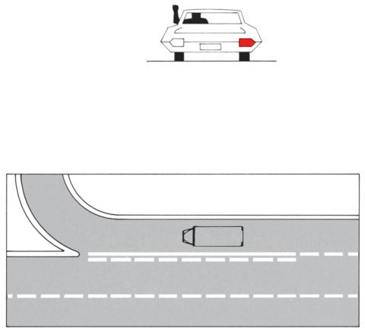

**34**

1. The truck in the picture has a solid white line in his lane of trav- el. The truck:
   1. May cross the line at any time.
   2. May cross the line to enter freeway.
   3. Should not cross the line.
   4. Is on the wrong side of the line.

**44** 171. You are approaching a 4-way stop sign:

1. You must stop and yield to all traffic within the intersection.
2. You may drive through the stop sign if there is no other cross- ing traffic.
3. You do not have to stop if turning right.
4. Both 2 and 3 are correct.

Ref. Pg.

**64** 172.

**58** 173.

**95** 174.

**61** 175.

**27** 176.

**27** 177.

Hawaii law prohibits leaving a child unattended in a motor vehicle:

1. By you or any adult passenger of the motor vehicle.
2. For five minutes or longer.
3. If the child is under the age of nine.
4. All of the above.

As a driver, you should know that the safest precaution regarding the

use of a phone or other hand-held electronic mobile devices and driving is:

1. Use hand-free devices so you can keep both hands on the steering wheel, unless you are under the age of eighteen.
2. Keep your cell phone or IPOD within easy reach so it is easy for you to retrieve it.
3. Check the number before answering.
4. None of the above.

When you see a pedestrian with a white cane or a guide dog on the roadway as a driver you should know:

1. The use of a white cane identifies the pedestrian as a

pedestrian who is blind or visually impaired.

1. The use of a guide dog identifies the pedestrian as a pedestrian

who is blind, visually impaired or has other special needs.

1. You must stop for all pedestrians, including those pedestrians

who are blind or visually impaired.

1. All of the above are correct.

Safety belts are life belts. They:

1. Must be worn at all times when driving or riding in a vehicle.
2. Should be worn only when driving at high speeds.
3. Should be worn loosely.
4. Need to be worn only if riding in the front seat of the vehicle.

Who may park in an accessible parking space?

1. Any vehicle transporting a disabled person.
2. Any vehicle that displays a disabled parking placard.
3. Any vehicle that displays a disabled parking placard that was issued to the disabled person being transported in the vehicle.
4. Any vehicle if there is no regular parking space available.

What is the purpose of the access aisle next to an accessible parking space?

1. To allow for parking for emergency vehicles.
2. To allow for the deployment of a wheelchair lift/ramp and other mobility devices from a vehicle parked in the accessible parking space.
3. To allow parking space for motorcycles, mopeds and bicycles.
4. To allow vehicles to park temporarily while waiting for a passenger.

127

# NOTES

**NOTES**

**NOTES**

### VEHICLE REGISTRATION OFFICES

**City & County of Honolulu**

Hours of Operation Monday-Friday except holidays 7:45 a.m. to 4:00 p.m. Satellite City Hall offices:

Ala Moana Shopping Center, 1450 Ala Moana Boulevard #1286, Phone 768-4300 Fort Street Mall, 1000 Fort Street Mall, Phone 768-4103

Hawaii Kai, 6600 Kalanianaole Highway #101, Phone 768-4800

Kapalama Satellite City Hall, 925 Dillingham Blvd, #101, Phone: 768-4500, M-F

(8:00 am–4:00 pm).

Kapolei, 1000 Uluohia Street, Phone 768-3400

Pearlridge Shopping Center, 98-1005 Moanalua Road (9:00 am–5:00 pm), Phone 768- 5000

Wahiawa, 330 N. Cane Street, Phone 768-4700 Waianae, 85-670 Farrington Highway, Phone 768-4900

Windward City Shopping Center, 45-480 Kaneohe Bay Drive C06, Phone 768-4100

### County of Hawaii

Hilo, 101 Pauahi Street, Suite #5, Phone 961-8351

Hours of Operation . . . . . . . . . . . . . . . . . . . . . . . . 7:45 a.m. to 4:30 p.m.

Closed Sat., Sun., and Holidays

### County of Maui

Maui Mall, Kahului, Phone 270-7840

Hours of Operation . . . . . . . . . . . . . . . . . . . . . . . . 7:45 a.m. to 4:30 p.m.

Closed Sat., Sun., and Holidays

### County of Kauai

Lihue Civic Center, Kapule Building, 4444 Rice Street, Suite 466, Phone 241-6577 Hours of Operation . . . . . . . . . . . . . . . . . . . . . . . . 7:45 a.m. to 4:15 p.m.

Closed Sat., Sun., and Holidays

### RECONSTRUCTED VEHICLE INSPECTION STATIONS

**City and County of Honolulu**

Honolulu, 1112 Kapahulu Avenue

Hours of Operation . . . . . . . . . . . . . . . . . . . . . . . . 1:00 p.m. to 3:15 p.m.

Closed Sat., Sun., and Holidays

### Counties of Hawaii, Kauai and Maui

No reconstructed vehicle inspection rules. County code, state laws and administrative rules concerning safety inspection apply.



Hawaii Drivers’ Manual is printed and published by Hagadone Printing Company in conjuction with the State Department of Transportation.

